Digital IV Therapy Passport – Learner User Guide

The Digital Learning Solutions (DLS) platform, provided by the Technology Enhanced Learning (TEL) Team within Health Education England (HEE), hosts the Digital IV Therapy Passport.

This user guide is designed to provide first time access guidance to a Learner.

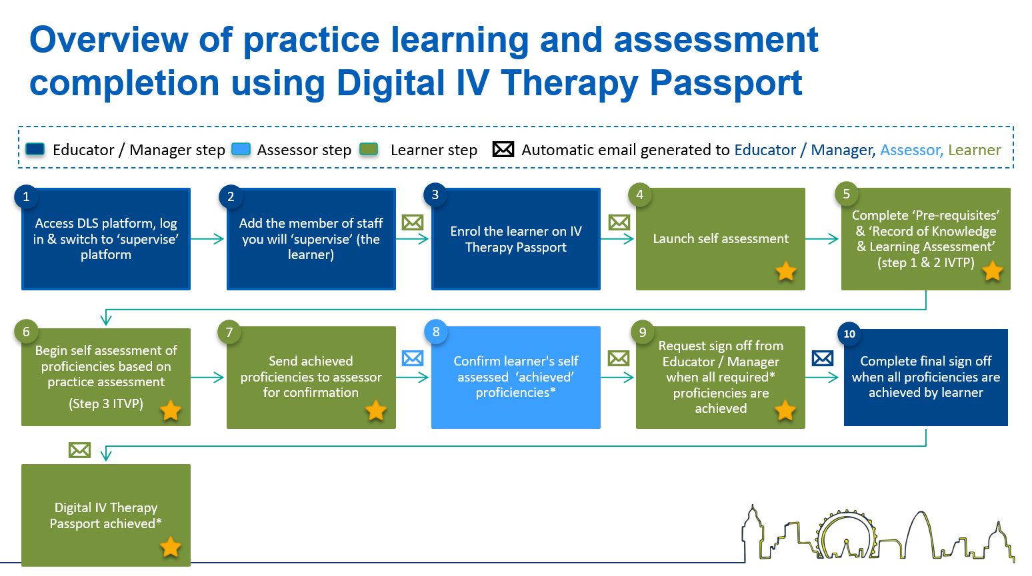
Indicates the Learner steps in the process

For information:

- The learner: Person completing the self-assessment in the IV Therapy Passport
- The Educator / Manager: the person who is facilitating the passport and will ultimately sign it off when all proficiencies have been assessed.
- The Assessor: the person supervising, completing practice assessment and confirming achievement of proficiencies.

Note:
The DLS platform uses the term ‘supervise’ or ‘supervisor’ – these terms indicate the assessment, or sign off, process performed by the Assessor or Educator/Manager.

For support, please contact: your assessor or the local educator/manager at your organisation.

Contents
Essential guidance 3
A. Register for a DLS account 3
B. Log in procedure 6
C. Add an assessor (supervisor) 7
D. Start your self-assessment (prerequisites) 11
E. Manage optional proficiencies 16
F. Complete your self-assessment 18
G. Request proficiency confirmation 21
H. Action plan 24
I. Request Educator/Manager sign off 25
J. Log out procedure 27
Additional guidance 28
K. Download Self-assessment 28
L. Self-assessment confirmation status explained 29
M. Forgotten the password 30

Essential guidance

Register for a DLS account

 | 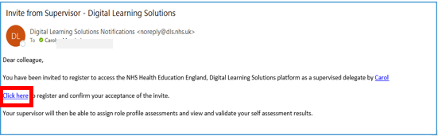 | The learner may receive an email invitation from their Educator /Manager  Select the link in the email: Click here
 | 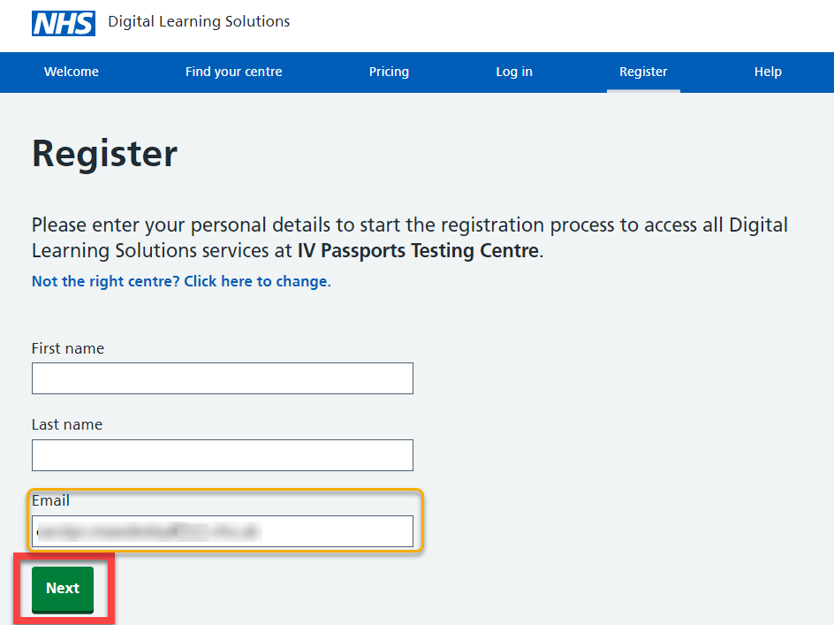 | For information:  If you don’t already have a DLS account, you’ll need to register for an account. If your organisation has set up your account, you will receive an email like the above with a link to set a password, go to Create a password. If they have not invited you, you can use the DLS register page to self-register  The Register screen will open  Complete the registration fields, your email address will be pre-populated into the form  Select: Next  If you already have a DLS account, you can skip this section and follow the Log in procedure
 | 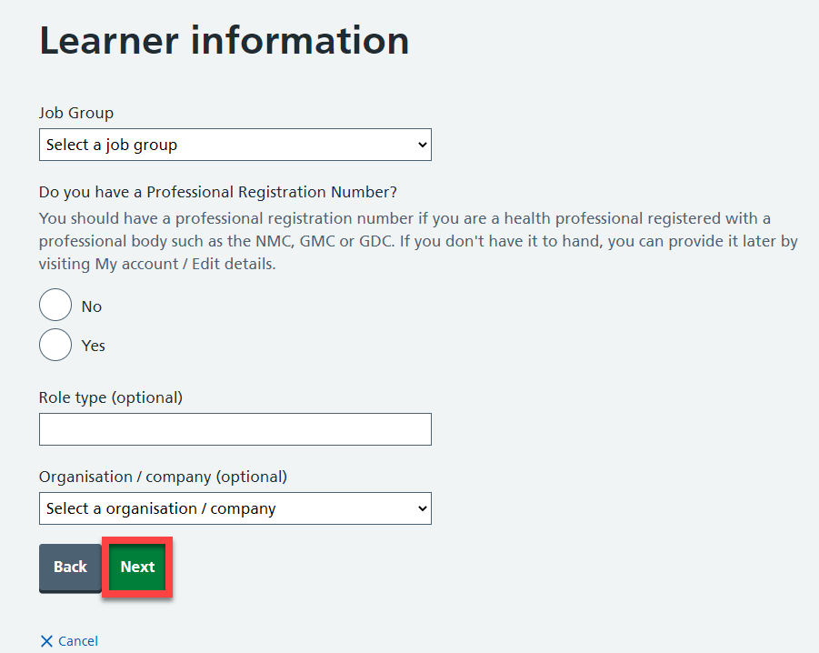 | Complete the learner information  For information:  If you have a professional registration number, you will be asked to record this when you respond Yes  Registration questions asked by your centre may vary to those shown here.  Select: Next
 | 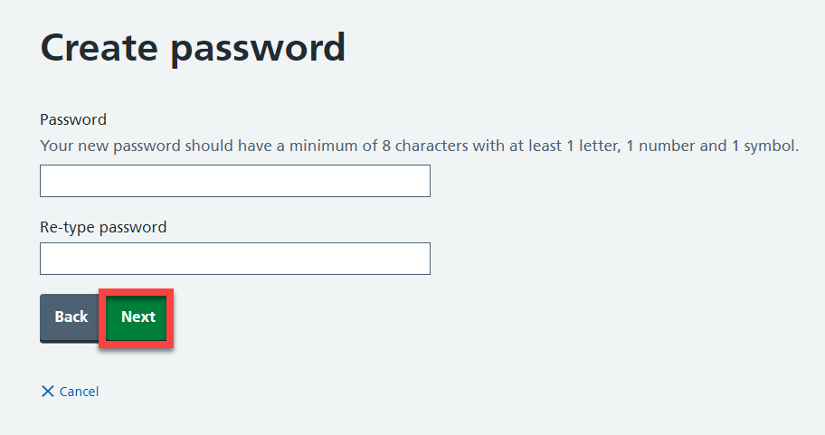 | Create a password  For information:  Your password should include a minimum of 8 characters, at least 1 number and a symbol  Select: Next
 | 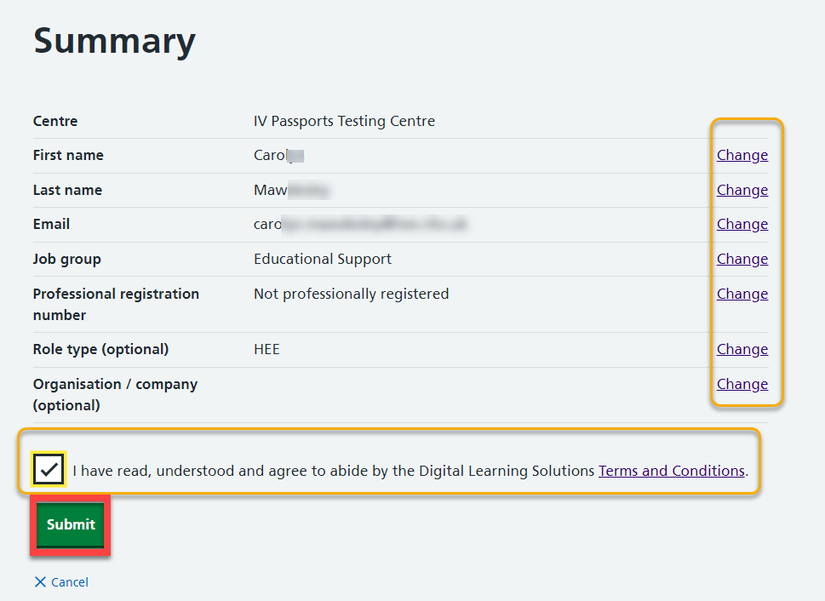 | A summary of your registration is available, you can select Change to amend any of the details  Select to agree to the Terms and Conditions  Select: Submit
 | 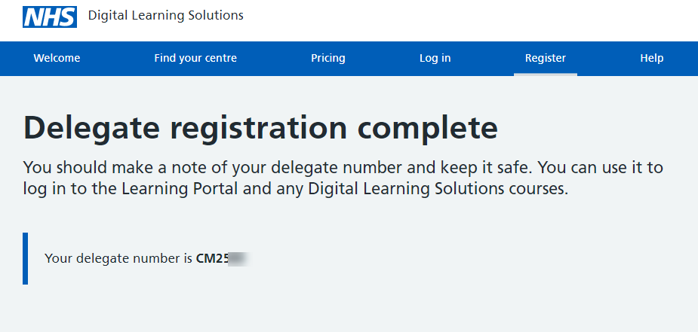 | Your registration to the system is complete. In some instances, you may have to wait while your registration is approved. You will receive an email when your registration is authorised  You can Log in at any time using your delegate number or your email address (recommended) and the password you set up at registration

Log in procedure

 | 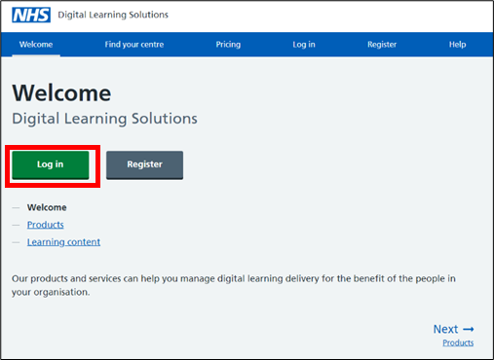 | For information:  The DLS system can be accessed using this link:  https://www.dls.nhs.uk/v2/Home/Welcome  Select: Log in  Alternatively, you may have received an email with a link
 | 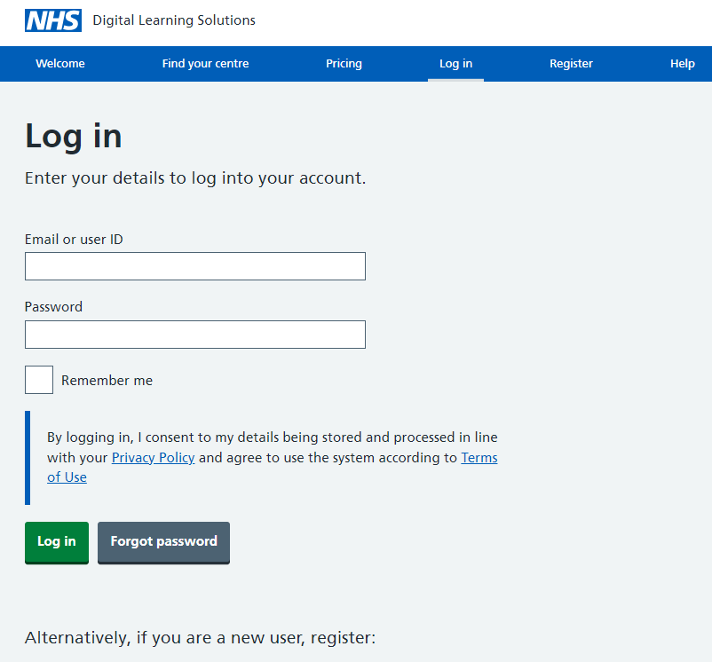 | Log in using your email address or delegate number and the password you set up at registration  Select: Log in

Add an assessor (supervisor)

 | 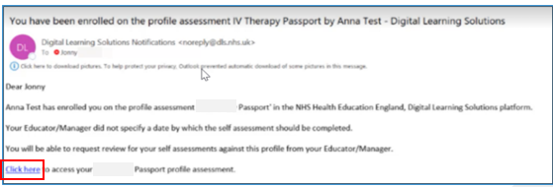 | For information:  Your Educator/Manager will enrol you on the assessment for the IV Therapy Passport  When your Educator/Manager has enrolled you, you’ll receive an email to confirm this  Select the Click here in the email and follow the login procedure  Alternatively, the DLS platform can be accessed using this link:  https://www.dls.nhs.uk/v2/Home/Welcome
2. | 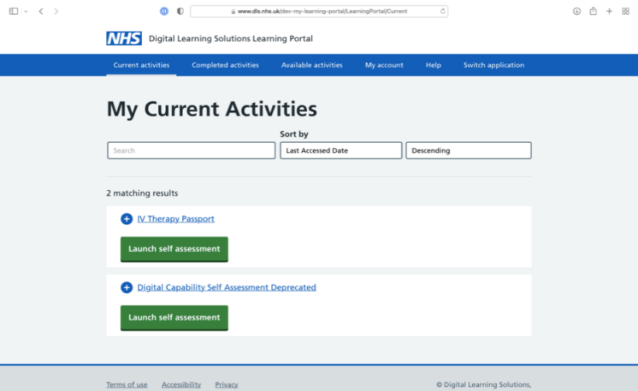 | Select: Launch self-assessment  For information: Select the expand button + to see when you enrolled, last accessed and set a completion date
3. | 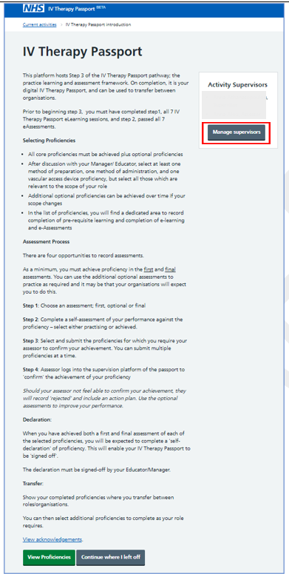 | From the IV Therapy Passport introduction page, read about the using the platform for practice assessment, how to select proficiencies and the assessment process.  You can also add educator / managers and / or assessors from here.  Select: Manage supervisors to add an assessor to your self-assessment.
4. | 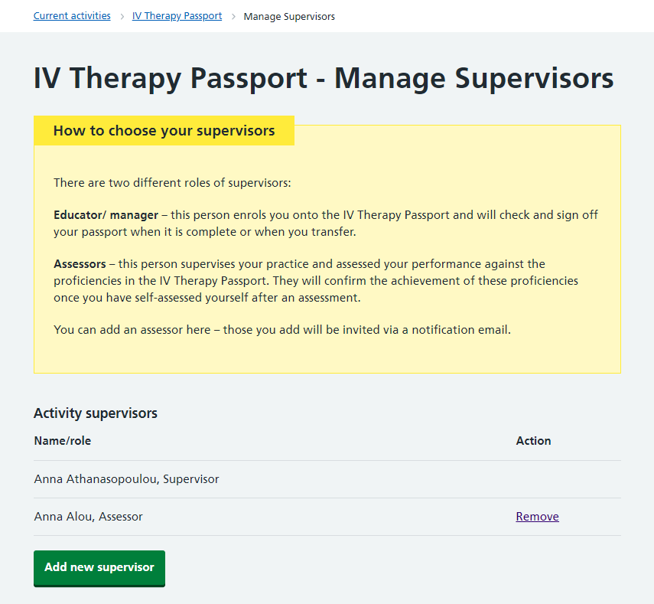 | Select: Add new supervisor  Select: Remove if you want to remove a supervisor from your assessment
5. | 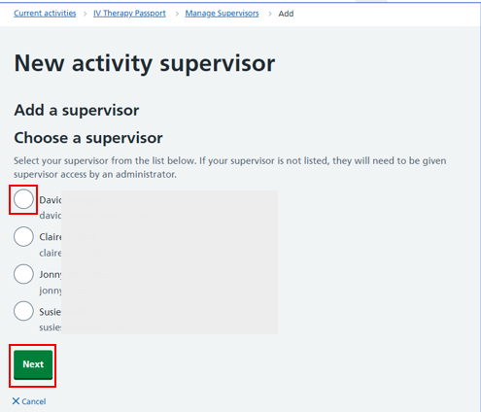 | Choose your supervisor  Select: Next  For information:  If your supervisor is not in the list, please contact your local Educator/Manager
6. | 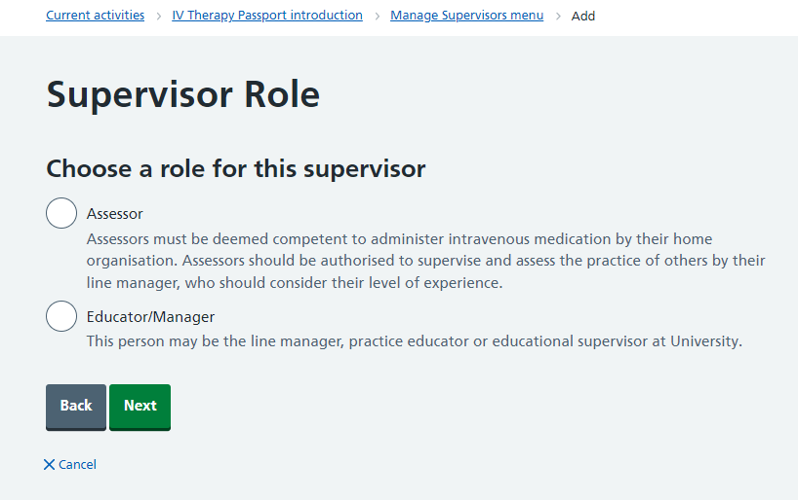 | Choose a role for your supervisor  Select: Next  For information:  Assessors must be deemed competent to administer intravenous medication by their home organisation. Assessors should be authorised to supervise and assess the practice of others by their line manager, who should consider their level of experience  Educator/Manager  This person may be the line manager, practice educator or educational supervisor at University
7. | 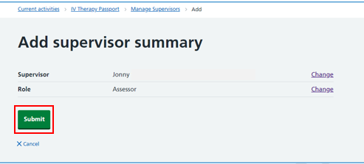 | Select: Submit  For information:  Your selected supervisor will receive an email notification.
 | 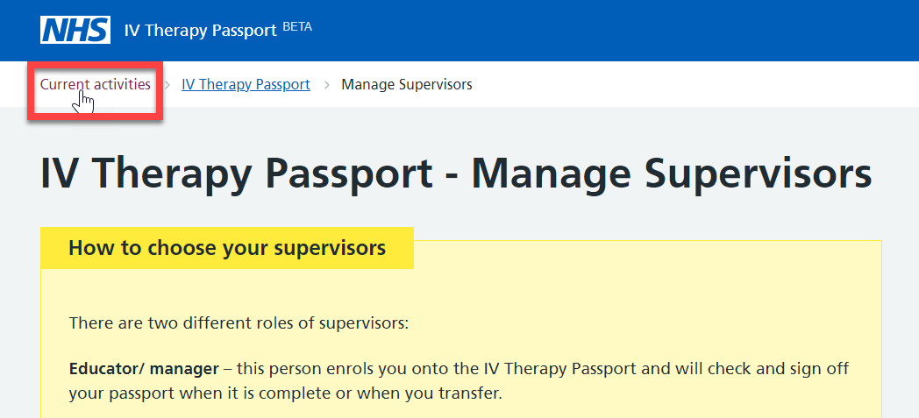 | Select: Current activities

Start your self-assessment (prerequisites)

Select: Launch self-assessment

For information: Select the expand button + to see when you enrolled, last accessed and set a completion date.

 | 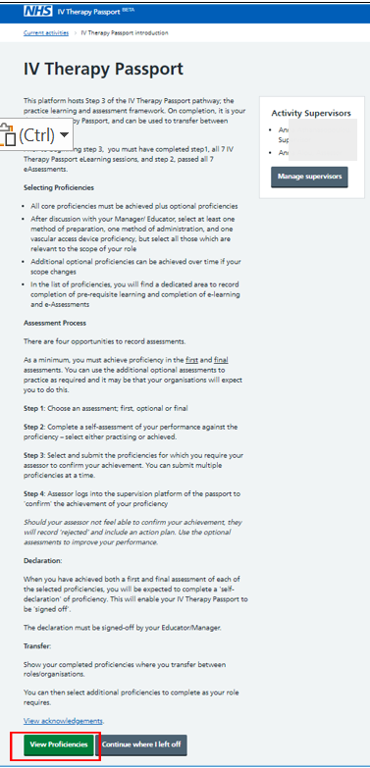 | Scroll down to see all the information and when you are ready to move on  Select: View Proficiencies  For information:  The page displays some instructions for the assessment process, as well as the declaration and sign off process which is available when all the selected proficiencies have been achieved in the first and final assessments  You can also see your activity supervisors and add a supervisor by selecting manage supervisors  If you are returning to your self-assessment, you will also see the useful option Continue where I left off
 | 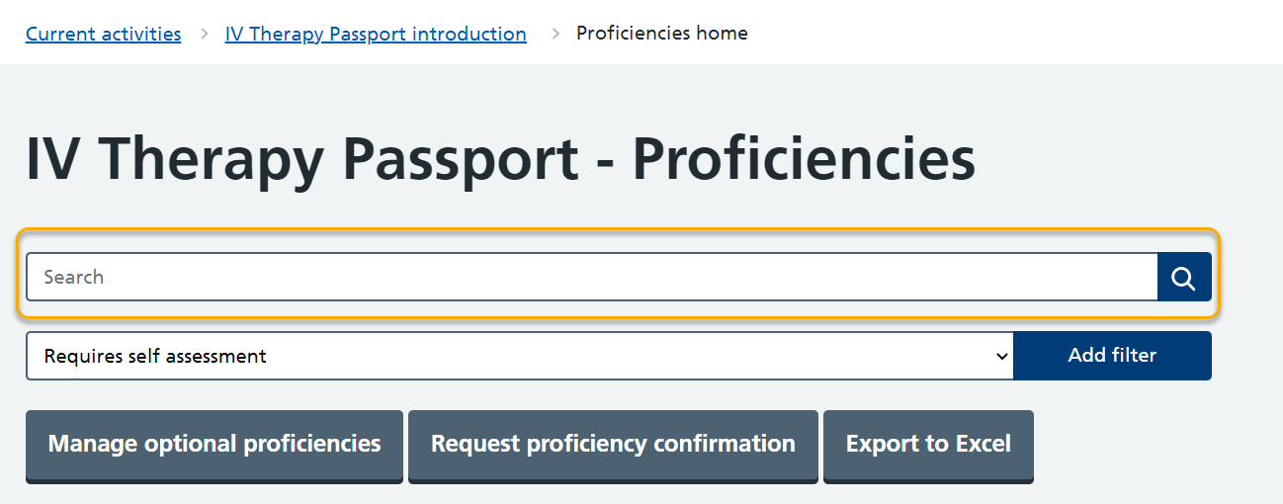 | For information:  A free text Search is available to search the proficiencies
 | 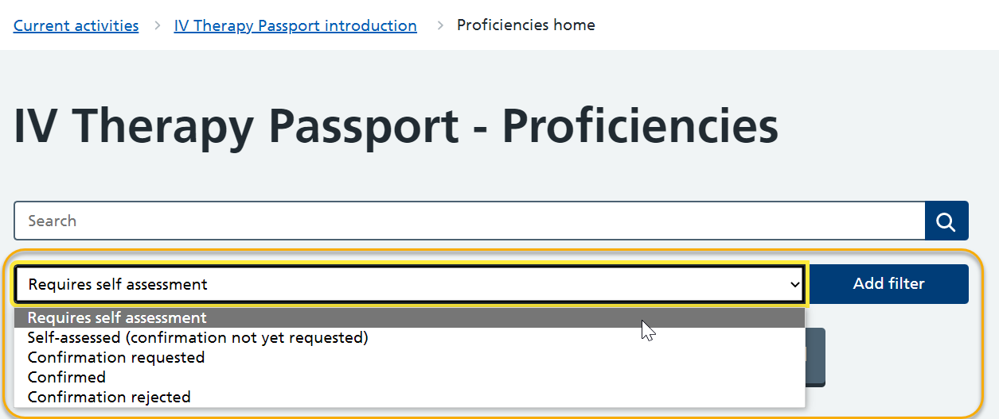 | For information:  As you start to work through your proficiencies, useful Filters are available, to choose from a drop down list
 | 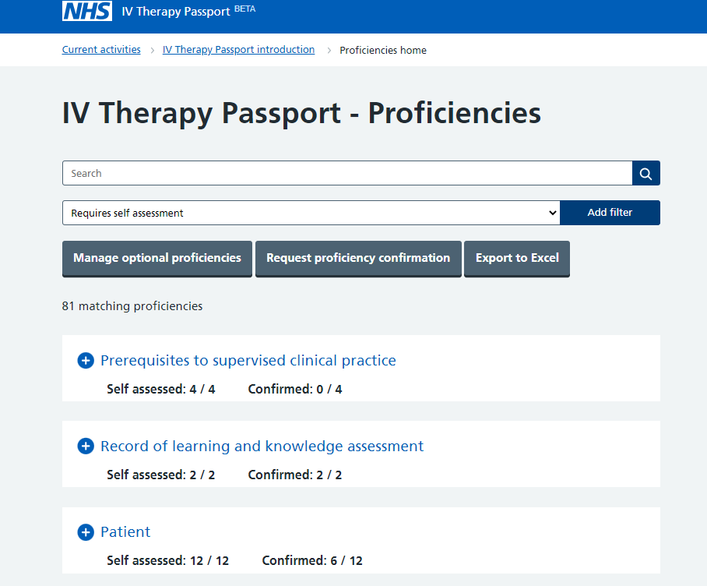 | Select: Expand + Prerequisites to supervised clinical practice
 | 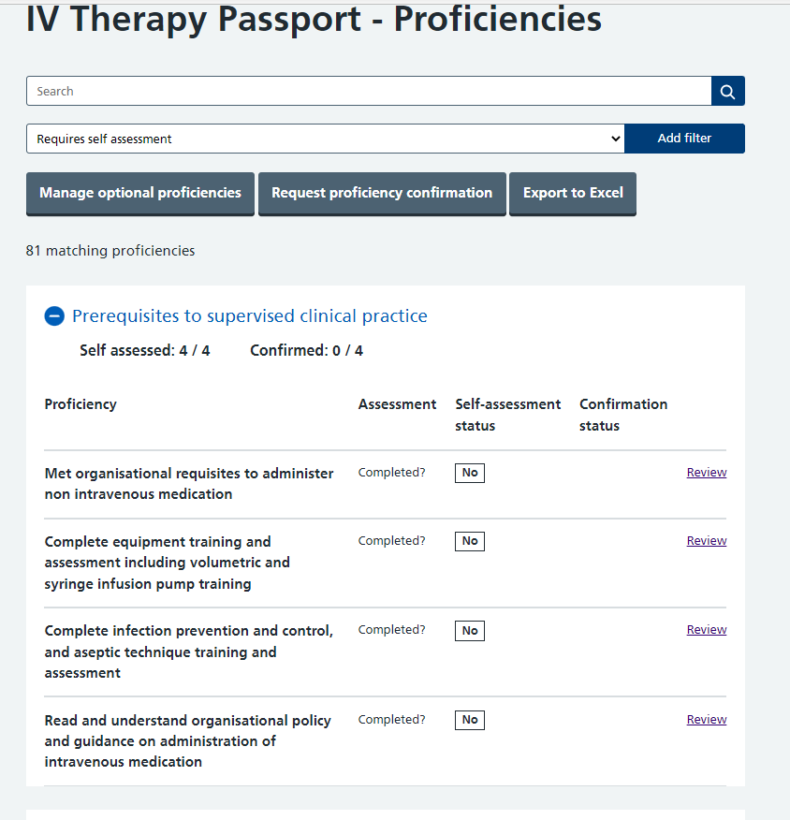 | Select: Review
 | 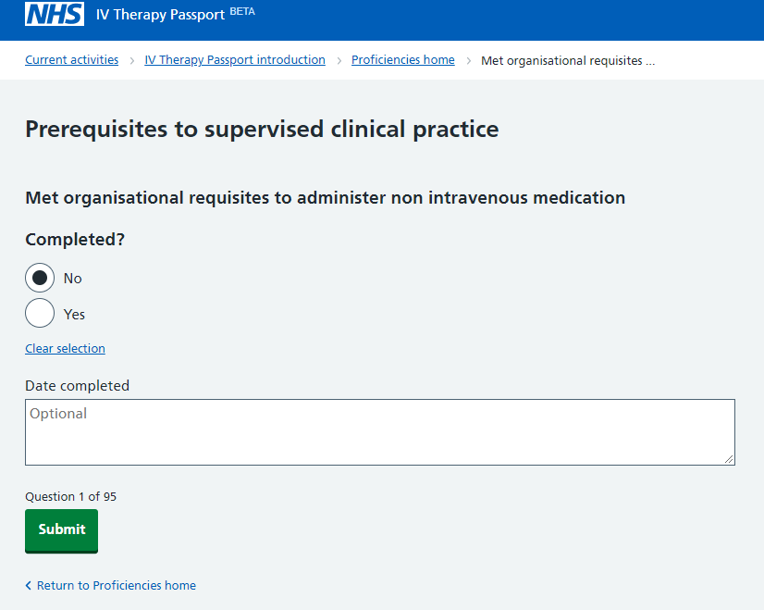  21/07/2022 | Use the Date completed box to record dates the training was completed.  Select: Submit  For information:  This should be completed for each proficiency in Pre-requisite learning
 | 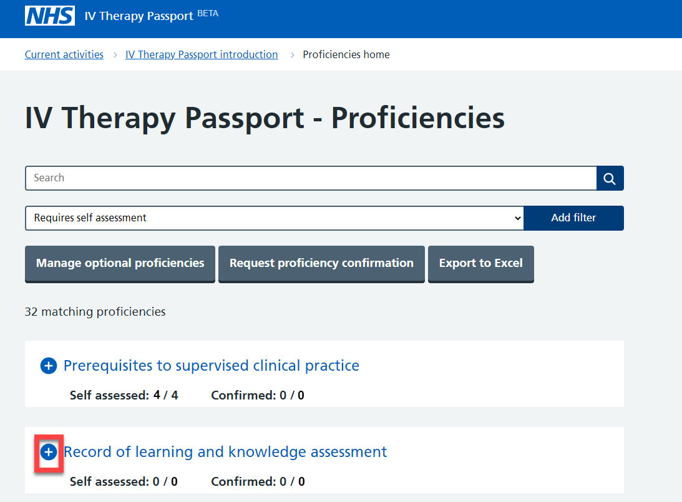 | Select: Expand + Record of learning and knowledge assessment
 | 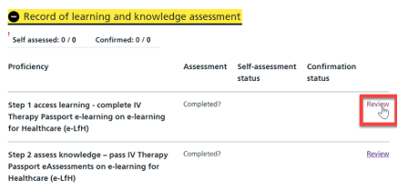 | Select: Review
 | 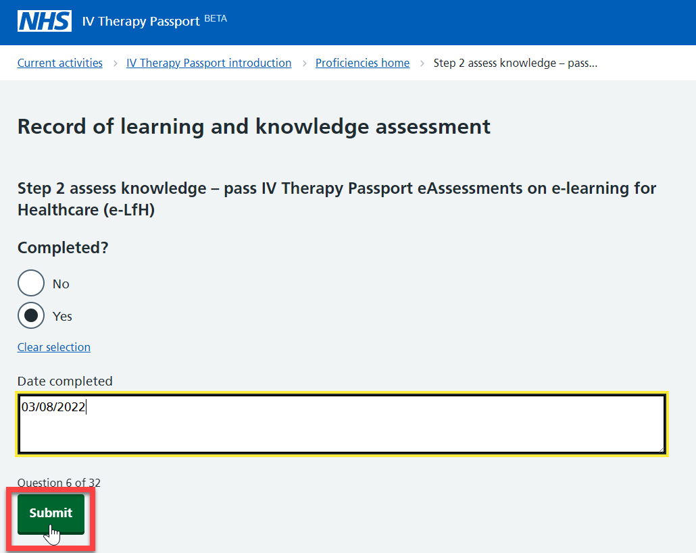 | Use the Date completed box to record dates the training was completed.  Select: Submit  For information: This should be completed for each proficiency in Record of learning and knowledge assessment

Manage optional proficiencies

 | 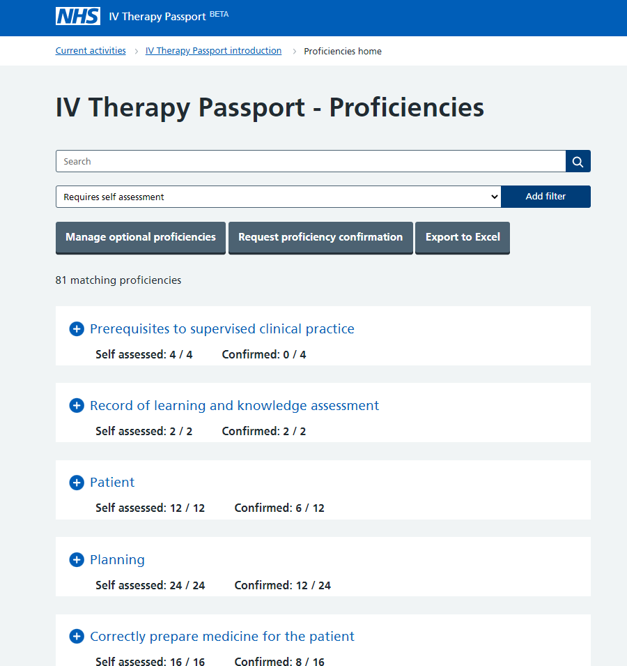 | Select: Manage optional proficiencies
 | 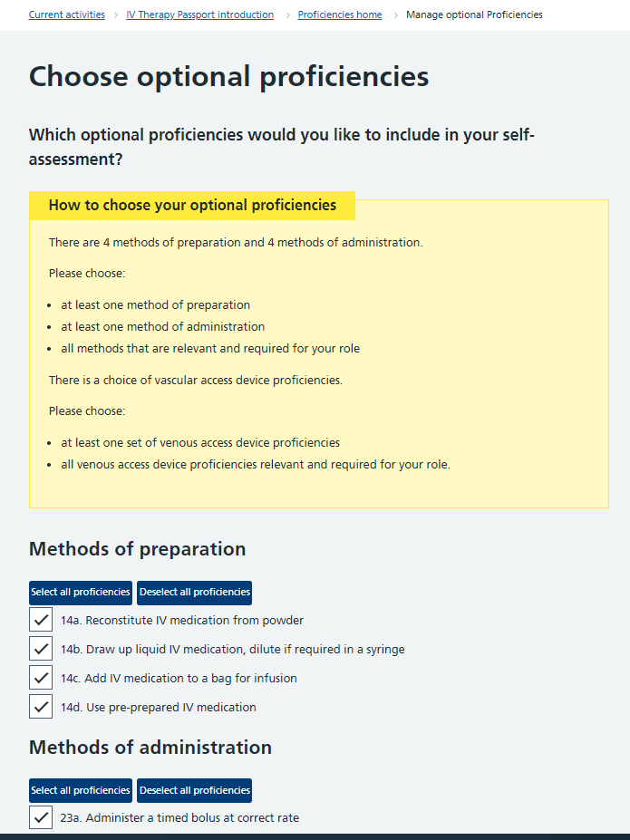 | Choose your optional proficiencies as per the guidance displayed on-screen in the yellow box.
 | 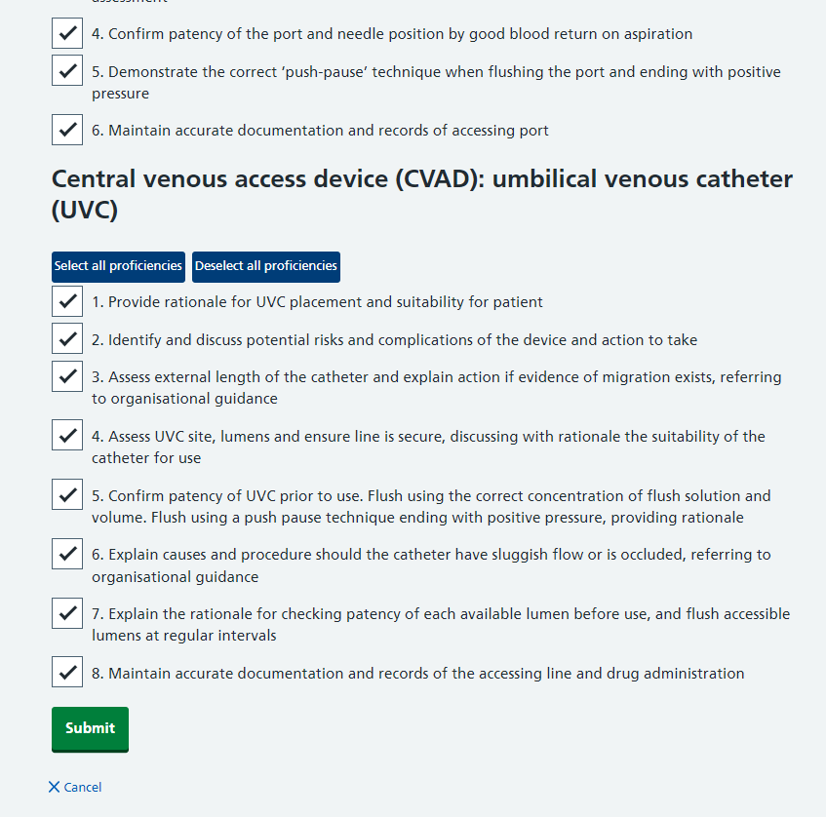 | Scroll to the bottom of the screen and select: Submit

Complete your self-assessment

 | 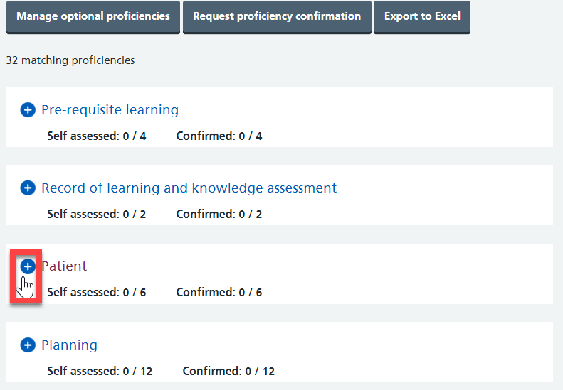 | After completing pre-requisite learning, and the record of learning and knowledge assessment, proceed with the other proficiencies  Select: Expand + next to the proficiency
 | 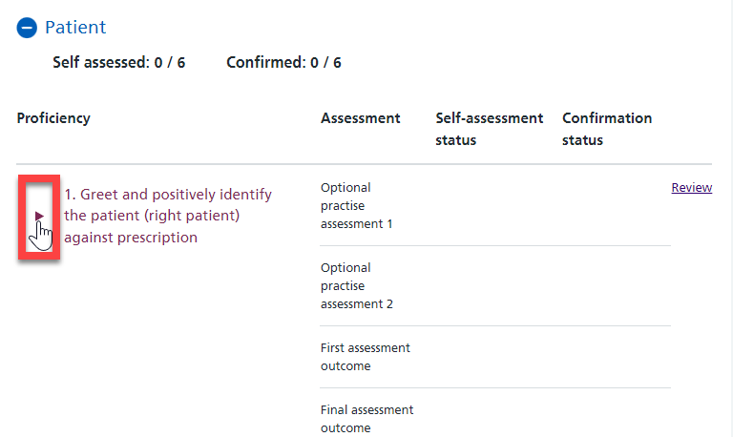 | To see more information about the proficiency  Select: the expander
 | 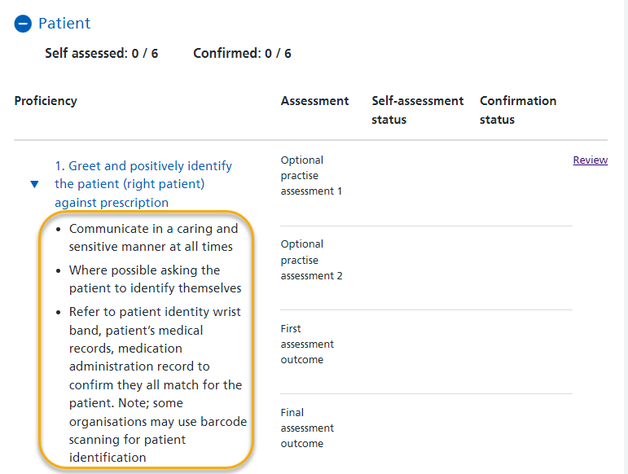 | Further information about the proficiency is displayed
 | 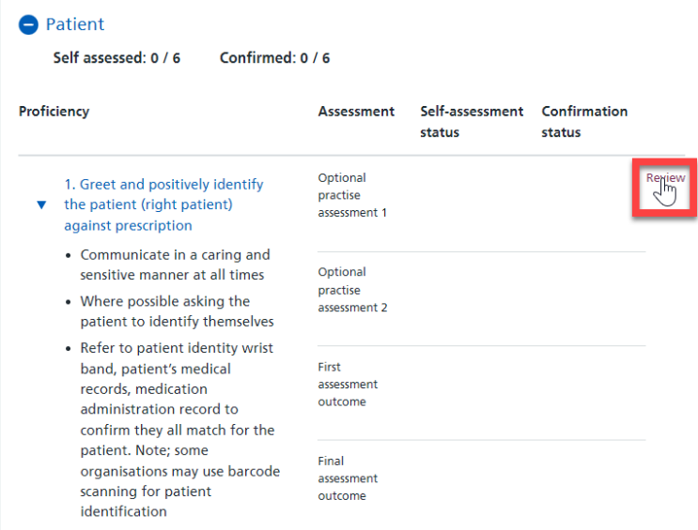 | Select: Review to record your result
 | 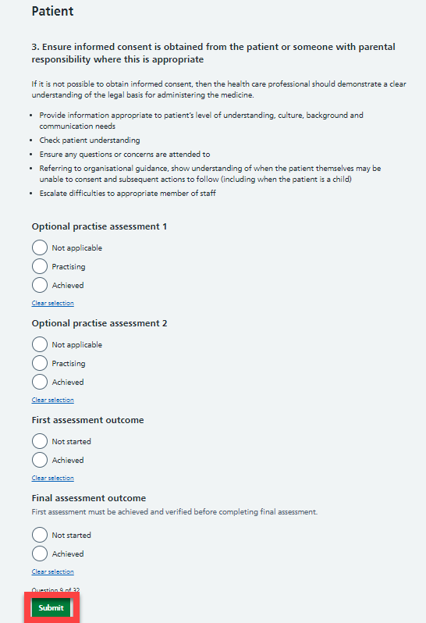 | For information:  Is this an optional, first or final assessment? (note: first and final are required)  Some organisations will expect an ‘optional’ assessment; others will expect the learner to use the first and final assessments and the optional ones if they need additional practice  Select: The appropriate self-assessment response  Select: Submit

Request proficiency confirmation

 | 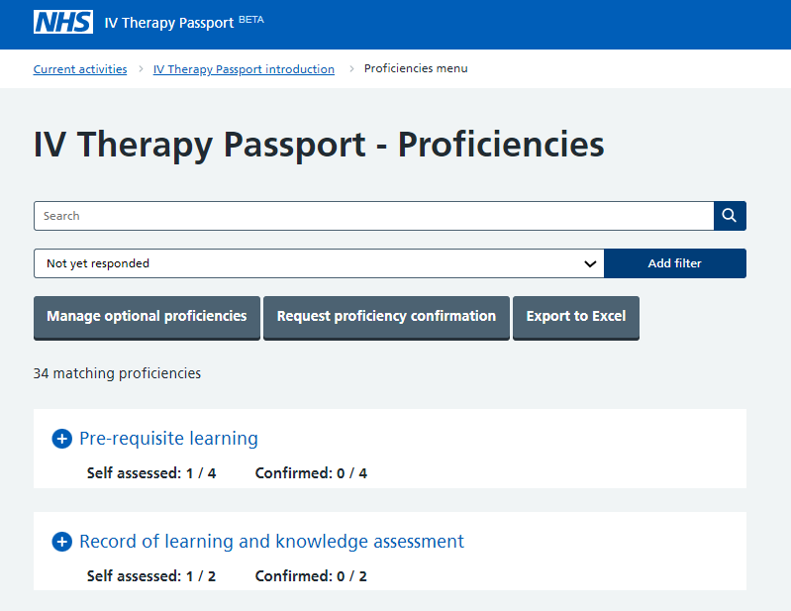 | When you are ready to request proficiency confirmation, for example, the data is entered for:  - Prerequisites  - Record of learning and assessment  or the self-assessment is completed for:  - Core proficiencies  - Optional proficiencies  Select: Request proficiency confirmation
 | 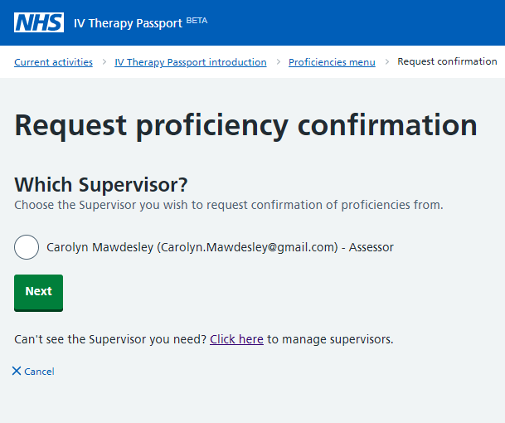 | For information:  From Which Supervisor? You will select which assessor supervised and assessed the practice – the assessor’s name will be available to pick on screen. Alternatively, you can select another assessor from an approved list  Select: The Assessor who will confirm achievement of these proficiencies  Select: Next
 | 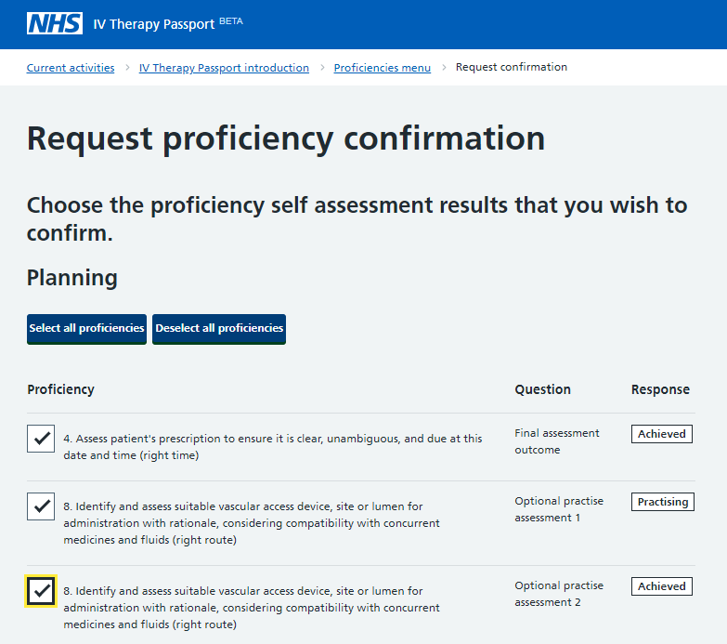 | Select each proficiency from the list that has been self-assessed and is ready for an assessor to confirm  Alternatively Select all proficiencies – you’ll need to do this for each group of proficiencies you are submitting  For information:  These will be listed without colour – when verified by their assessor they will turn green  Note: only those proficiencies you have self-assessed can be confirmed
 | 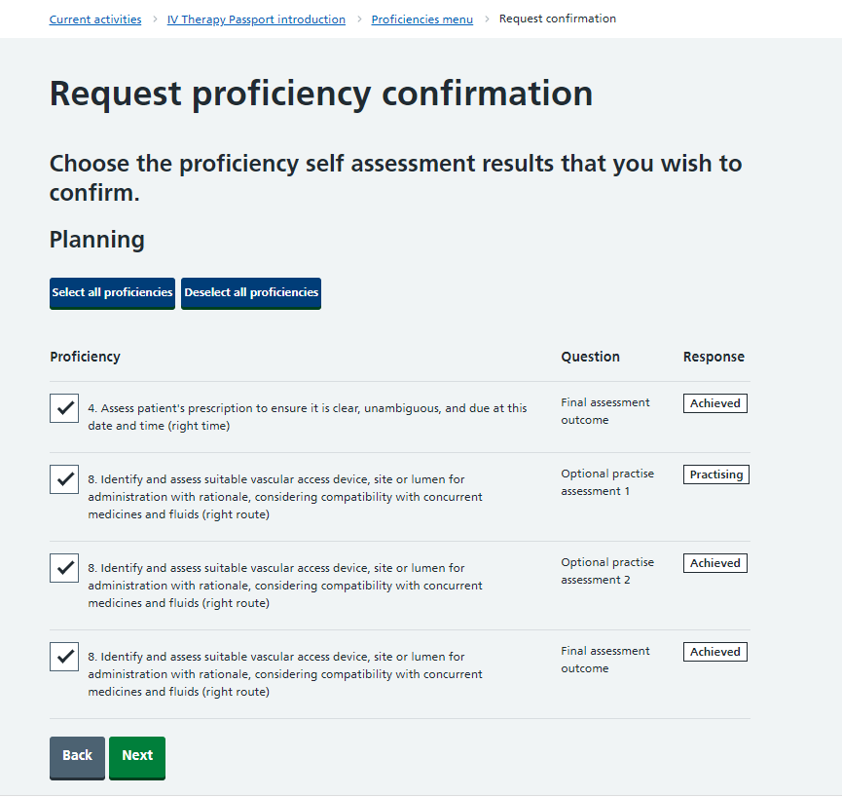 | When you’re ready:  Select: Next
 | 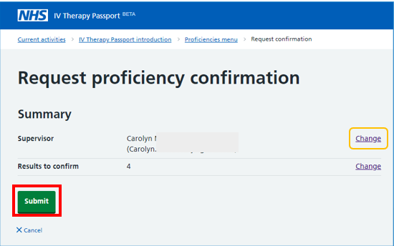 | For information:  If appropriate, you can change your assessor by selecting Change. You can choose from a pre-approved list of assessors at your organisation  Select: Submit
 | 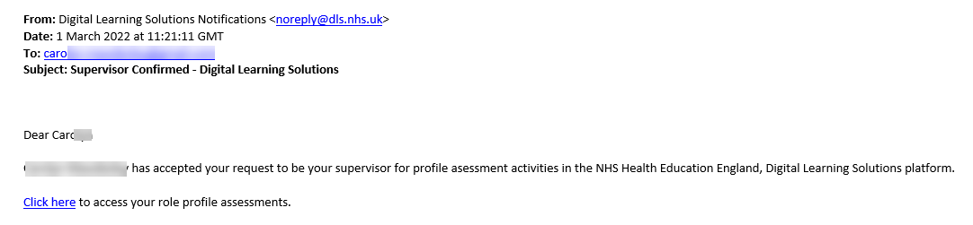 | For information:  Clicking submit will trigger an email to the selected Assessor
 | 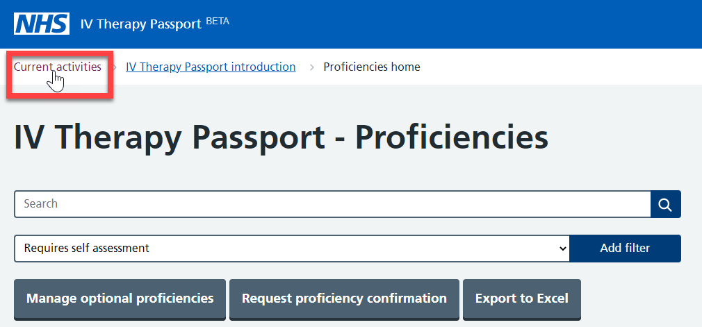 | Select: Current activities to return to the proficiencies home page  When you are finished follow the Log out procedure
 | 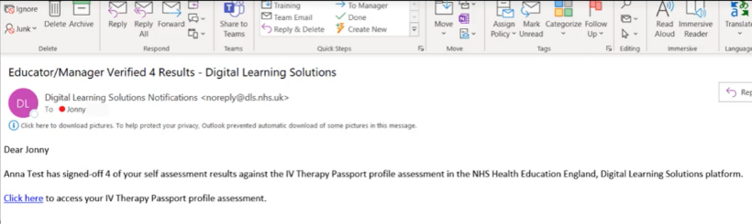 | For information:  As the proficiency results are confirmed by your Assessor you will receive an email

Action plan

 | 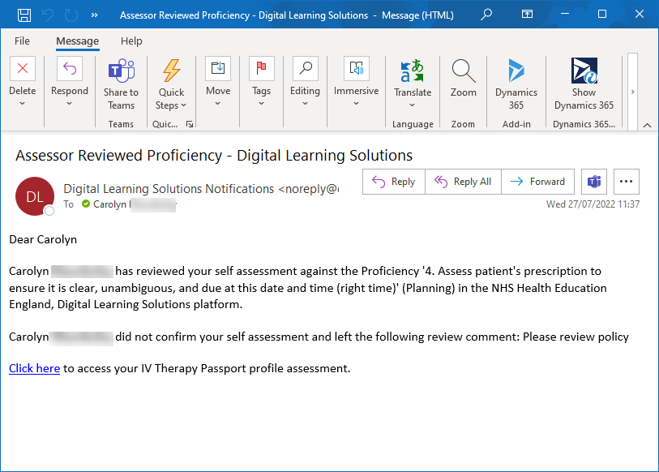 | If the Assessor did not agree with the learner’s self-assessment of having achieved the proficiency, they will reject it and write an action plan  The learner will receive this email to ensure they are notified
 | 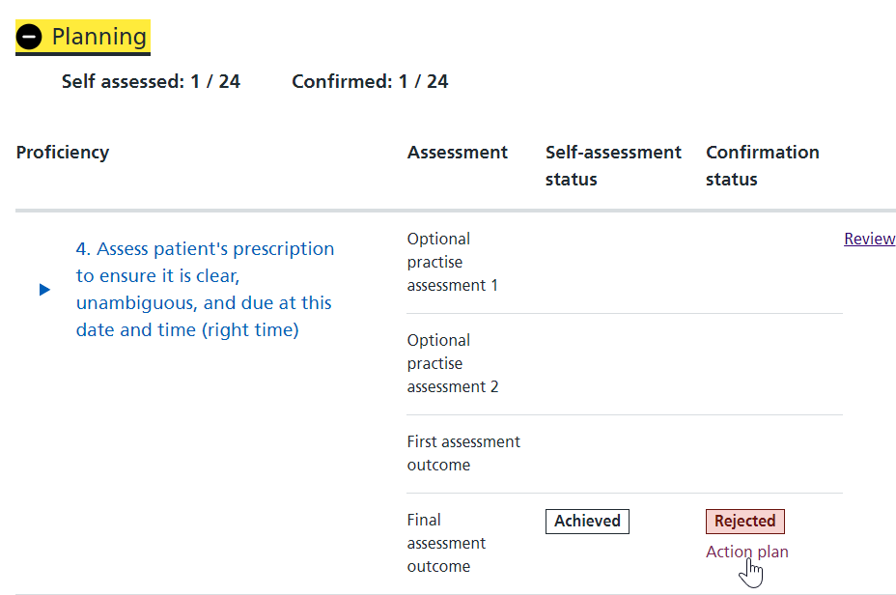 | The specific proficiency will have the status ‘rejected’ in red with an action plan link beneath it  Select the link to reveal the Action plan to follow  When the action plan is met, and the proficiency is re-assessed in practice, the learner can resubmit the proficiency for confirmation

Request Educator/Manager sign off

 |  | Follow the Log in procedure
 | 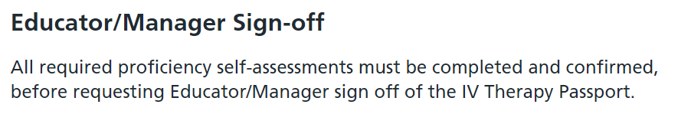 | For information:  The Educator/Manager Sign off will only become available when all core, and the selected optional, proficiency self-assessments are completed and confirmed
 | 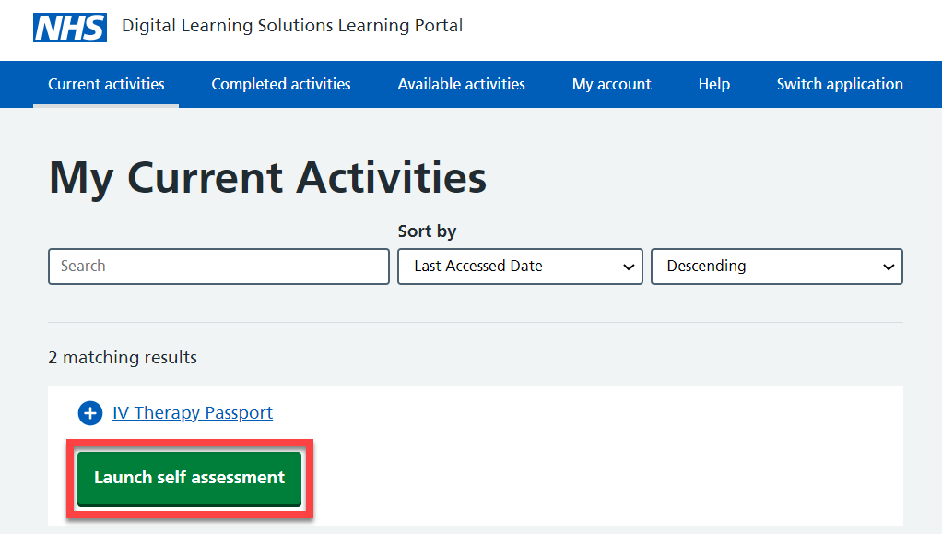 | Select: Launch self-assessment
 | 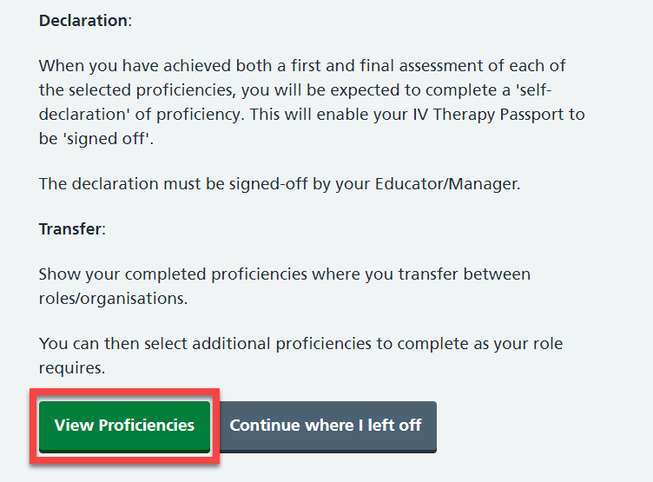 | Scroll down  Select: View proficiencies
 | 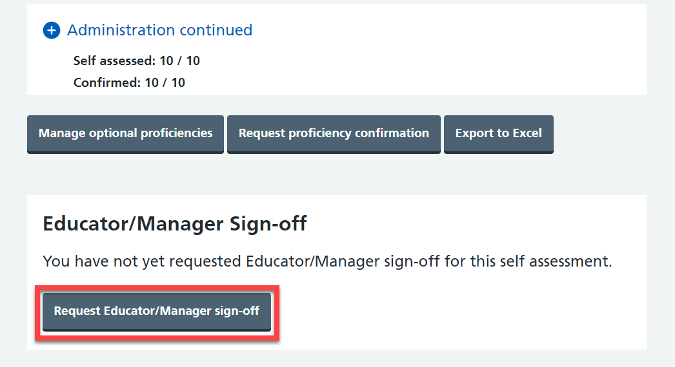 | Scroll down then when you are ready  Select: Request Educator/Manager sign-off
 | 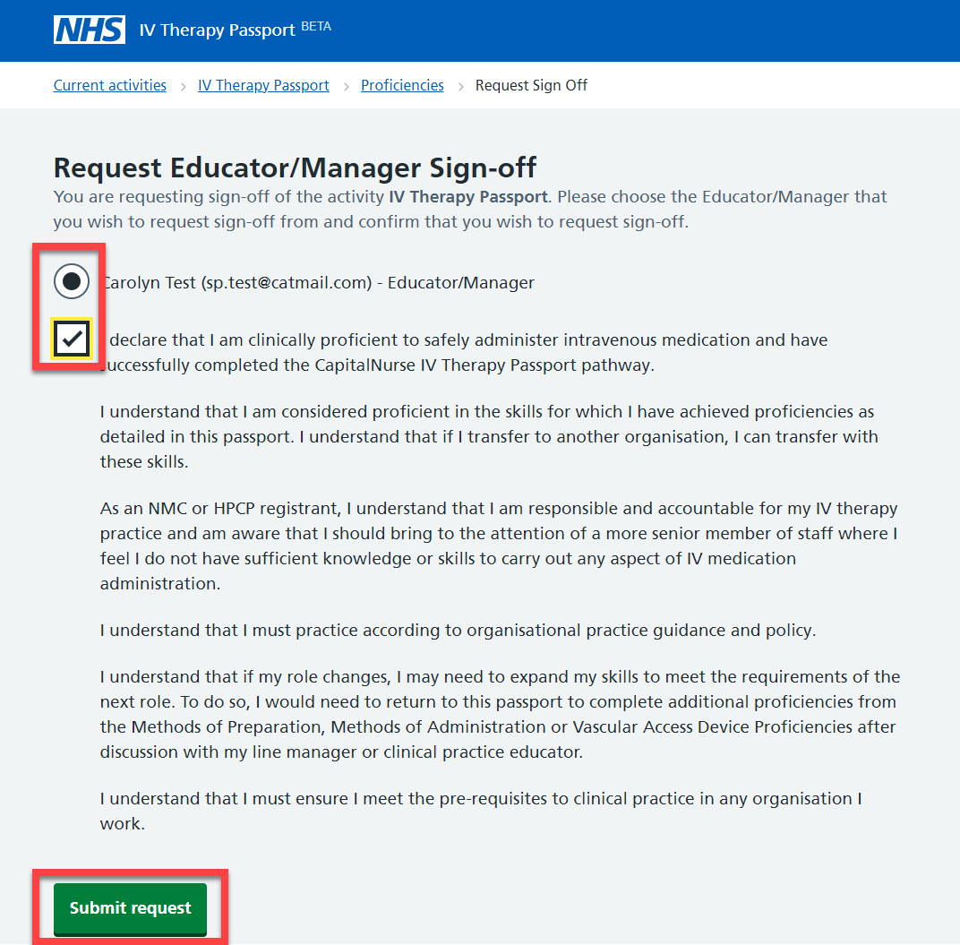 | Select: The Educator/Manager who will sign-off your passport  Select: read and agree to the declaration  Select: Submit request  Then follow the Log out procedure
 | 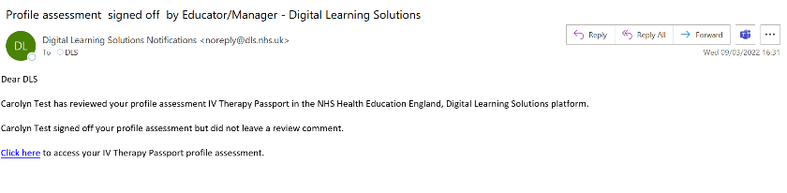 | For information:  You will receive a confirmation email when your passport has been signed off
 | 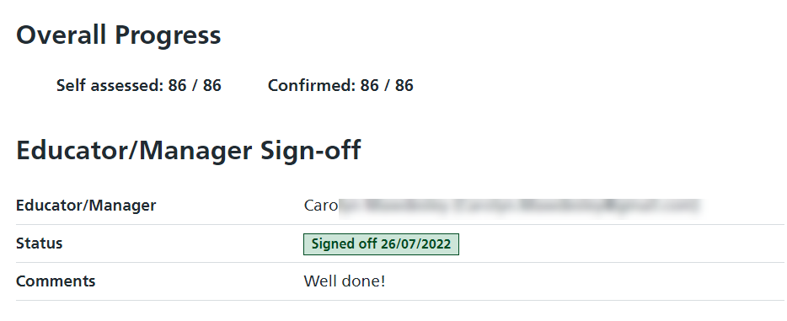 | Select the link in the email to see your signed off status

Log out procedure

 | 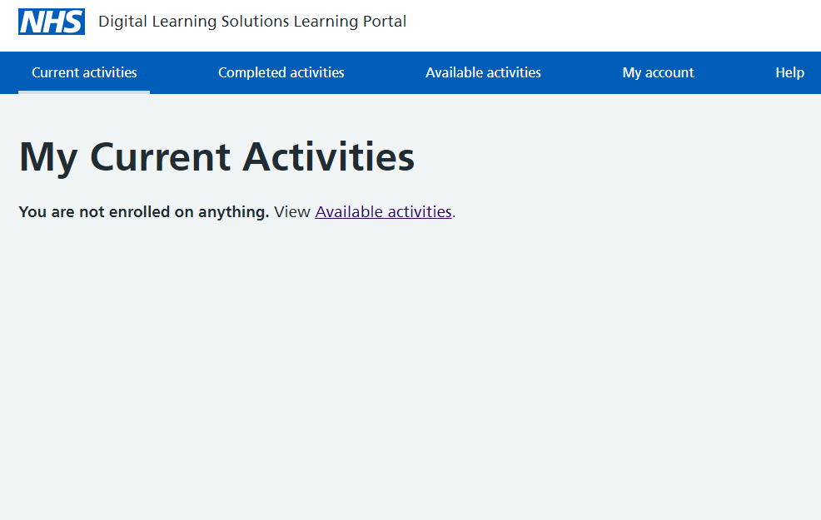 | Select: My account  For information:  If you can’t see My account, select Current activities then select My account
 | 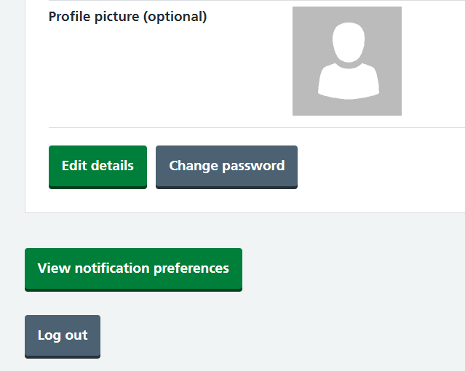 | Scroll to the bottom of the screen  Select: Log out  For information:  If you need to change your password before you go:  - Select: Change password  - Return to: My account  - Select: Log out  If you need to change any of your registration details, select Edit details. Don’t forget to select Save when you are finished

Additional guidance

Download Self-assessment

 | 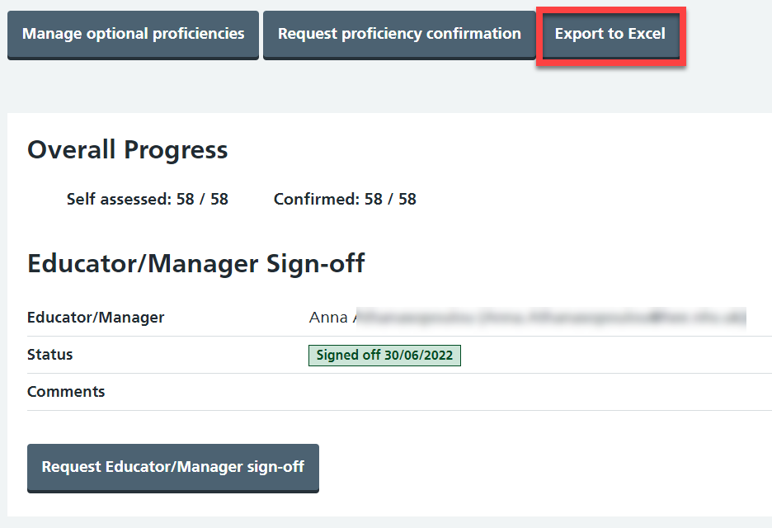 | For information:  Complete this step if you wish to keep a personal record of your Digital IV Therapy Passport or you are moving to another organisation.  Future development to the system will enable you to complete this transaction digitally.  Select: Export to pdf (available from November 2022)

Self-assessment confirmation status explained

 | 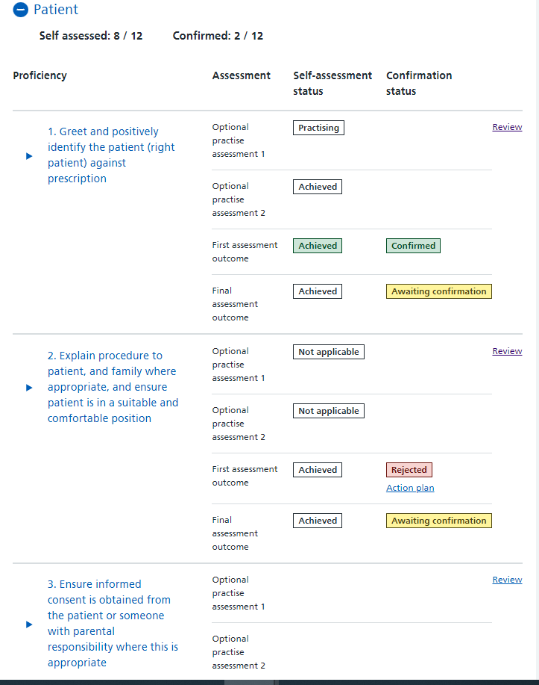 | Black border and text with a white background –  Learner has self-assessed against optional practice, but no confirmation request has been sent to the assessor yet  Green border, text and background –  Assessor has confirmed the results  Red border, text and background –  Assessor has rejected the assessment and an action plan has been recorded  Grey border, text and yellow background –  Learner has self-assessed against optional practice, confirmation request has been sent to the assessor, but no response has been provided yet

Forgotten the password

 | 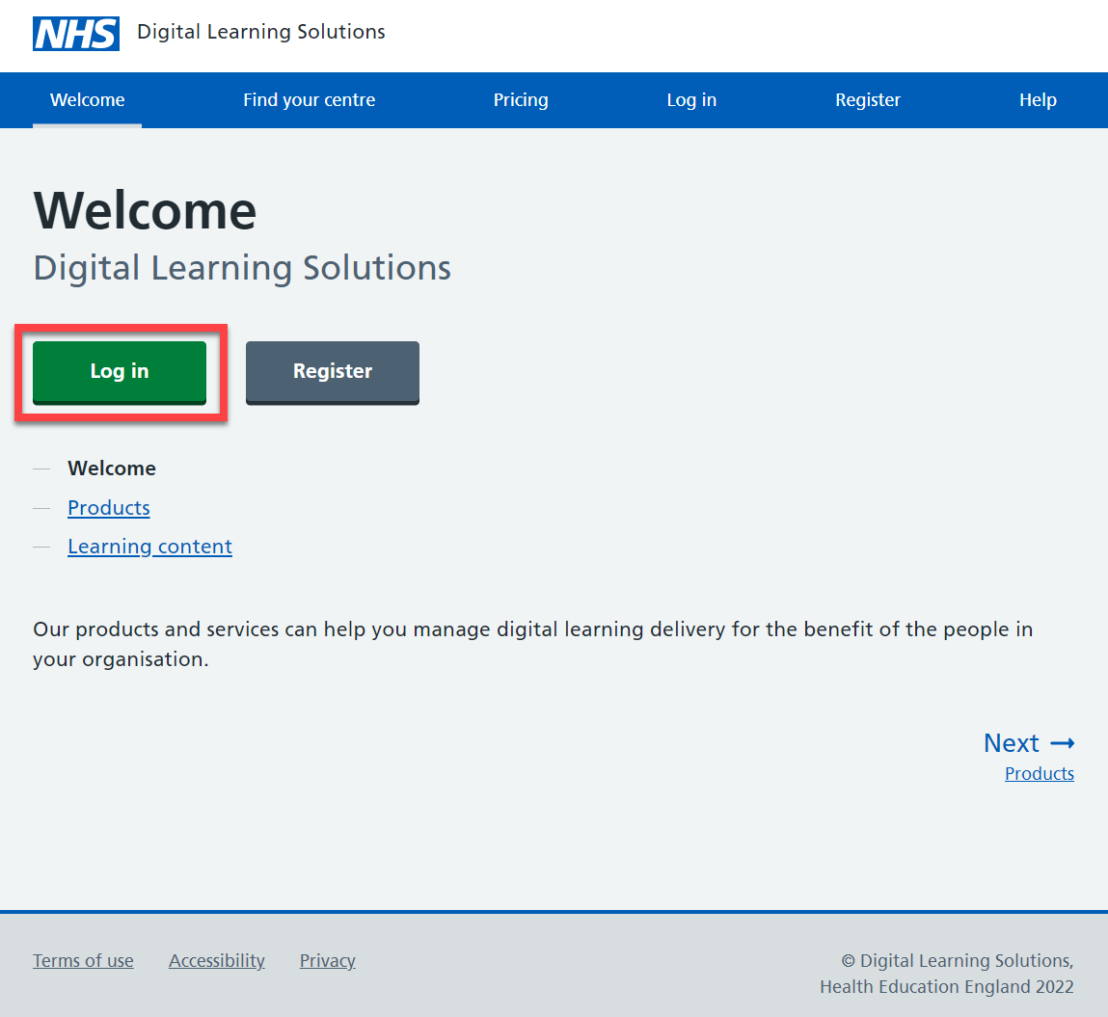 | Access the DLS landing page: https://www.dls.nhs.uk/v2/Home/Welcome  Select: Log in
 | 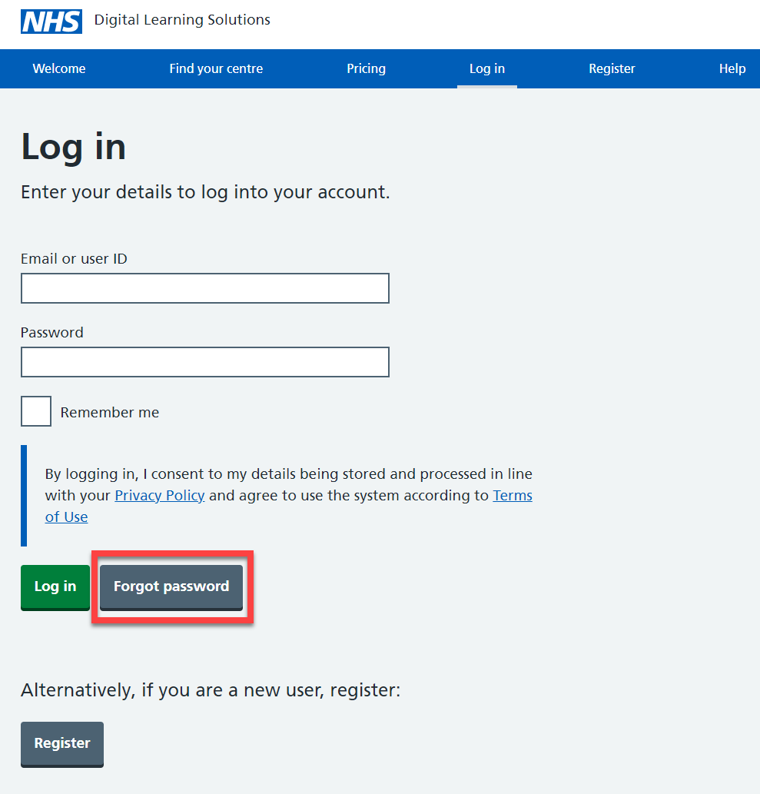 | Select: Forgot password
 | 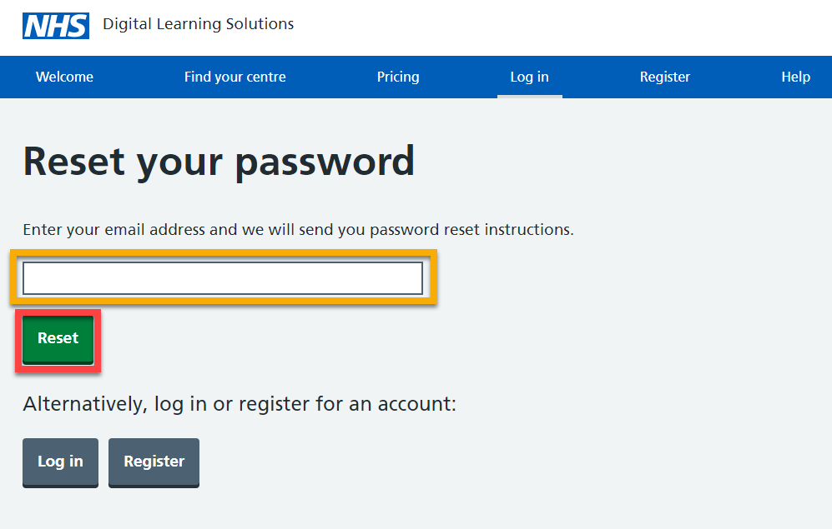 | Enter your email address  Select: Reset
 | 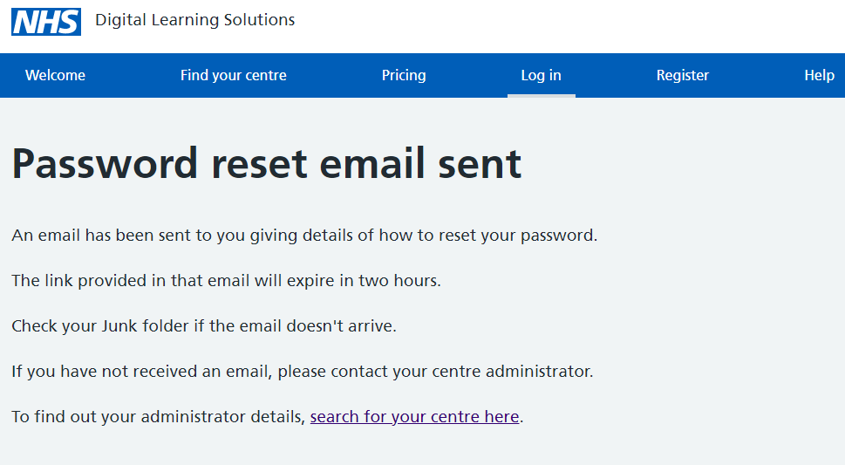 | For information:  You’ll see an onscreen confirmation message
 | 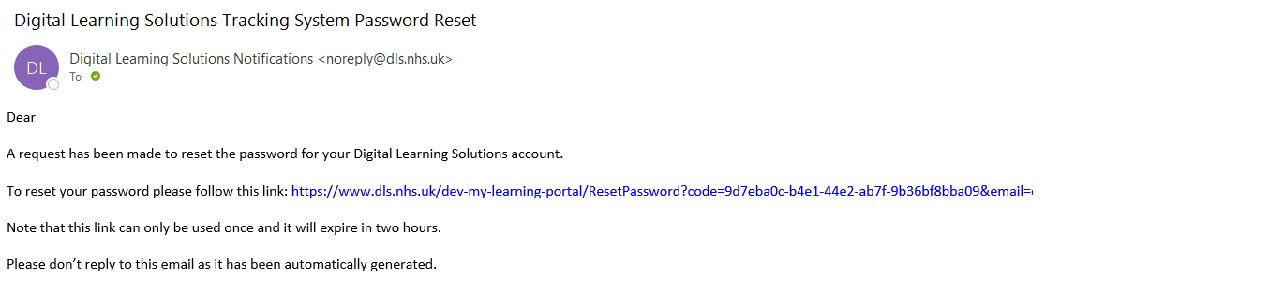 | You’ll receive a email that provides a 2 hour time limited reset link  Select: the link
 | 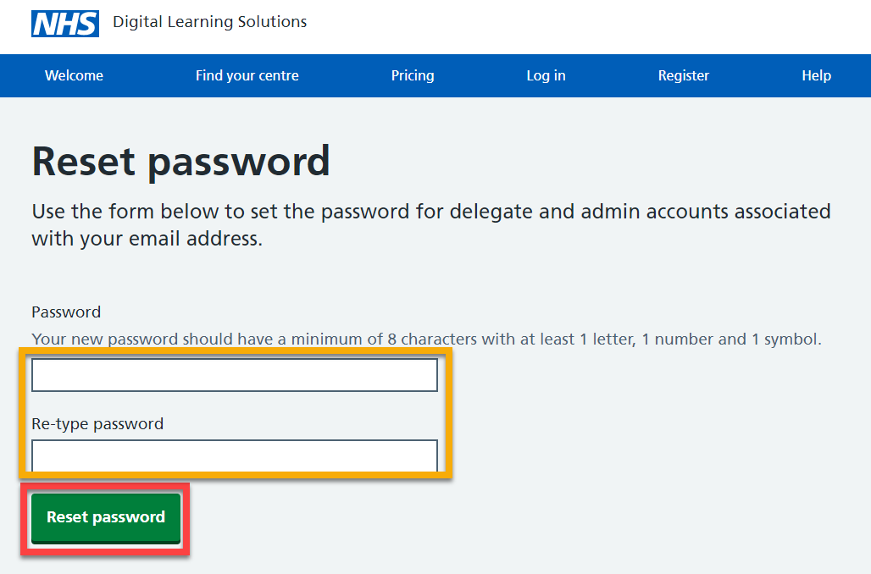 | Complete the fields  Select: Reset password
 | 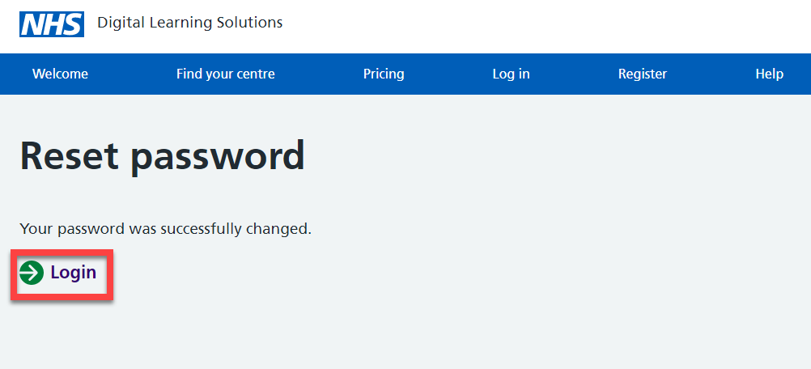 | Select: Login
 | 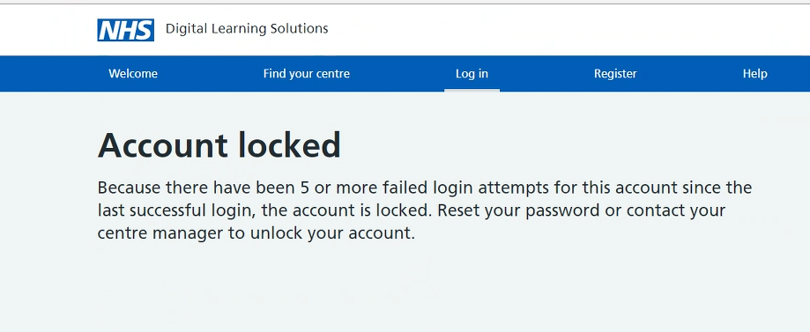 | For information:  If at any time you receive an Account locked message you should follow the Forgot password process

For support, please contact:
Your Assessor or the local Educator/Manager at your organisation.

