Digital IV Therapy Passport – Educator/Manager User Guide

The Digital Learning Solutions (DLS) platform, provided by the Technology Enhanced Learning (TEL) Team within Health Education England (HEE), hosts the Digital IV Therapy Passport.

This documentation is designed to provide first time access guidance to an Educator/Manager.

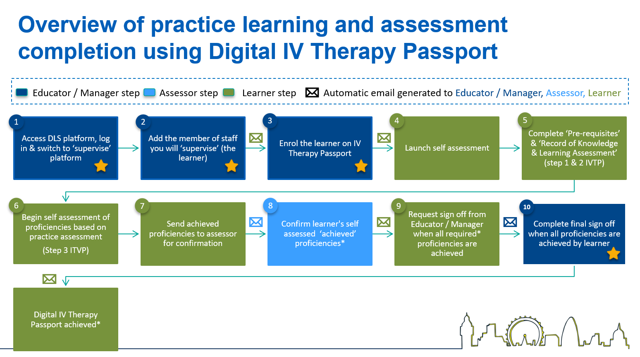
Indicates the Educator/Manager steps in the process

For information:

- The learner: Person completing the self-assessment in the IV Therapy Passport
- The Educator / Manager: the person who is facilitating the passport and will ultimately sign it off when all proficiencies have been assessed.
- The Assessor: the person supervising, completing practice assessment and confirming achievement of proficiencies.

For support, please contact: the local clinical centre manager or administrator at your organisation.

Contents

Essential guidance 3
A. Log in procedure 3
B. Add learners to supervise and invite to register 5
C. Enrol learners to self-assessment 6
D. Self-assessment final sign-off 9
E. Log out procedure 13
Additional guidance 14
F. Self-assessment results review and confirm (this is usually the assessor’s role but may be appropriate for some Educators /Managers) 14
G. Review and update self-assessment results with an Action Plan 17
H. Remove a member of staff from your supervision list 20
I. Send a reminder to a member of staff from your supervision list 22
J. Nominate a member of staff as an assessor (nominated supervisor) 23
K. Forgotten the password 25

Essential guidance

Log in procedure

STEP | Visual location | Guidance
 | 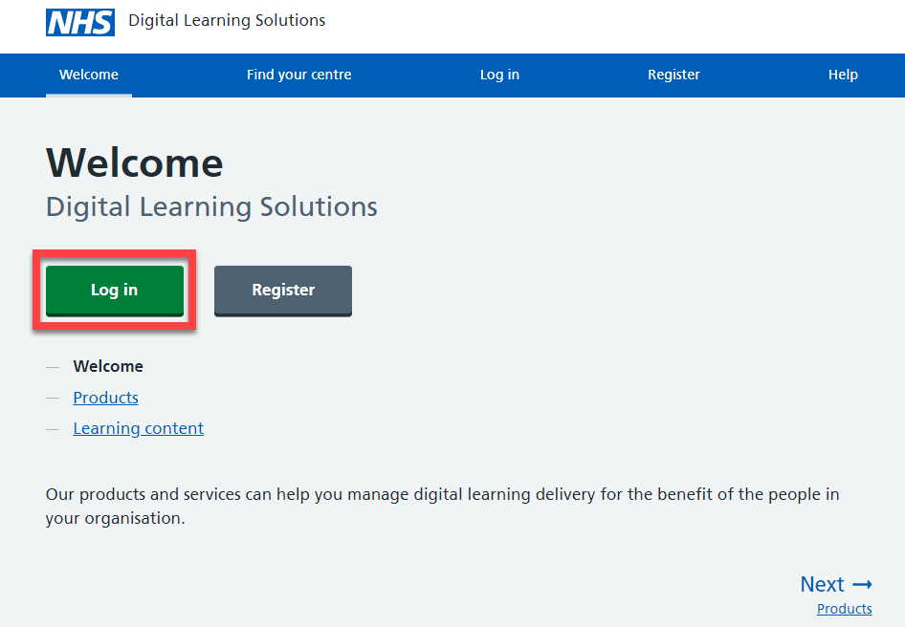 | For information:  Before you can proceed, you should have a DLS account and your clinical centre manager will have assigned you as an Educator / Manager on the system.  Access via the DLS platform  Select: Log in
 | 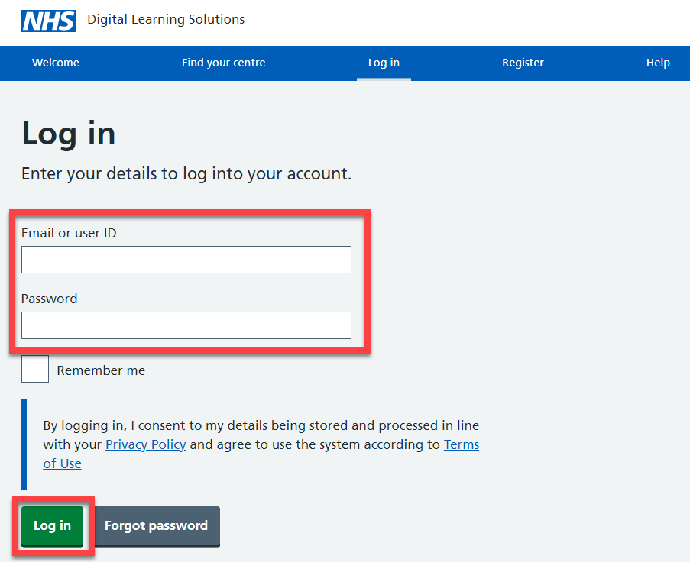 | Log in using your email address and the password set up at registration  Select: Log in  For information:  Educators / Managers may also have a delegate user ID to access the system – this should be disregarded. Always use your email address.  Forgotten your password? Follow the guidance available.
 | 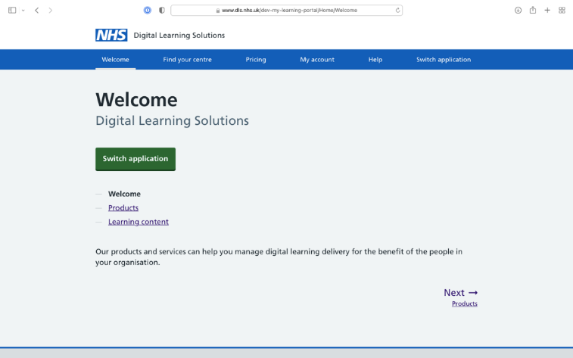 | Select: Switch application
 | 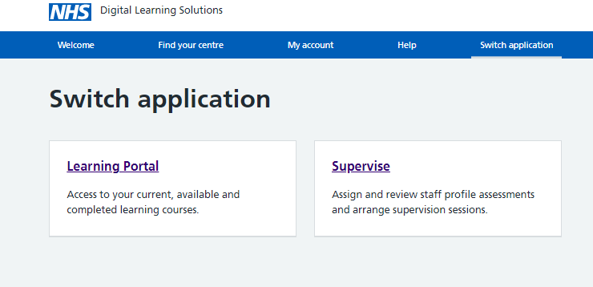 | Learning Portal: enables the Learner to complete an assessment  Supervise: takes all those acting as educator/manager or assessor to the platform to work in these roles  Select: Supervise

Add learners to supervise and invite to register

STEP | Visual location | Guidance
1. | 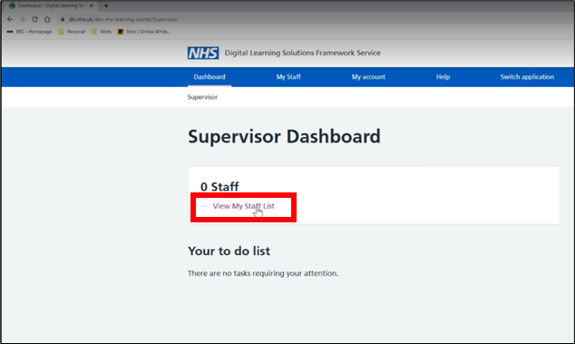 | For information:  First, the Educator/Manager will need to add a Learner(s) onto their supervision list and then enrol them on a self-assessment.  Select: View My Staff List
2. | 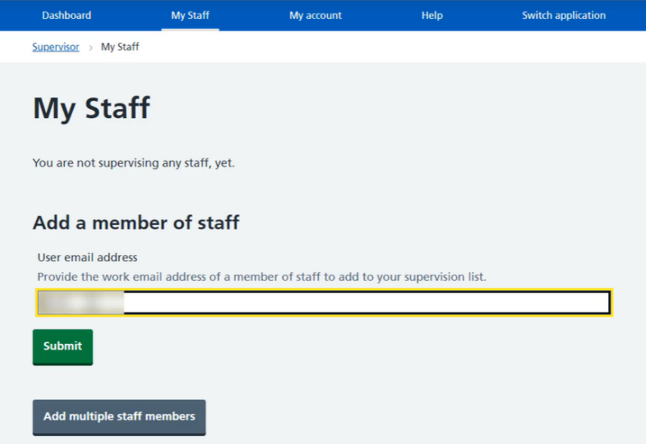 | Add the email address of your learner(s) and then select: Submit  Alternatively add multiple staff members
3. | 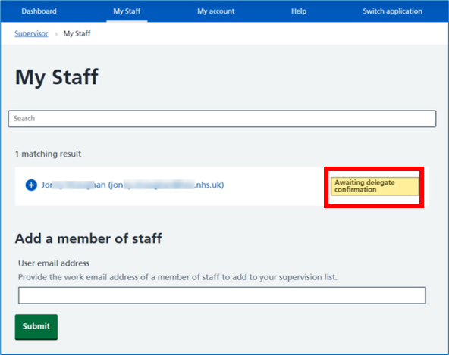 | For information:  If the staff member(s) have already registered with DLS, then they will be added into your supervision list, and they can be enrolled onto the self-assessment.  If the staff member(s) have not registered with DLS, then they will receive an email inviting them to register. You will receive an email when they accept the invite. They can then be enrolled onto the self-assessment.  When you have finished follow the Log out procedure

Enrol learners to self-assessment

STEP | Visual location | Guidance
 | 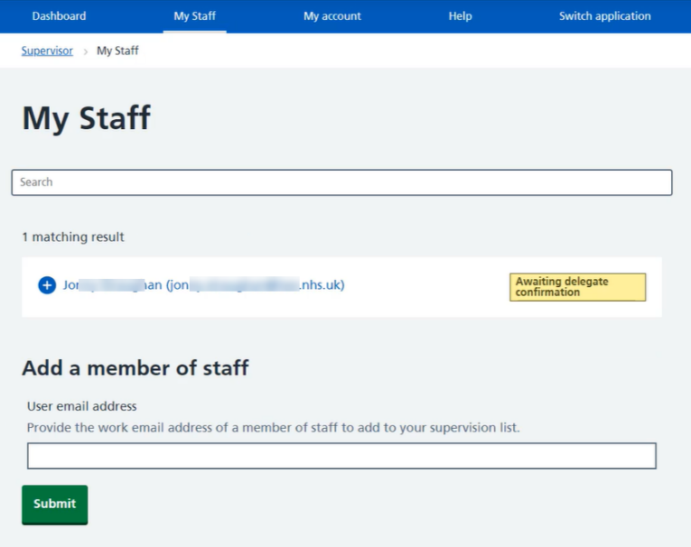 | For information:  The Educator/Manager will need to enrol the Learner onto the IV Therapy Passport before the learner can start their self-assessment.  Select: My staff
 | 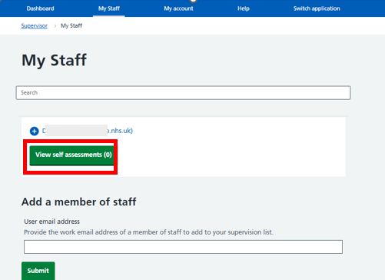 | Select: View self assessments
 | 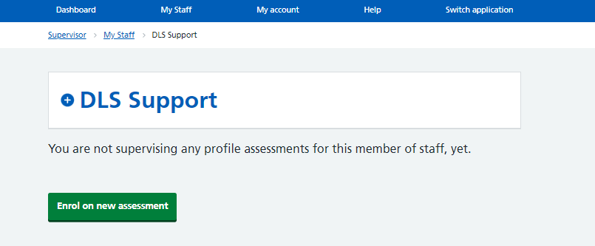 | Select: Enrol on new assessment
 | 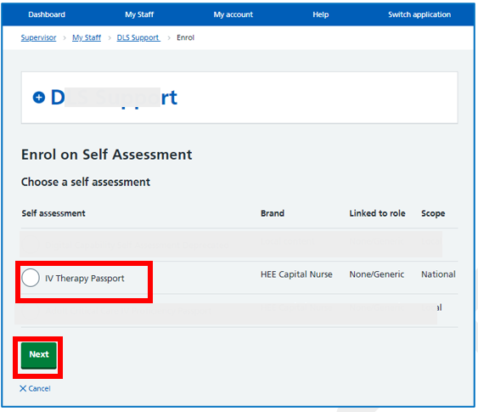 | Choose a self-assessment then  Select: Next
 | 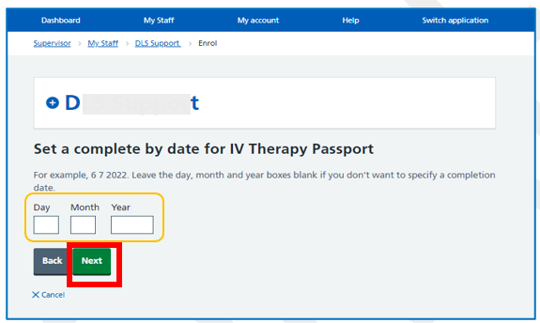 | For information:  At this point you can select an optional completion date for the staff member.  Leave the boxes blank if you don’t want to specify a completion date.  Select: Next
 | 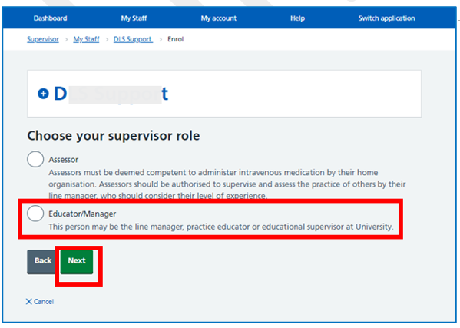 | Select: Educator/Manager  Select: Next
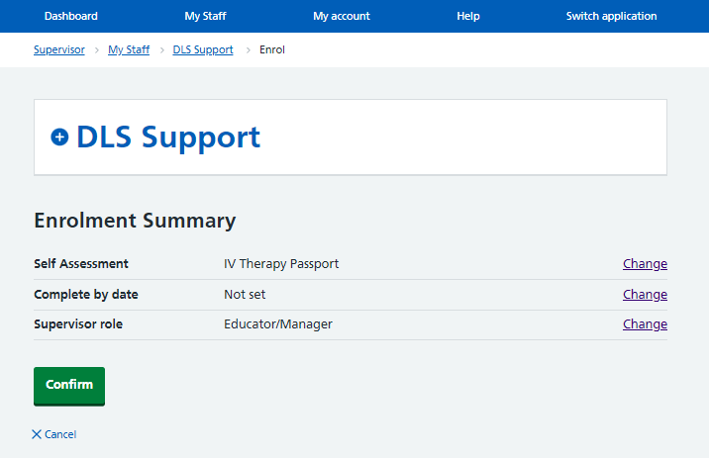
For information:
Prior to completing the enrolment, you can review and change the information you have entered.

Select: Confirm when you are ready to proceed.

For information: The staff member is now enrolled onto the self-assessment.

When you have finished follow the Log out procedure

 | 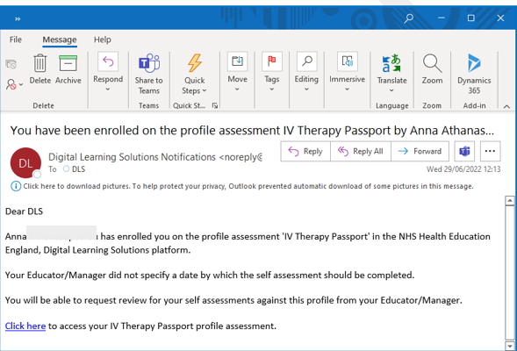 | For information:  The staff member (Learner) will receive a notification informing them that the self-assessment is available for completion.

Self-assessment final sign-off

STEP | Visual location | Guidance
 | 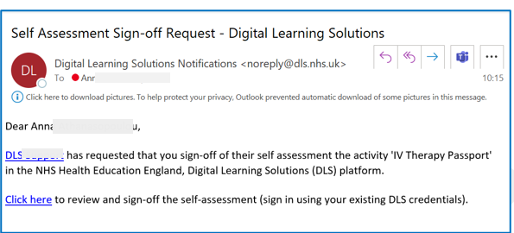 | For information:  When the learner has completed all their core and optional proficiencies and they have been reviewed and confirmed by their assessor, the Educator/Manager will receive an email notification requesting them to Sign off the passport and complete the declaration.
 | 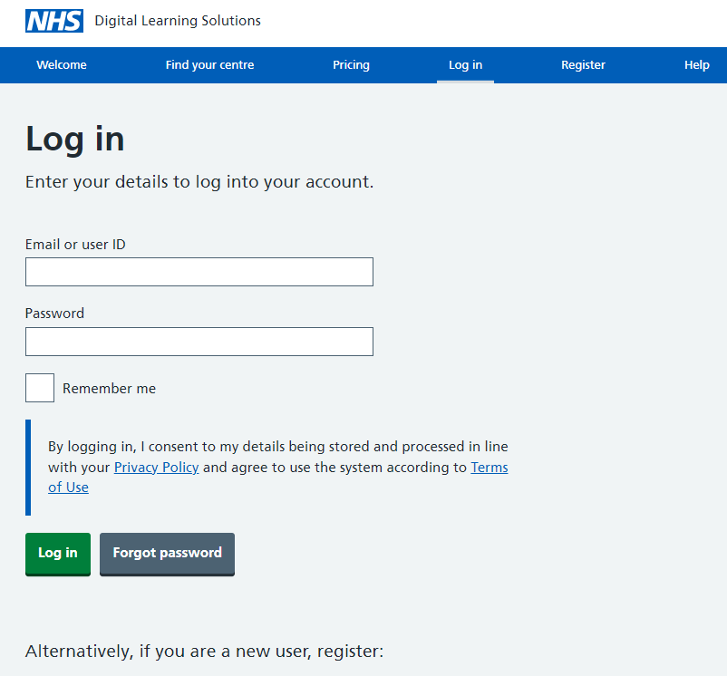 | Follow the Log in procedure
 | 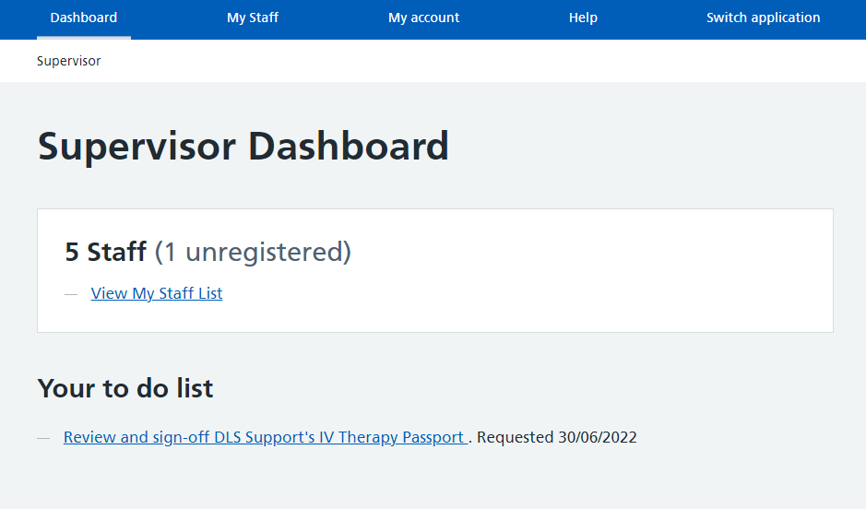 | Go to the Supervisor Dashboard, Your to do list  Select: Review and sign off
 | 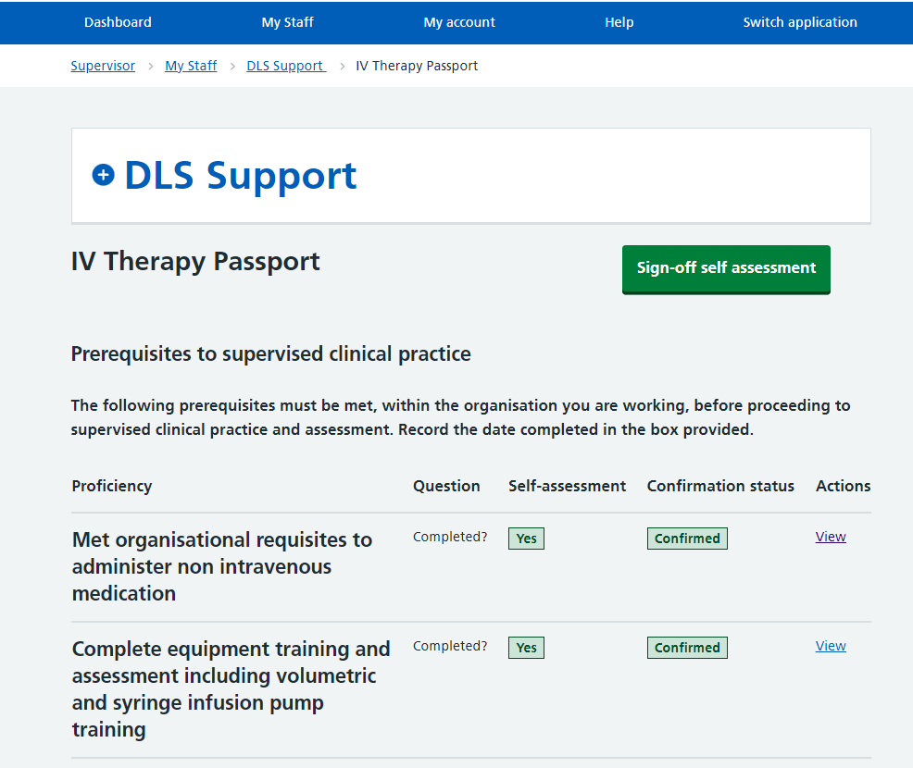 | If you are content that the learner has completed the following with appropriate assessors, then proceed to sign off:  - Prerequisites to supervised practice  - Record of learning and knowledge assessment  - Completed all core and the required optional proficiencies (minimum for role and at least one of each method of prep/ admin and one vascular access device proficiency)  Select: Sign-off self-assessment
 | 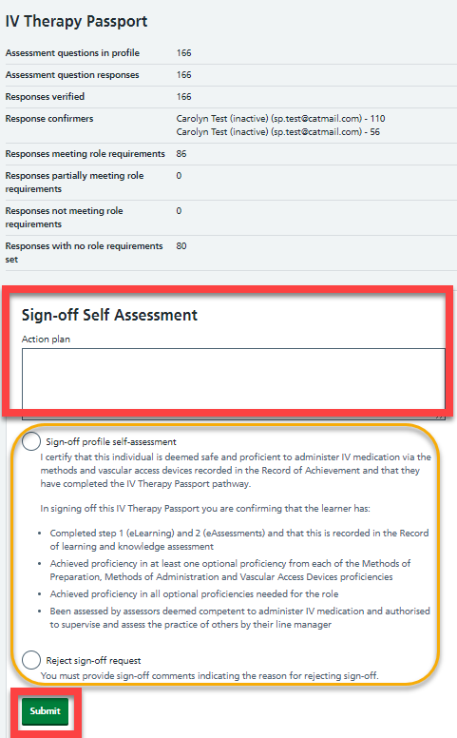 | Complete the Reviewer comments  Select: Sign-off profile assessment or Reject as appropriate  Select: Submit
 | 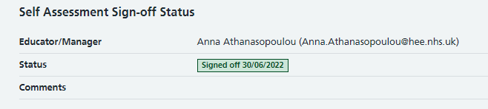 | Scroll down to the bottom of the screen to view the Status
 | 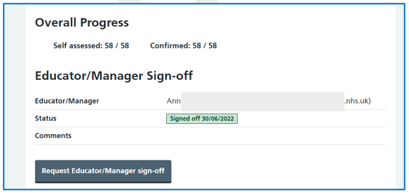 | For information:  When viewing the self-assessment from My staff list, you can also see the status highlighted in green Signed off
 | 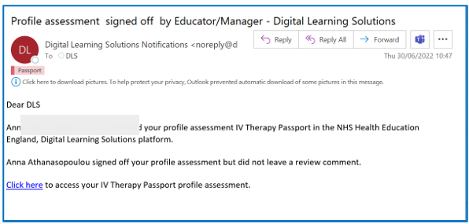 | For information:  The learner will receive a confirmation email when the passport has been signed off

Log out procedure

STEP | Visual location | Guidance
 | m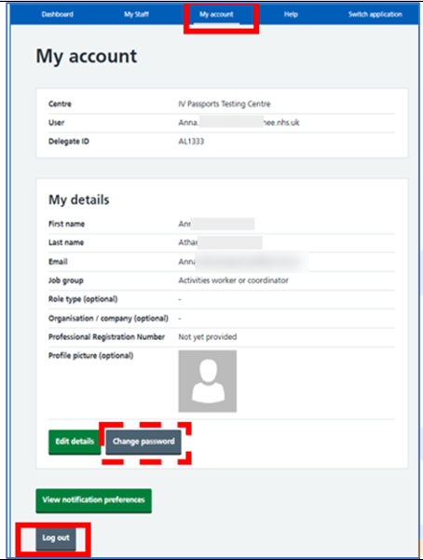 | Select: My account  Select: Log out  For information:  If you need to change your password:  - Select: Change password  - Return to: My account  - Select: Log out  If you need to change any of your registration details, select Edit details.  Don’t forget to select Save when you are finished.

Additional guidance

Self-assessment results review and confirm (this is usually the assessor’s role but may be appropriate for some Educators /Managers)

STEP | Visual location | Guidance
1. | 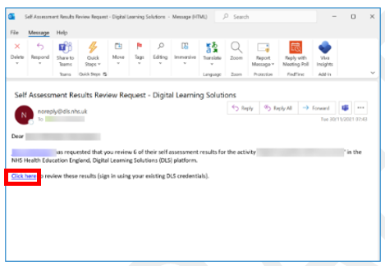 | For information:  The Educator/Manager can confirm learner’s self-assessed proficiencies if this is appropriate (this is usually the assessor’s role).  They will receive a notification email when a learner submits self-assessment results to them for review.  Select: Click here  Alternatively, access DLS:  https://www.dls.nhs.uk/v2/Home/Welcome  Then follow the Log in procedure
2. | 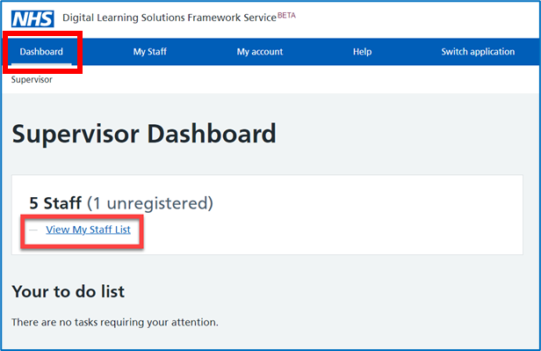 | Select: Dashboard and then  Select: View My Staff List
3. | 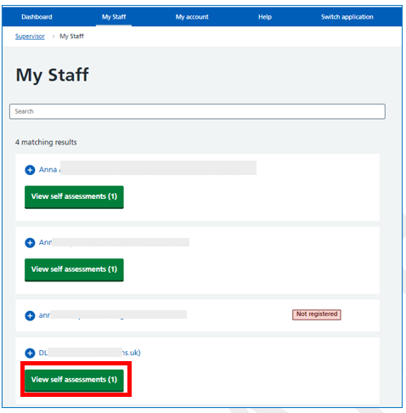 | Select: View self-assessment for the staff member you are reviewing.
4. | 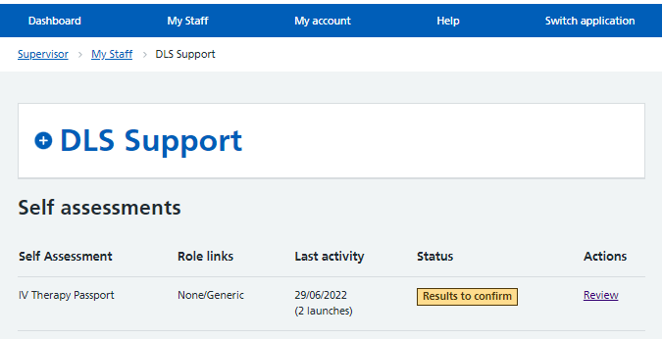 | Select: Review
5. | 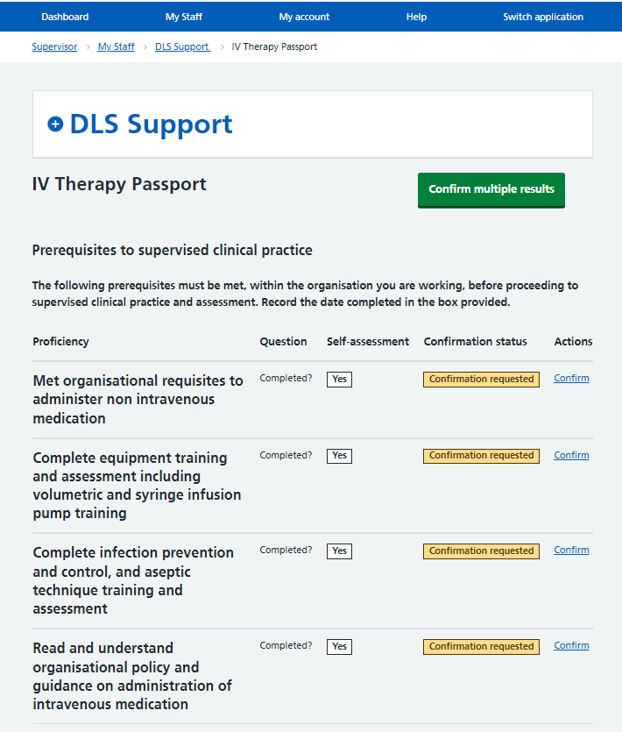 | For information:  Guidance notes are visible when proficiencies are confirmed singularly but not when confirming multiple proficiencies.  There is not an option to select ‘reject’ and record an action plan when confirming multiple proficiencies – these would need to be confirmed by each proficiency and rejected.  Confirmation requested results are highlighted in yellow.  Select: Confirm by each proficiency or  Select: Confirm multiple results
6. | 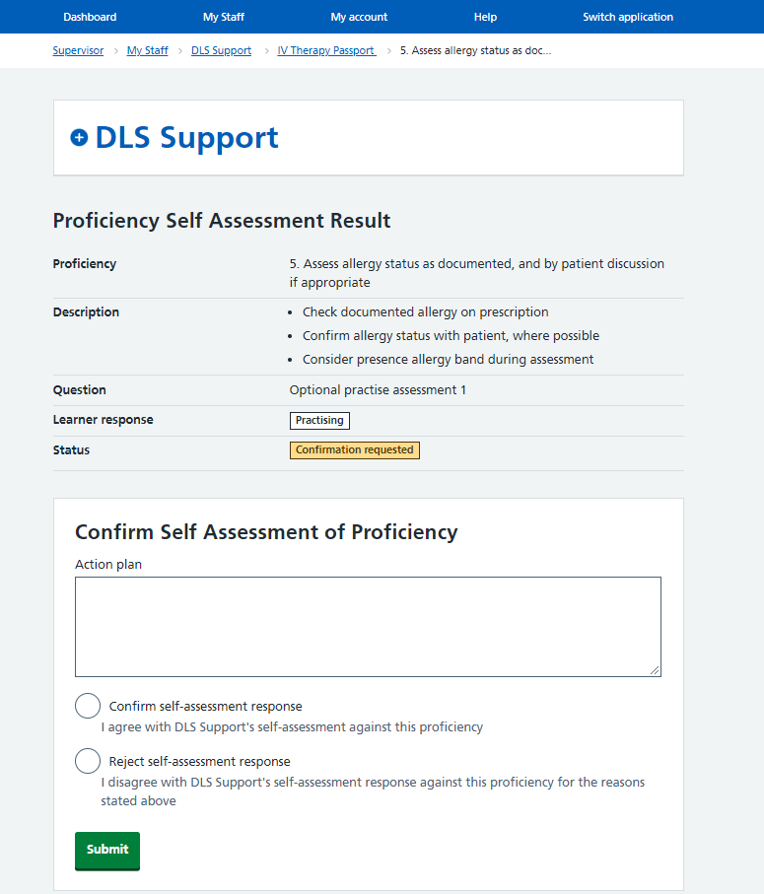  When selecting reject you are required to add an action plan. | Select: Confirm or Reject as appropriate.  For information: when selecting reject you are required to add an action plan.  Select: Submit
- Review and update self-assessment results with an Action Plan

STEP | Visual location | Guidance
 | 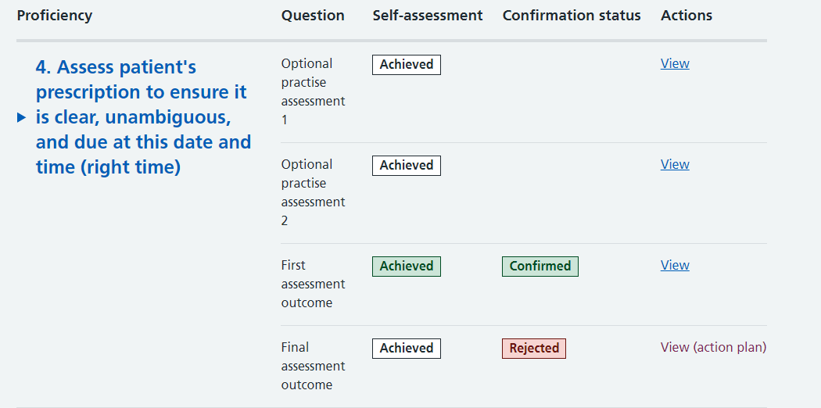 | To review a proficiency action plan, Select: View (action plan)
 | 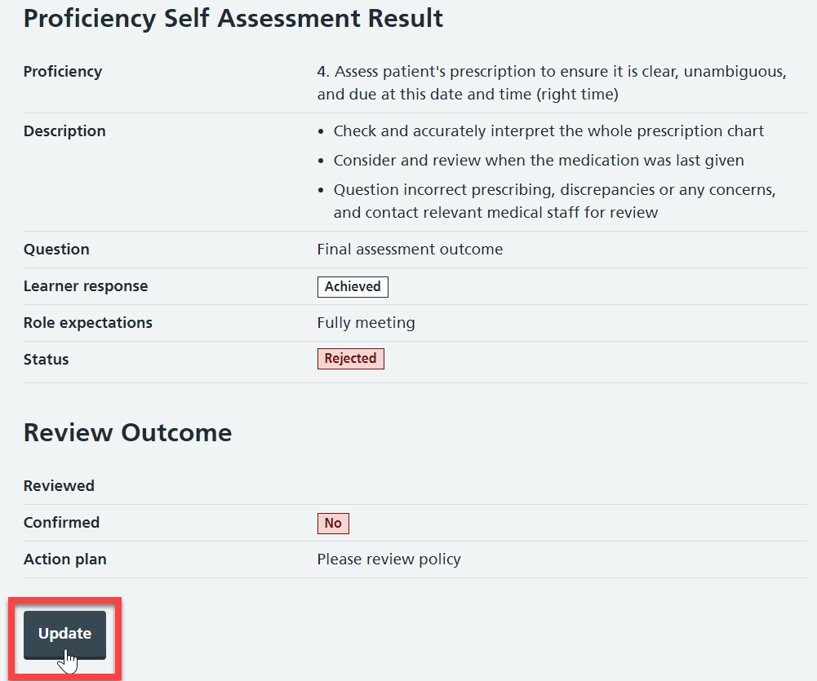 | Select: Update
 | 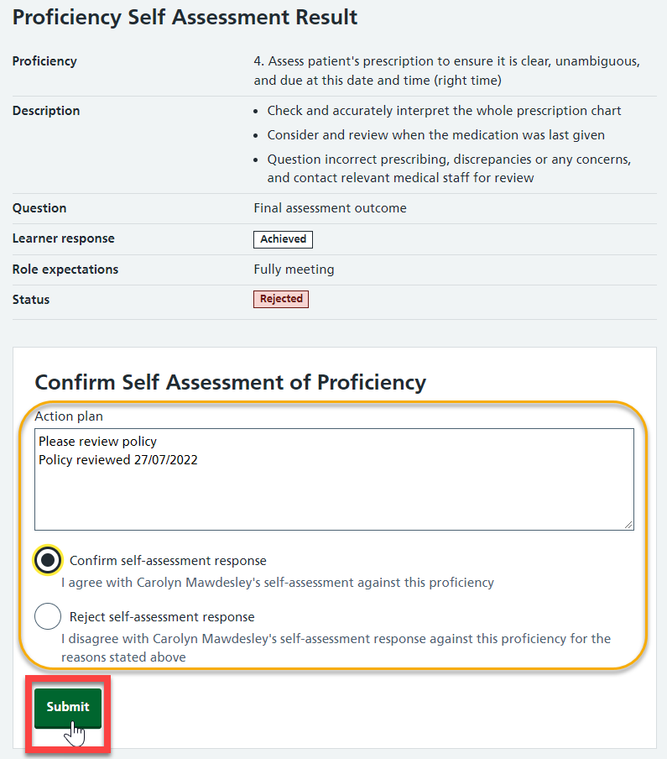 | Record a response and select: Submit  For information:  when selecting ‘reject’ you are required to add an action plan before submitting the assessment.
 | 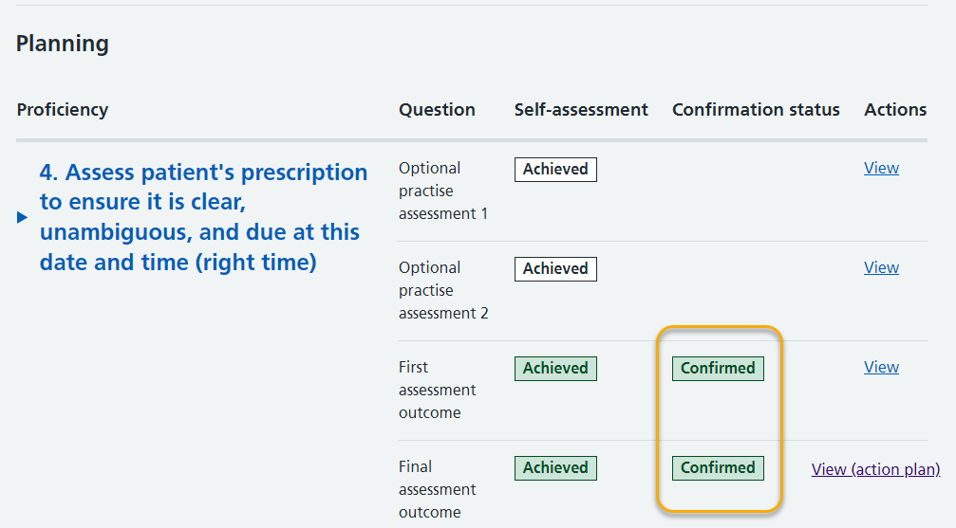 | For information:  The confirmed results are highlighted in green  When you are finished follow the Log out procedure
 | 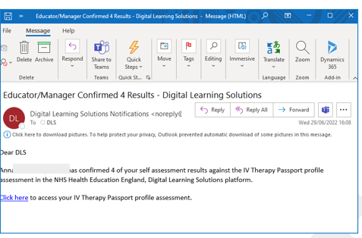 | For information:  As their proficiency results are confirmed, the learner will receive an email.

Remove a member of staff from your supervision list

STEP | Visual location | Guidance
 | 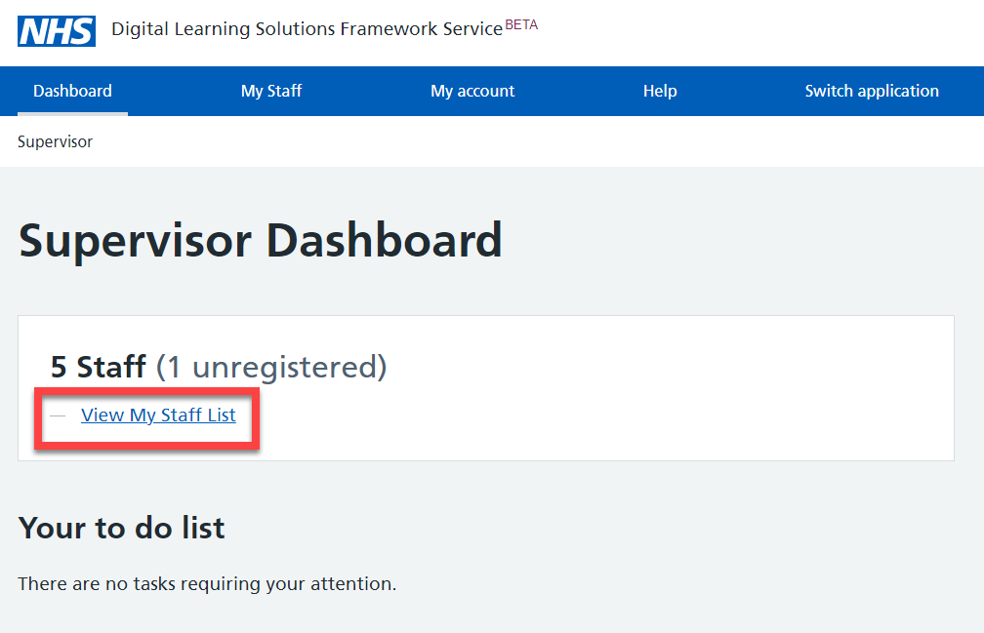 | Select: View My Staff List
 | 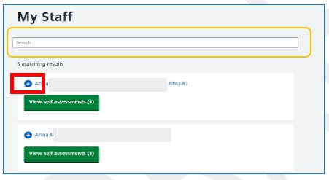 | For information:  You can use the search funtion to find staff on your supervision list  Select: Expand + next to the member of staff you want to remove
 | 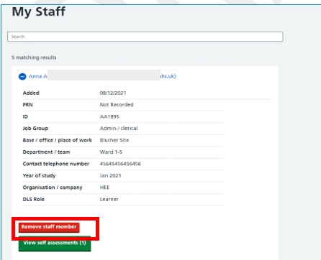 | Select: Remove staff member
 | 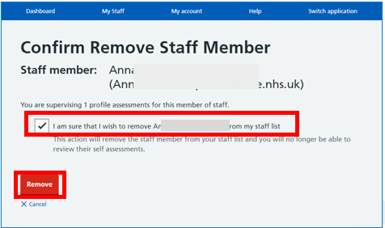 | Confirm remove staff member  Select: I am sure  Select: Remove
 | 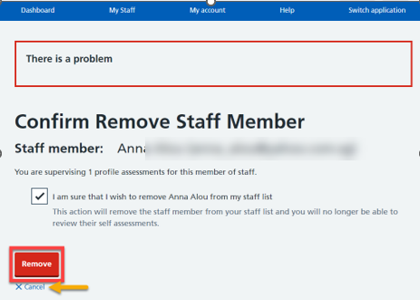 | For information:  There is an on-screen warning about the implications of removing the staff member. If you are sure that you no longer need to review this staff members self-assessment, you can proceed  Select: Remove  Alternatively you can Cancel the action

Send a reminder to a member of staff from your supervision list

STEP | Visual location | Guidance
 | 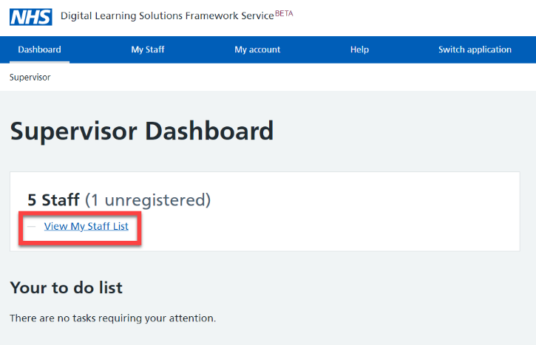 | Select: View My Staff List
 | 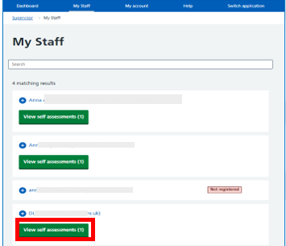 | Select: View self-assessment for the staff member you are reminding.
 | 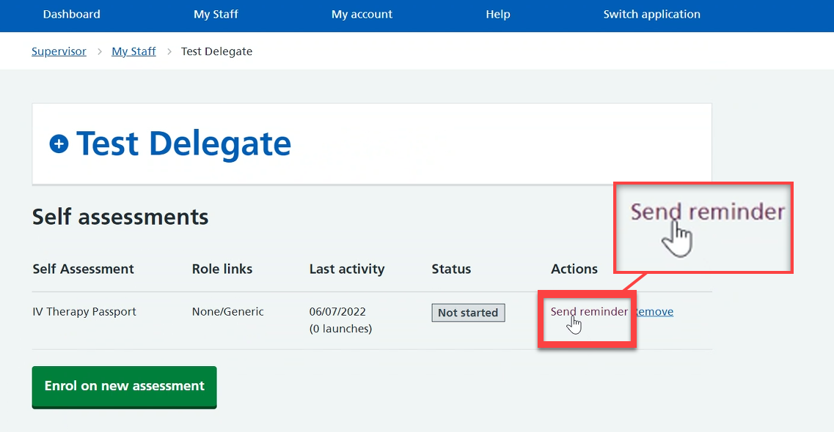 | Select: Send reminder
 | 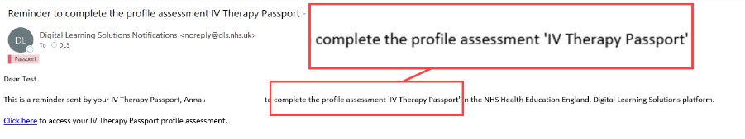 | For information: the delegate will receive an email, to their registered email account, reminding them to complete their assessment.

Nominate a member of staff as an assessor (nominated supervisor)

 | 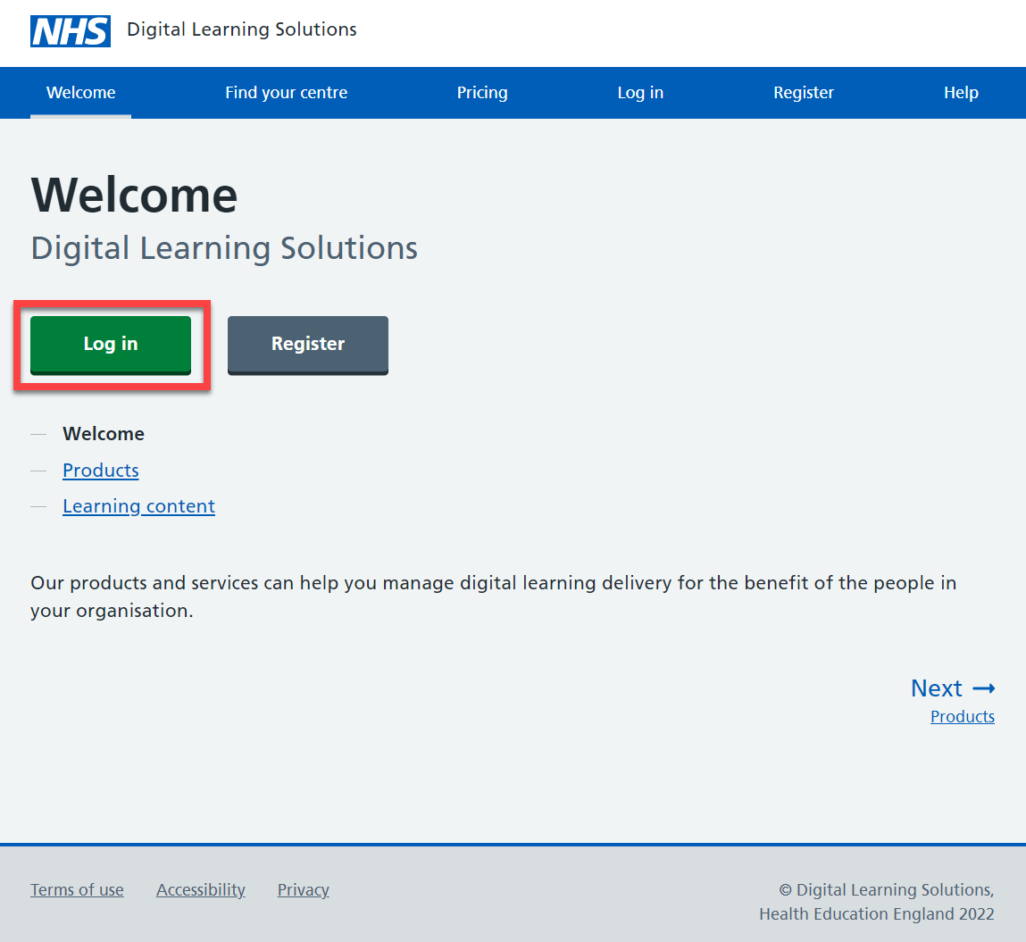 | Access the DLS landing page  Select: Log in
2. |  | Select: Dashboard and then  Select: View My Staff List
3. | 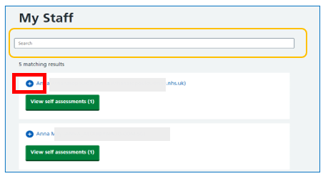 | For information:  You can use the search funtion to find staff on your supervision list  If you do not see the name of the assessor on your staff list you should add them from Add member of staff at the bottom of the screen. The assessor you are adding will need to be a registered DLS delegate.  The member of staff will be added to your Staff list  Select: Expand + next to the member of staff you want to remove
4. | 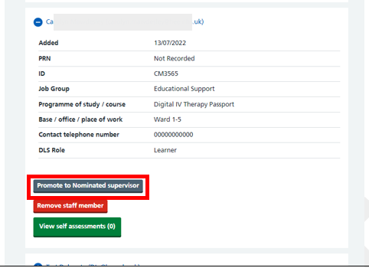 | Select: Promote to nominated supervisor
5. | 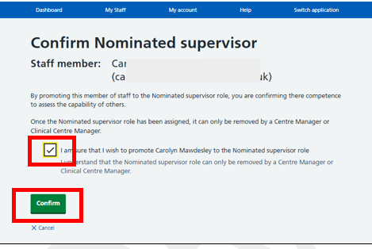 | Confirm nominated supervisor  Select: I am sure  Select: Confirm

Forgotten the password

Access the DLS landing page

Select: Log in

 | 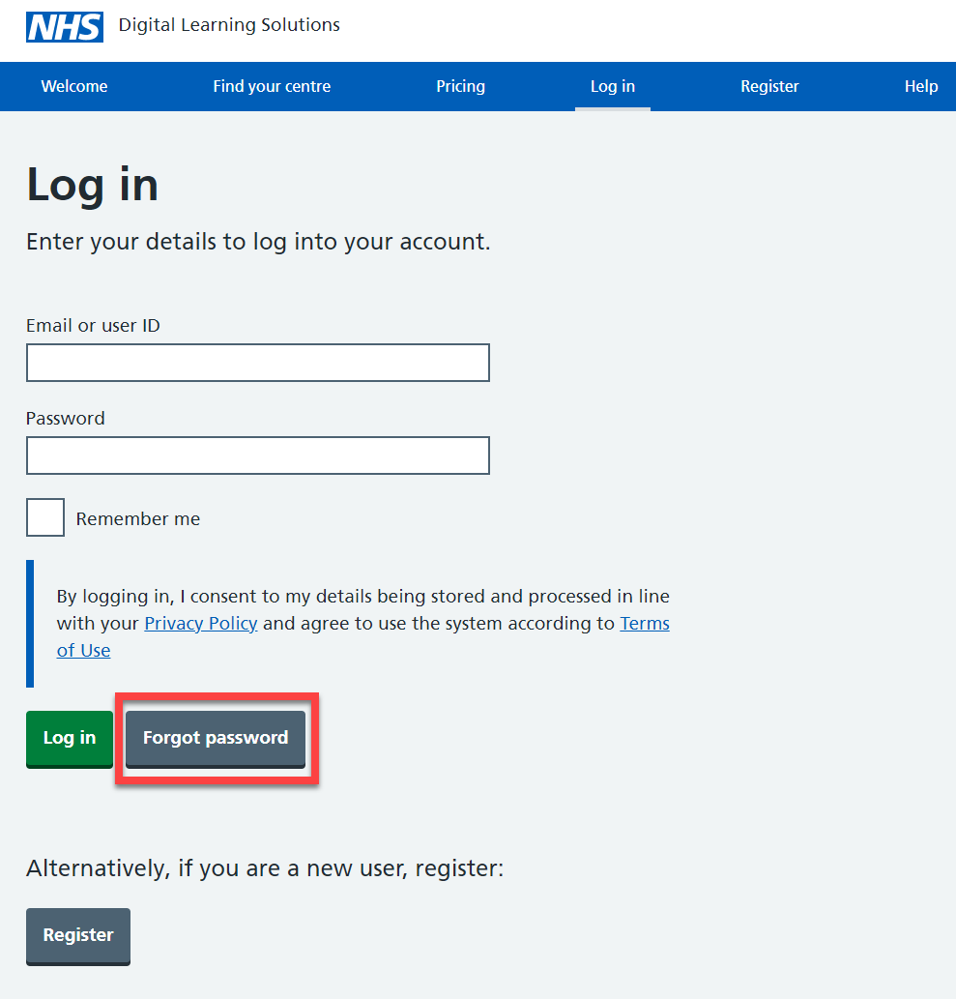 | Select: Forgot password
 | 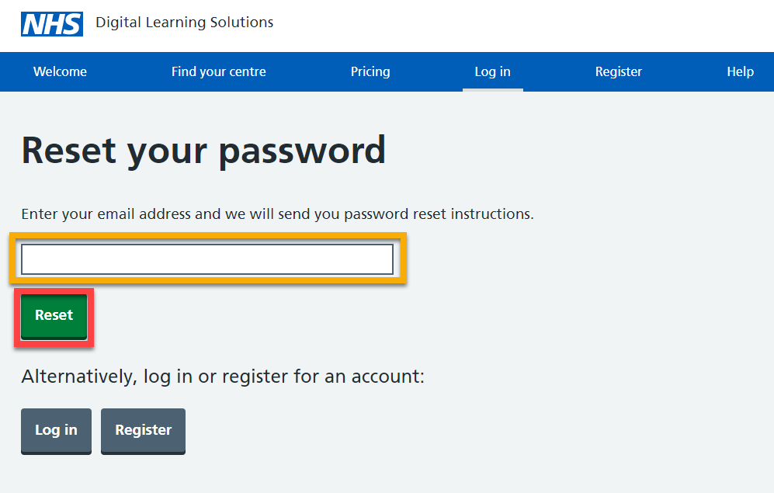 | Enter your email address  Select: Reset
 | 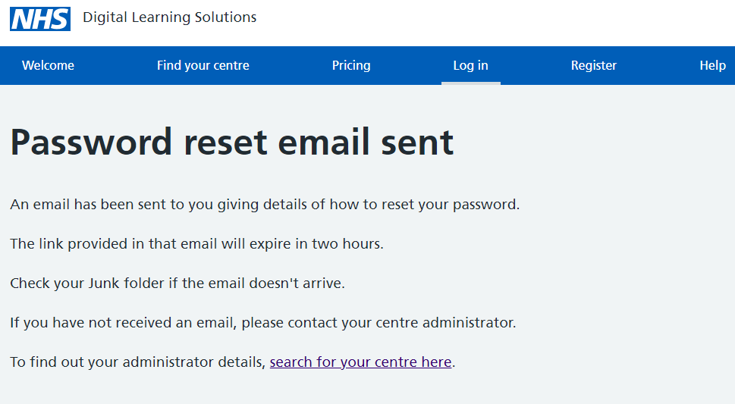 | For information: You’ll see an onscreen confirmation message
 | 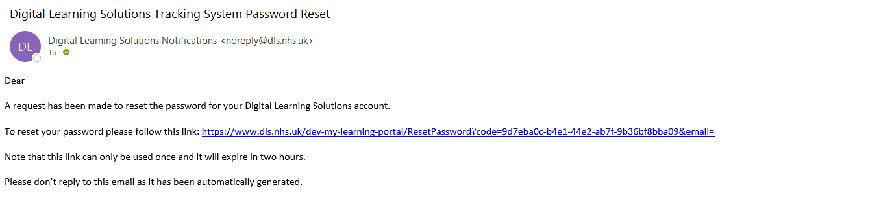 | You’ll receive a email that provides a 2 hour time limited reset link  Select: the link
 | 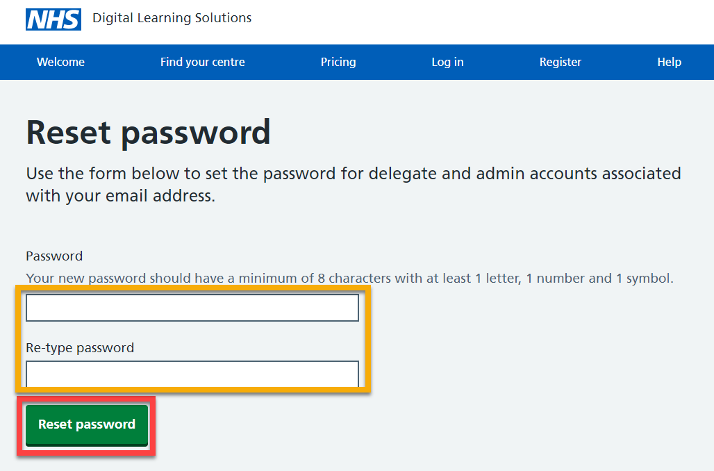 | Complete the fields  Select: Reset password
 | 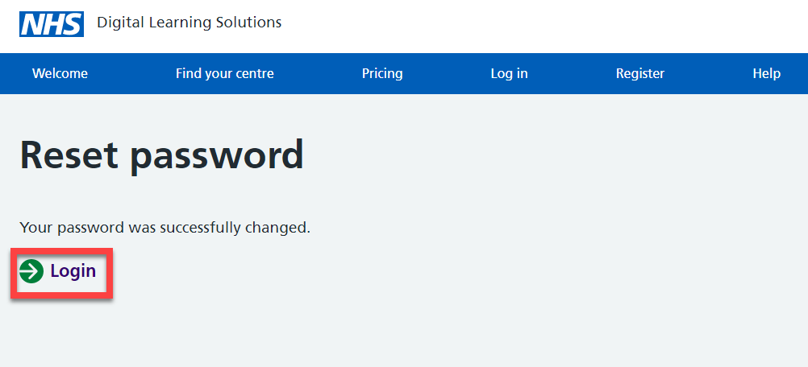 | Select: Login
 | 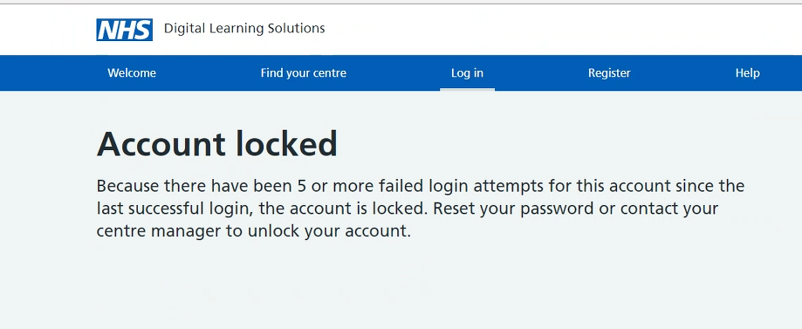 | For information:  If at any time you receive an Account locked message, you should follow the Forgot password process

For support, please contact: the local clinical centre manager or administrator at your organisation.

