Digital IV Therapy Passport –
Assessor User Guide

The Digital Learning Solutions (DLS) platform, provided by the Technology Enhanced Learning (TEL) Team within Health Education England (HEE), hosts the Digital IV Therapy Passport.

This user guide is designed to provide first time access guidance to an Assessor.

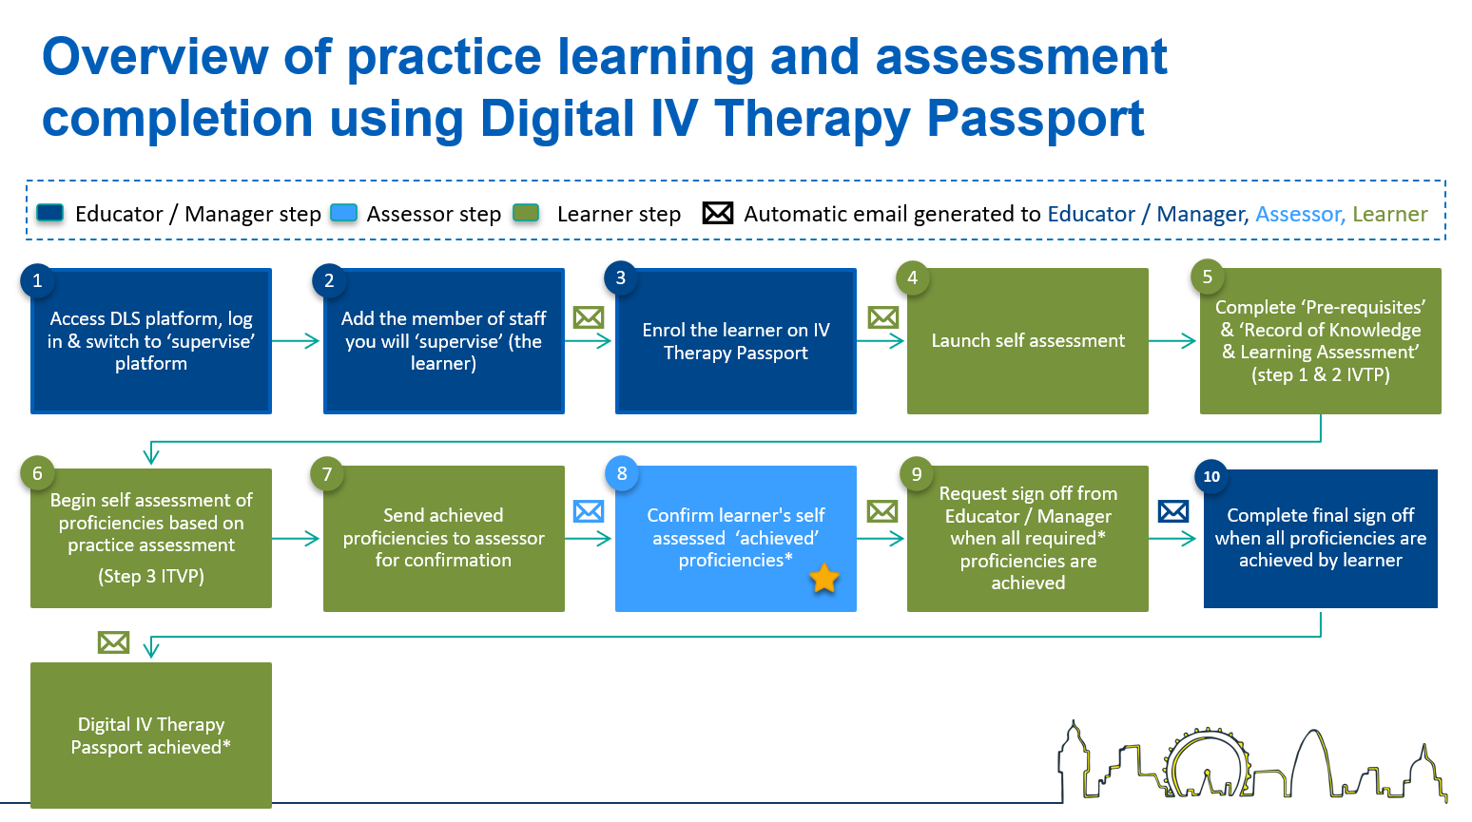
Indicates the Assessor steps in the process

For information:

- The learner: Person completing the self-assessment in the IV Therapy Passport.
- The Educator / Manager: the person who is facilitating the passport and will ultimately sign it off when all proficiencies have been assessed.
- The Assessor: the person supervising, completing practice assessment and confirming achievement of proficiencies.

Note:
The DLS platform uses the term ‘supervise’ or ‘supervisor’ – these terms indicate the assessment, or sign off, process performed by the Assessor or Educator/Manager.

For support, please contact: the local educator/manager, clinical centre manager or administrator at your organisation.

Contents
Essential guidance 3
A. Log in procedure 3
B. Access your staff list 5
C. Self-assessment results review and confirm 6
D. Log out procedure 9
E. Review and update self-assessment results with an Action Plan 10
F. Remove a member of staff from your supervision list 12
G. Forgotten the password 14

Essential guidance

- Log in procedure

STEP | Visual location | Guidance
 | 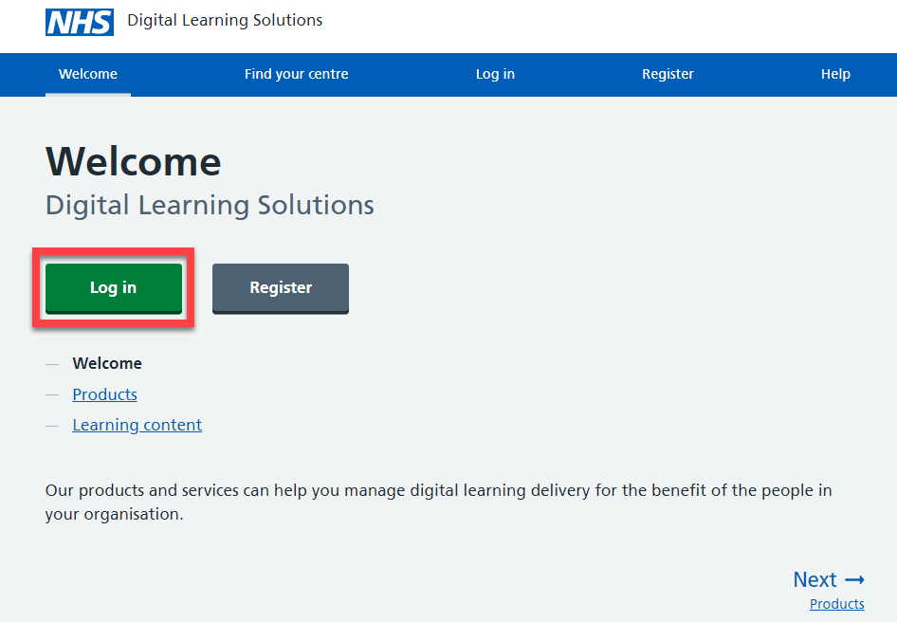 | For information:  Before you can proceed, you should have a DLS account and your clinical centre manager will have assigned you as a assessor on the system.  Access via the DLS platform  Select: Log in
 | 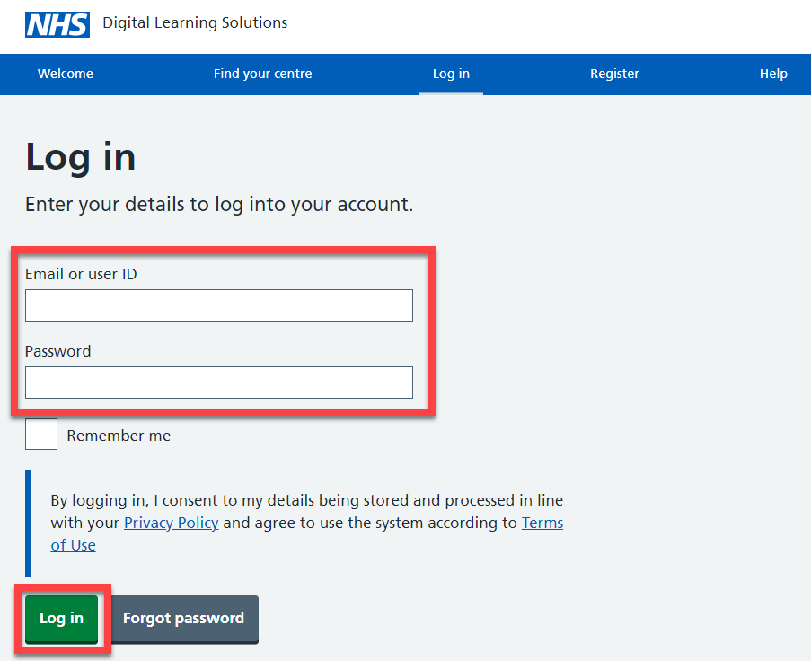 | Log in using your email address and the password set up at registration  Select: Log in  For information:  Assessors may also have a delegate user ID to access the system, this should be disregarded, always use your email address.  Forgotten your password? Follow the guidance available.
 | 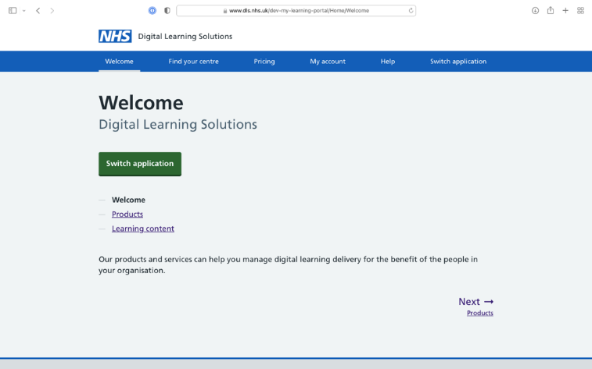 | Select: Switch application
 | 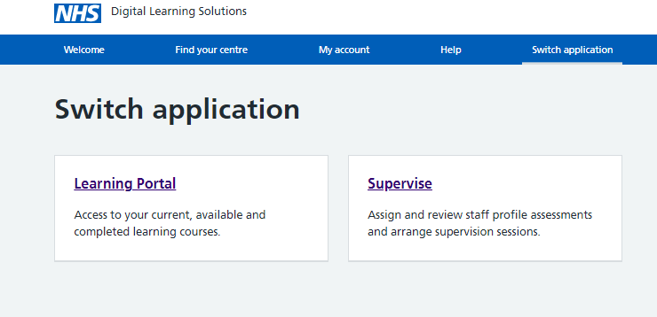 | Learning Portal: enables the Learner to complete an assessment  Supervise: takes all those acting as educator/manager or assessor to the platform to work in these roles  Select: Supervise

Access your staff list
STEP | Visual location | Guidance
1. | 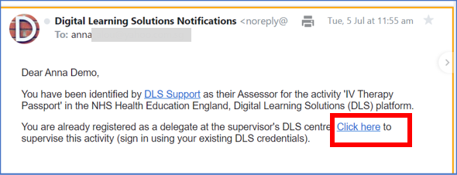 | For information:  The Educator/Manager will enrol the learner onto the IV Therapy Passport.  The Learner will then select an assessor to confirm the activity.  The Assessor will receive an email notifying them that they have been identified as an assessor.  Select: the link in the email to access your staff list
2. | 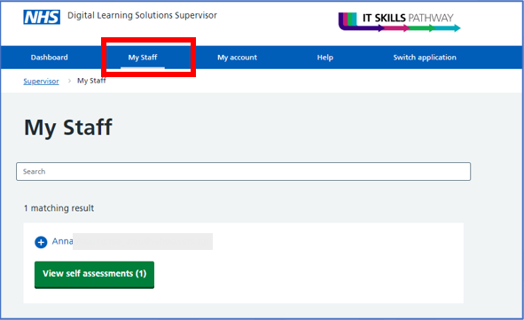 | Select: My staff to access your supervision list.  When you’ve finished follow the Log out procedure

Self-assessment results review and confirm

STEP | Visual location | Guidance
1. | 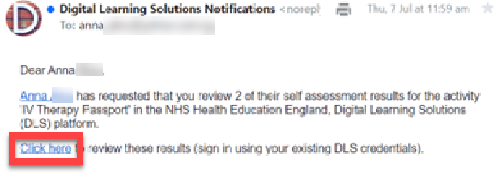 | For information:  As an Assessor, you will receive a notification email when a learner submits self-assessment results for review.  Select: from the email access the link Click here  Alternatively, access DLS  Then follow the Log in procedure
2. | 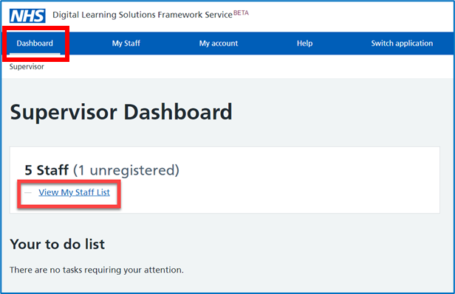 | Select: Dashboard and then  Select: View My Staff List
3. | 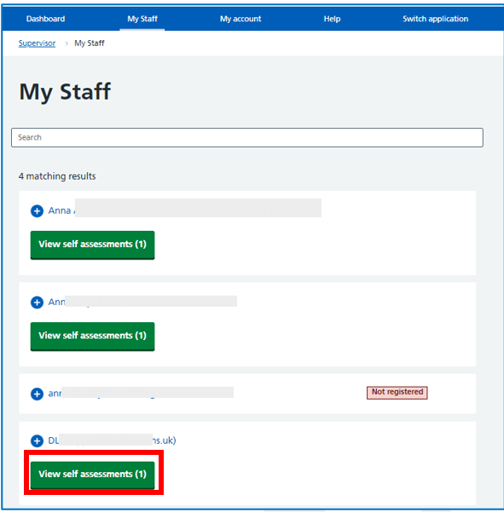 | Select: View self-assessment for the staff member you are reviewing.
4. | 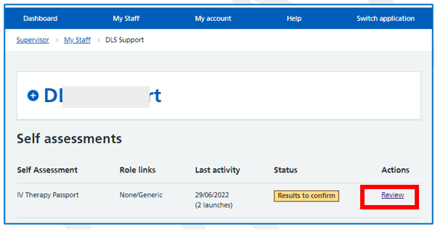 | Select: Review
5. | 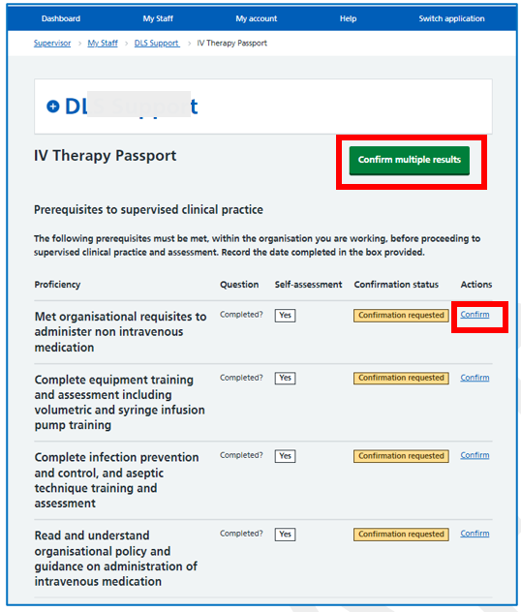 | For information:  Guidance notes are visible when proficiencies are confirmed singularly but not when confirming multiple proficiencies.  There is not an option to select ‘reject’ and record an action plan when confirming multiple proficiencies – these would need to be confirmed by each proficiency and rejected.  Confirmation requested results are highlighted in yellow.  Select: Confirm by each proficiency or  Select: Confirm multiple results
6. | 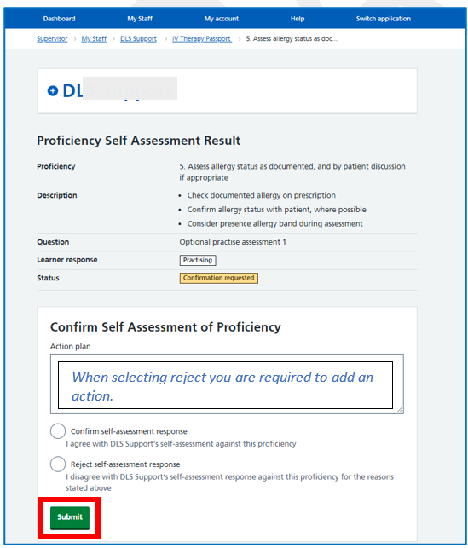 | Select: Confirm or Reject as appropriate.  For information:  When selecting ‘reject’, you are required to add an action plan.  Select: Submit

Log out procedure

STEP | Visual location | Guidance
 | 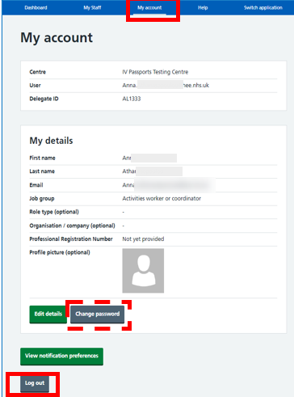 | Select: My account  Select: Log out  For information:  If you need to change your password before you go  Select: Change password  Return to: My account  Select: Log out  If you need to change any of your registration details, select Edit details. Don’t forget to select Save when you are finished.

Additional guidance

Review and update self-assessment results with an Action Plan

STEP | Visual location | Guidance
 | 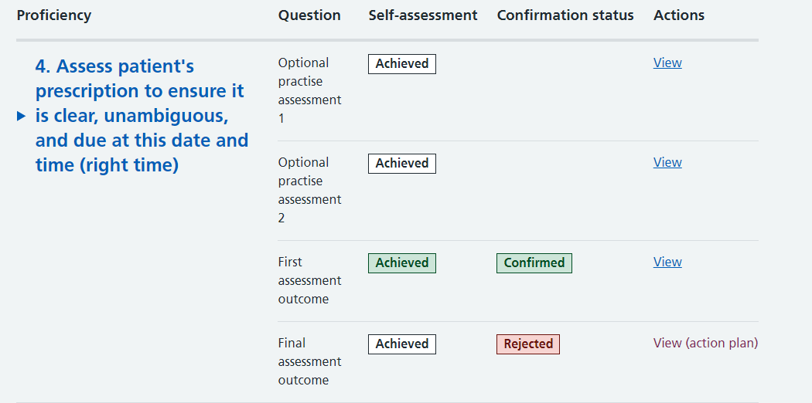 | To review a proficiency action plan, Select: View (action plan)
 | 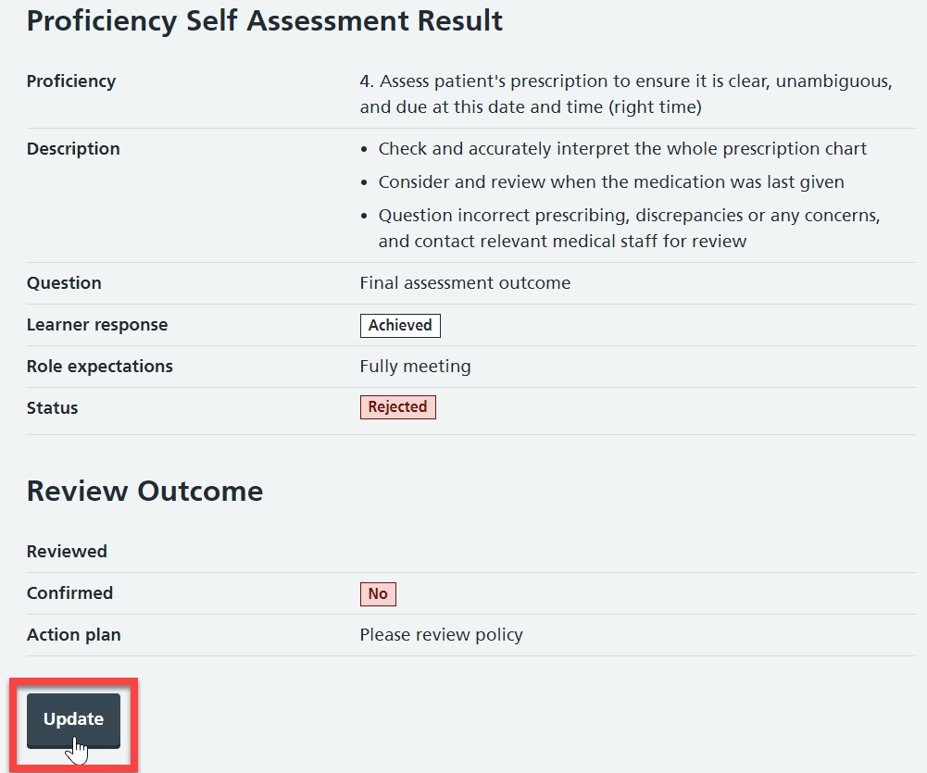 | Select: Update
 | 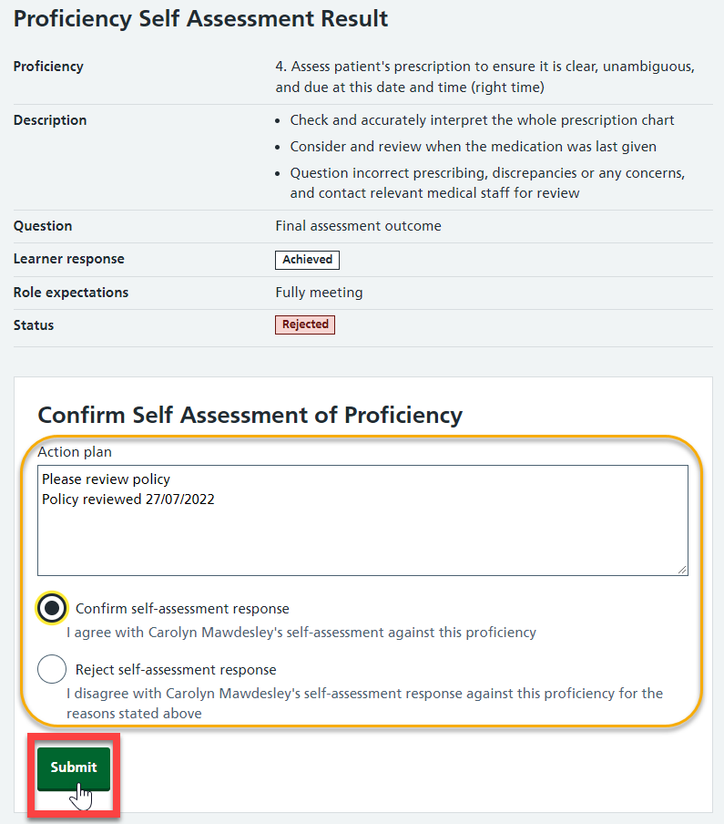 | Record a response and select: Submit  For information:  When selecting ‘reject’, you are required to add an action plan before submitting the assessment.
 | 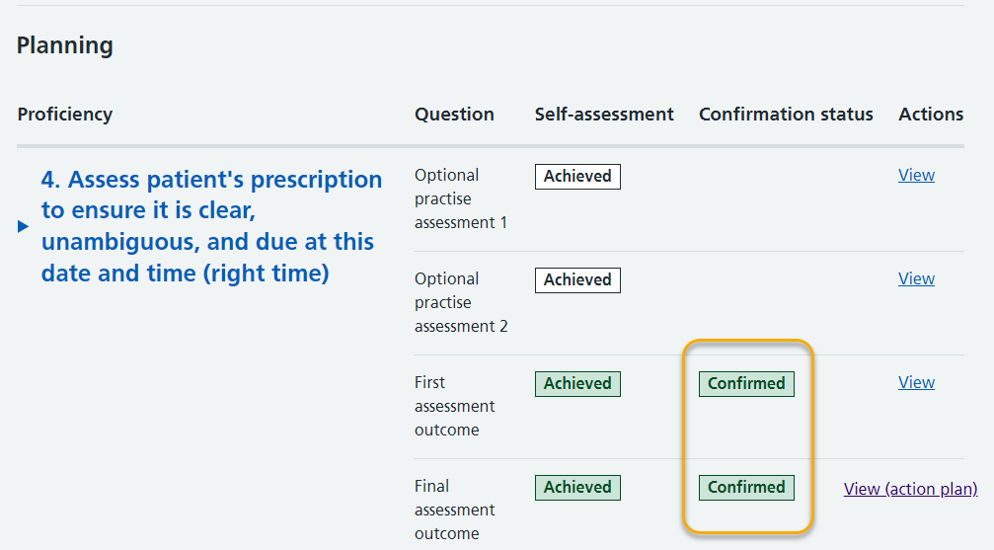 | For information:  The confirmed results are highlighted in green.  When you are finished, follow the log out procedure.
 | 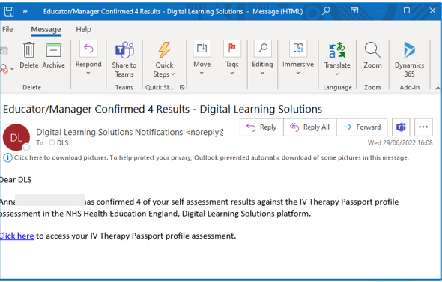 | For information:  As their proficiency results are confirmed, the learner will receive an email.

Remove a member of staff from your supervision list

STEP | Visual location | Guidance
 | 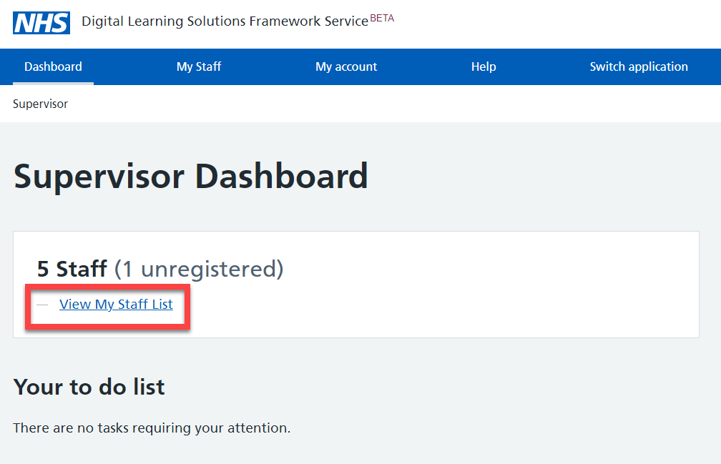 | Select: View My Staff List
 | 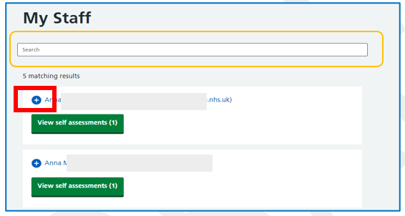 | For information:  You can use the search funtion to find staff on your supervision list  Select: Expand + next to the member of staff you want to remove
 | 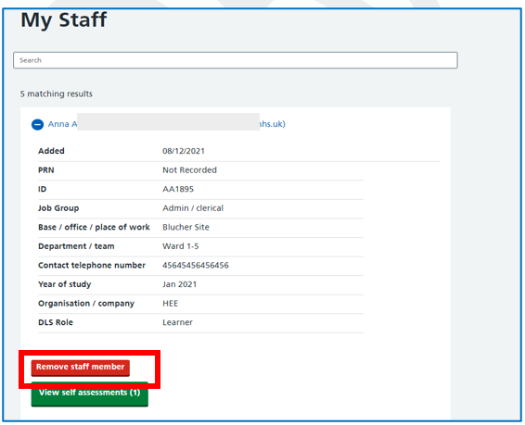 | Select: Remove staff member
 | 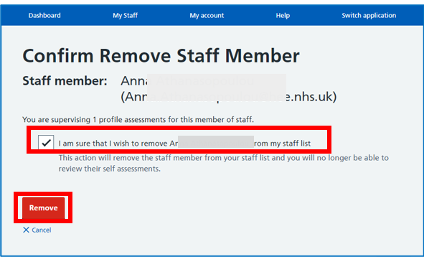 | Confirm remove staff member  Select: I am sure  Select: Remove
 | 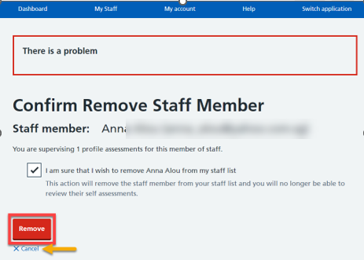 | For information:  There is an on-screen warning about the implications of removing the staff member. If you are sure that you no longer need to review this staff members self-assessment, you can proceed  Select: Remove  Alternativly you can Cancel the action

Forgotten the password

 | 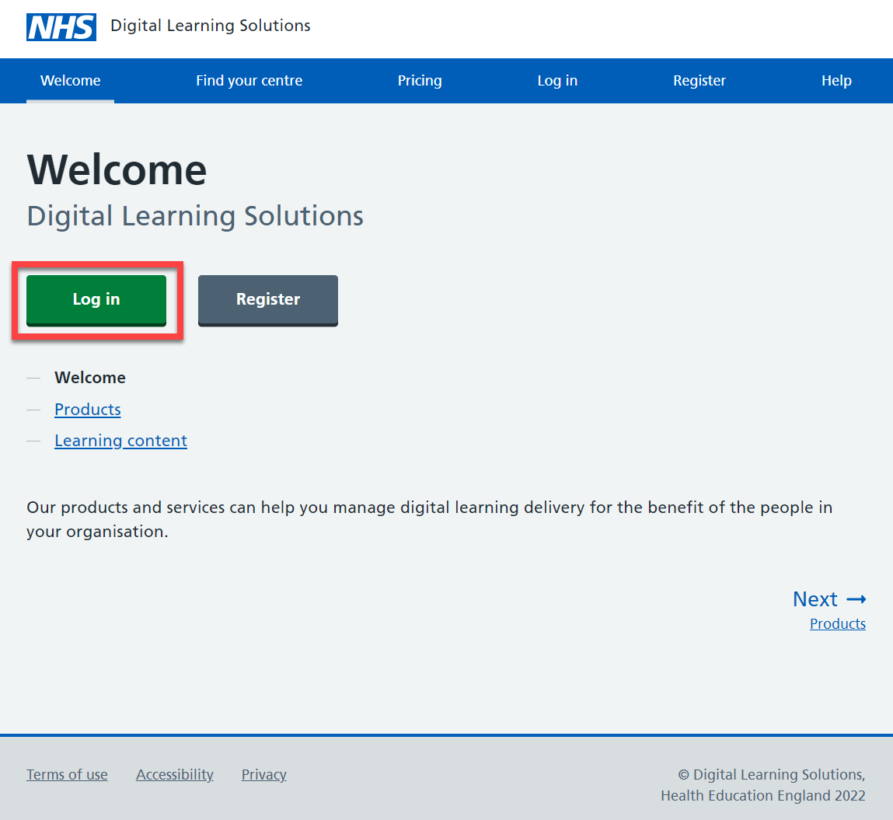 | Access the DLS landing page  Select: Log in
 | 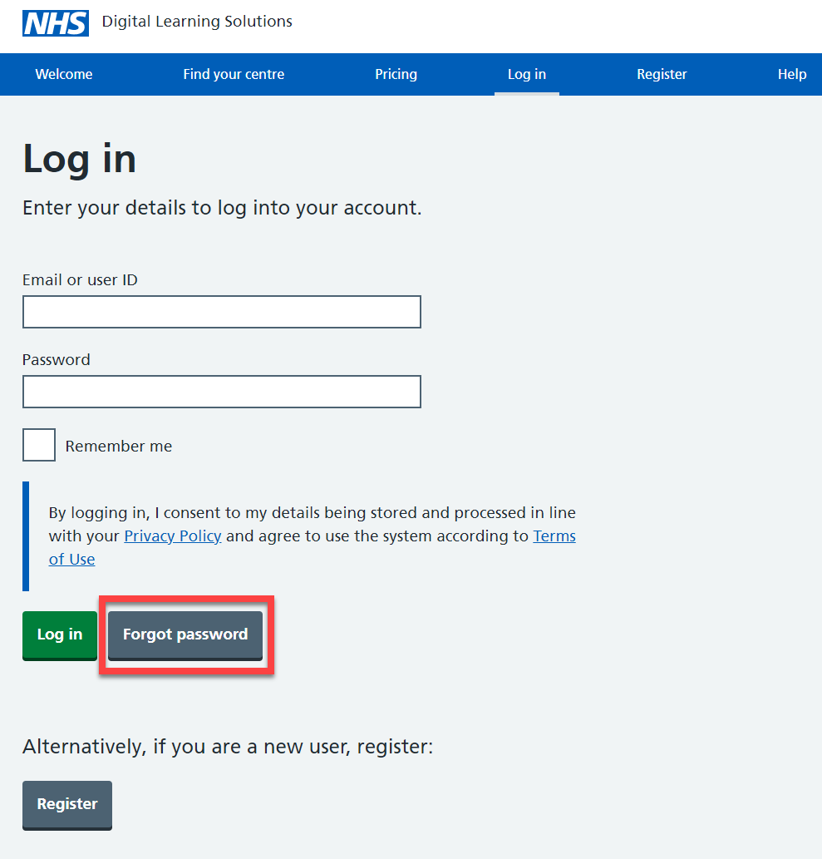 | Select: Forgot password
 | 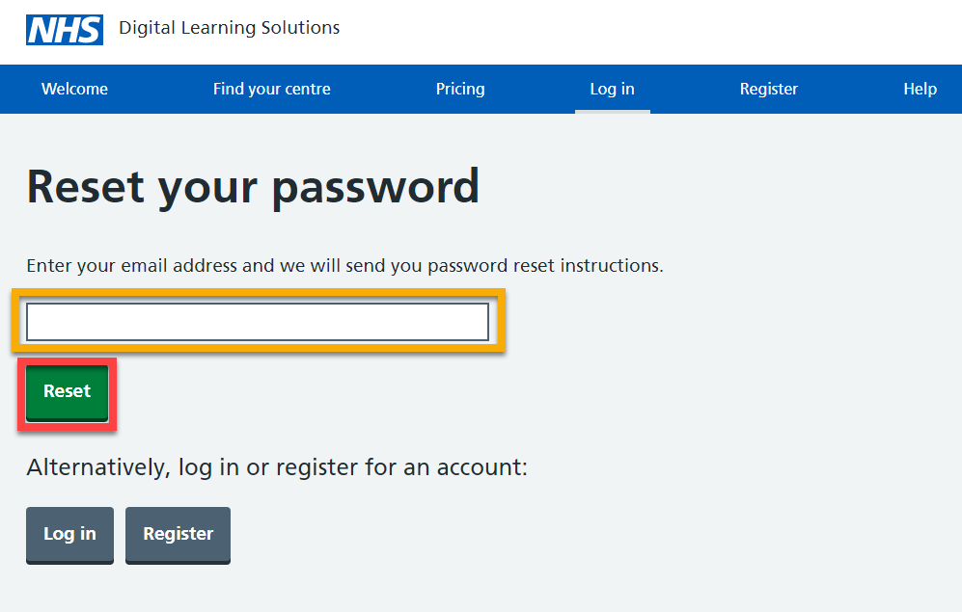 | Enter your email address  Select: Reset
 | 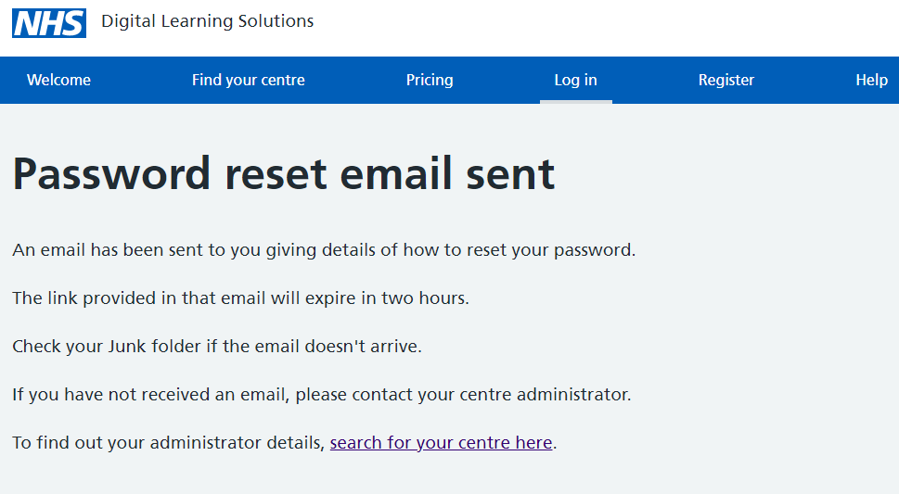 | For information:  You will see an onscreen confirmation message
 | 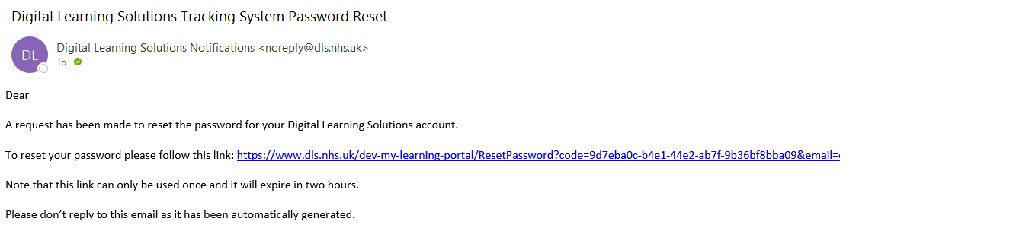 | You will receive a email that provides a 2 hour time limited reset link  Select: the link
 | 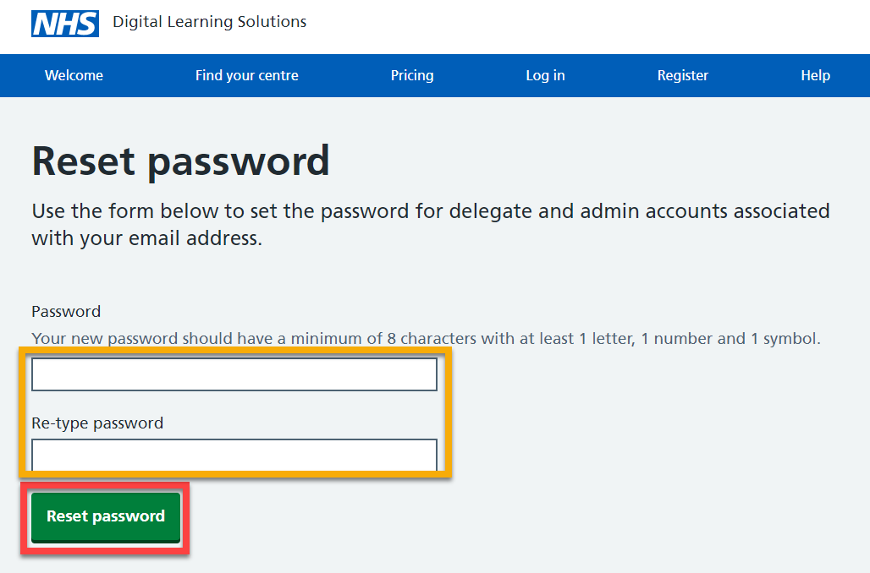 | Complete the fields  Select: Reset password
 | 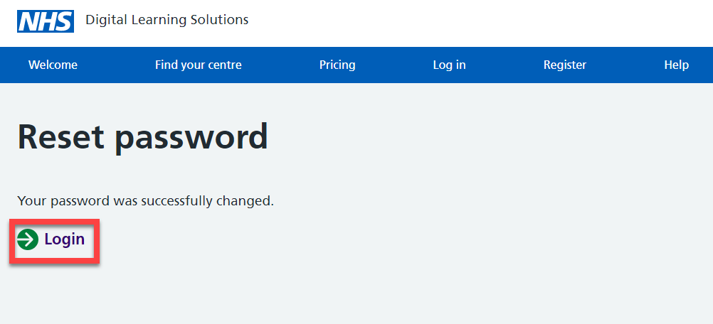 | Select: Login
 | 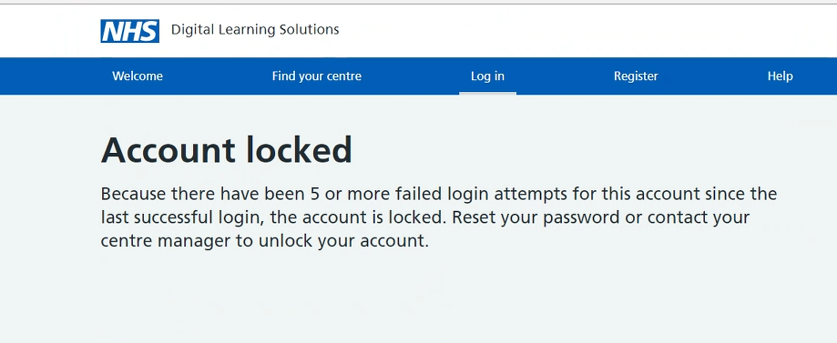 | For information:  If at any time you receive an Account locked message, you should follow the Forgot password process

For support, please contact: the local Educator/Manager, clinical centre manager or administrator at your organisation.

