Digital IV Therapy Passport - Frequently Asked Questions for Learners

Contents
1. Guidance and support 4
2. Roles in IV Therapy passport 5
What user roles are there in the digital IV Therapy passport? 5
What is a learner expected to do in the digital IV Therapy passport? 5
3. Learner Platform 6
How do I register as a learner? 6
I’ve received an Invite from Supervisor email from noreply@dls.nhs.uk what should I do? 6
Why have I not received my activation email yet? 6
I’ve self-registered, why does my account need approval? 6
How do I access my digital IV Therapy Passport? 6
What is my username? 7
Can I change my password when I first log into the digital IV Therapy passport? 7
I’m locked out of my account, what should I do? 7
What do I do if I’ve been set up with an incorrect email address? 7
My email address has changed since I started using the digital IV Therapy passport. Who do I need to contact to notify this change? 7
Who can assess my proficiencies? 8
What is the role of the educator / manager? 8
How do I invite my assessor to the digital IV Therapy Passport? 8
Can I change my assessor halfway through my self-assessment? 8
How can I find and filter my proficiencies? 8
What if my assessor has gone on leave after I have submitted my request for them to confirm the self-assessment of some of my proficiencies? 8
I need to withdraw the request I have made to my assessor, what do I do? 9
What are the pre-requisites and Record of learning and knowledge assessment? 9
Can I amend a self-assessment before I submit it for confirmation? 9
Can I self-assess several proficiencies at one time? 9
How do I ask my assessor to confirm the achievement of my proficiencies? 9
Can I notify my assessor that I have multiple proficiencies that need assessing? 9
What do I do if my assessor disagrees with / rejects my first self-assessment? 10
What if my assessor disagrees with / rejects my final assessment? 10
How do I transfer my digital IV Therapy Passport to my new Trust? 10
Can I alter my self-assessment after my assessor has confirmed my self-assessment? 10
Can my assessor alter the confirmation status should my performance improve? 10
Can I request confirmation of self-assessment for a final proficiency before I have achieved in the first assessment? 10
How will I know if I have an action plan? 10
My assessor keeps getting lots of emails from me to notify them of self-assessments I have completed – can I prevent this? 11
How do I request sign off of my digital IV Therapy Passport? 11
Why won’t my digital IV Therapy Passport progress to sign off? 11
Who can sign off my digital IV Therapy Passport? 11
How will I know if I have requested sign off successfully? 11
How do I log out? 11
What does the colour key mean? 11
Can I download a copy of my self-assessment ? 12
4. Support 12

1. Guidance and support

Learner resources can be found here:
https://www.dls.nhs.uk/cms/cmscontent/ivtherapy/help/index.html

DLS Guidance documents and videos resource locator:

If you have been unable to resolve your question after reading the guidance and checking the FAQs below you should contact:

Learners: Your Educator / Manager or Assessor

Contact details for your local DLS centre should be made available here: https://www.dls.nhs.uk/v2/FindYourCentre

2. Roles in IV Therapy passport

What user roles are there in the digital IV Therapy passport?

- Learner : any nursing or midwifery staff member, and in the future undergraduate student nurse, who is following the pathway to the IV Therapy Passport.
- Supervisor: an umbrella term in the DLS for any person acting as either an assessor or an educator /manager for the digital IV Therapy Passport, who would be interacting with the supervise dashboard to contribute to learner assessments.
- Educator / Manager: a person who is responsible supervising the pathway through the IV Therapy Passport – this will include enrolling a learner to begin the digital passport and signing it off at the end. Educator /Managers can also assess learners.
- Assessor: a person who supervises and assesses the performance of a learner in practice and records this in the digital IV Therapy Passport.

What is a learner expected to do in the digital IV Therapy passport?

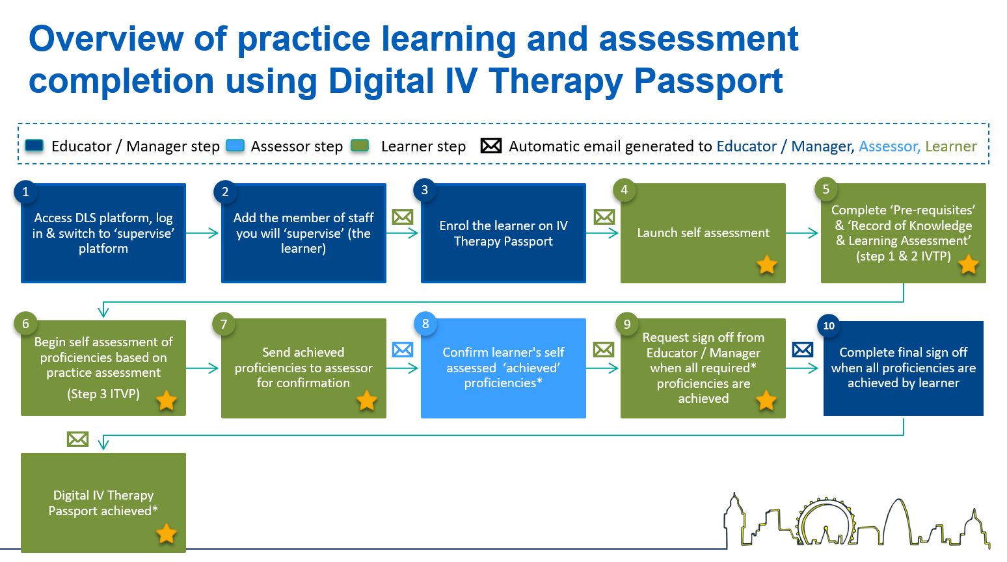
Indicates the learner steps in the process

3. Learner Platform

How do I register as a learner?
A learner may receive an email invitation from their educator / manager with a link to the registration form, complete the fields on the form and set up a password for your account.
For guidance see the learner guide, section A - Register for a DLS account

Your registration to the system is complete.

You can login at any time using your delegate number or your email address (recommended) and the password you set up at registration

Alternatively, a learner can self-register here: https://www.dls.nhs.uk/v2/Home/Welcome
For guidance see the learner guide, section A - Register for a DLS account
In some instances, (for example if you were not at work when you self-registered), you may have to wait while your registration is approved. You will receive an email when your registration is authorised.

Please note: If you have completed any digital skills courses at your organisation in the past, you may already have a DLS account.

I’ve received an Invite from Supervisor email from noreply@dls.nhs.uk what should I do?
This email is safe and you can click the links within it. Access the Click here link in the email and complete the fields to register and set up a password.

Why have I not received my activation email yet?
If you have been pre-registered to the DLS platform you should receive an email with a link to set up your password. If you don’t receive this email we’d recommend that you check your junk folder. If you were expecting to receive the email and it doesn’t arrive in the next 48 hours, contact your local administrator.

I’ve self-registered, why does my account need approval?
If you have registered for access to DLS outside of your organisation your centre administrator will need to approve your access to the system. You’ll receive an email when your access has been approved. Your centre manager will add the permissions required for your role so you can access the supervise platform.

How do I access my digital IV Therapy Passport?
You can access the system using the links in any email notifications you may receive from: Digital Learning Solutions Notifications noreply@dls.nhs.uk

Alternatively access the system here: https://www.dls.nhs.uk/v2/Home/Welcome
For guidance see the learner guide, section B - Log in Procedure
We recommend that you use your registered email address and the password you set up at registration to access the system.

What is my username?
We recommend that you use your registered email address as your username at login. If you have a DLS registration at another organisation you may be asked to choose which account you want to use at log in.

Can I change my password when I first log into the digital IV Therapy passport?
Yes. When you’ve logged into your account you can change your password from My account, if you don’t see the My account menu go to Learning Portal, Current Activities then My account.
For guidance see the learner guide, section J - Log out procedure

I’m locked out of my account, what should I do?
If you have entered an incorrect password on 5 occasions, your account will be locked.
You will still be able to reset your password if you are locked out or forget it. You can easily do this from the log in screen, select Log in, then select Forgot password, enter your email address, and select Reset.
You will receive an email with a link to a screen that enables you to reset your password. Your account will unlock.
For guidance see the learner guide, section M – Forgot password

What do I do if I’ve been set up with an incorrect email address?
If you can log in, you can update your own details in the system from My account. For guidance see the learner guide, section J - Log out procedure
If you are unable to log in, you should contact your local centre and inform them of the correct details so that this can be corrected in the system. You’ll find the contact details for your local centre here: https://www.dls.nhs.uk/v2/FindYourCentre

My email address has changed since I started using the digital IV Therapy passport. Who do I need to contact to notify this change?
Everyone can update their own registration details from the Learning Portal, My account.
For guidance see the learner guide, section J - Log out procedure

If you are unable to log in, you should contact your local centre and inform them of the correct details so that this can be corrected in the system. You’ll find the contact details for your local centre here: https://www.dls.nhs.uk/v2/FindYourCentre

Who can assess my proficiencies?
You will identify assessors who can assess you in practice and then record this in your digital IV Therapy Passport. Your organisation will advise who can be an assessor for you.

An educator / manager can also assess your proficiencies.

What is the role of the educator / manager?
This person will enrol you on the digital IV Therapy Passport at a time that is suitable for your learning, and when you have met the pre-requisites and completed elearning and eAssessments. This person also signs off your passport when it is completed

How do I invite my assessor to the digital IV Therapy Passport?
From the platform you can add assessors and educator / managers from a pre-approved list.
For guidance see the learner guide, section C – Add an assessor (supervisor).

Can I change my assessor halfway through my self-assessment?
Yes, you may have different assessors on different days. You can add additional assessors to your passport should you need to.
For guidance see the learner guide, section G – Request proficiency confirmation.

How can I find and filter my proficiencies?
The Proficiencies page has a quick Search field where you can add free text to search for a proficiency. You can also add useful filters, for example Requires self-assessment, this filter will return only the proficiencies that you have not already self-assessed:

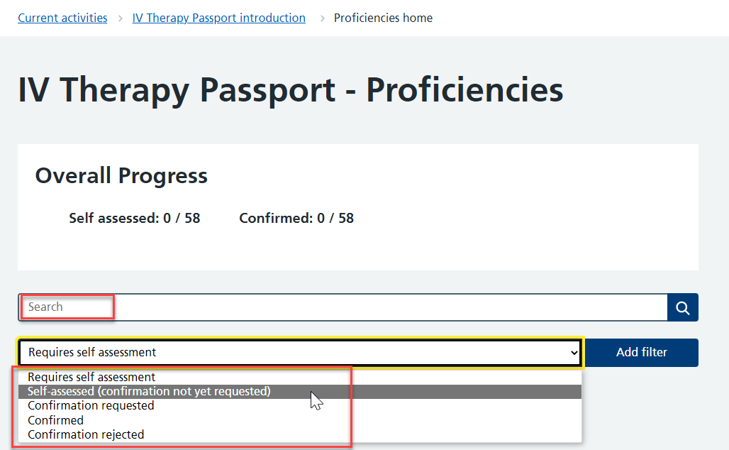

What if my assessor has gone on leave after I have submitted my request for them to confirm the self-assessment of some of my proficiencies?
You can resend these proficiencies to another assessor if they assess you again in the interim. You can Resend Proficiency confirmation requests from the system:

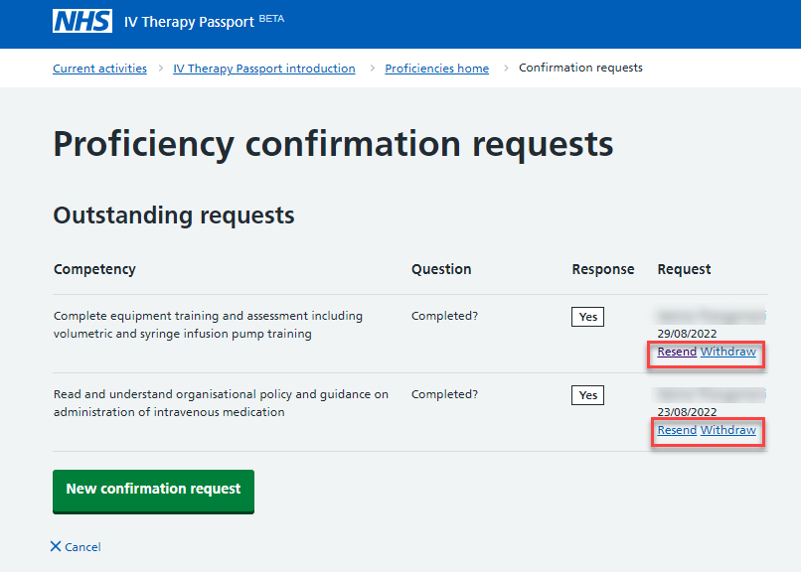

I need to withdraw the request I have made to my assessor, what do I do?
You can withdraw proficiency requests to your assessor You can Withdraw Proficiency confirmation requests from the system (see image above)

What are the pre-requisites and Record of learning and knowledge assessment?
The record of learning and knowledge assessment is the area where you confirm that you have completed the 7 IV Therapy Passport elearning sessions and passed the 7 eAssessments. You should record the date and show the evidence to your educator / manager prior to beginning supervised clinical practice. The pre-requisites are other aspects of learning required before beginning supervised clinical practice – completion of these must be recorded.

Can I amend a self-assessment before I submit it for confirmation?
Yes, you can select Review against that proficiency and alter your self-assessment.

Can I self-assess several proficiencies at one time?
No, not currently. There may however be scope to develop this functionality over time.

How do I ask my assessor to confirm the achievement of my proficiencies?
Select submit proficiencies to notify your assessor that you have self-assessed your performance after their assessment of your practice – in doing so you are requesting their confirmation of your achievement.
For guidance see the learner guide, section G – Request proficiency confirmation.

Can I notify my assessor that I have multiple proficiencies that need assessing?
Yes. Select Request proficiency confirmation, identify which assessor you would like to notify (who assessed you in practice), choose Select all proficiencies for each group. Select Next and then Submit.
For guidance see the learner guide, section G – Request proficiency confirmation.

What do I do if my assessor disagrees with / rejects my first self-assessment?
Review the action plan they have written for you so you can read the feedback and understand how to develop your performance. Use the optional assessments to practice under supervision until you think you are reaching the required performance. Submit your self-assessment for review. The assessor will be able to go back into the first assessment to amend it at a later date.
For guidance see the learner guide, section H - Action plan.

What if my assessor disagrees with / rejects my final assessment?
You will receive an email notification with an action plan. This can be reviewed again once your practice has developed and meets the proficiency.
For guidance see the learner guide, section H - Action plan.

How do I transfer my digital IV Therapy Passport to my new Trust?
Currently if you wish to keep a personal record of your digital IV Therapy Passport or you are moving to another organisation, you can export your signed off passport to Excel. Future development to the system will enable you to complete this transfer of records digitally to another centre (i.e. Trust).
For guidance see the learner guide, section K Download Self-assessment

Can I alter my self-assessment after my assessor has confirmed my self-assessment?
You can alter your self-assessment, but you will need to resubmit it for confirmation again. A record of the primary self-assessment and confirmation will be stored on the system. You can use one of the optional opportunities for assessment but if you have had a first or final proficiency rejected you will need to review this when you are ready as each proficiency must be achieved at the first and final assessments.

Can my assessor alter the confirmation status should my performance improve?
Yes, the assessor can view rejected proficiencies again and update the assessment. The action plan will always be visible.

Can I request confirmation of self-assessment for a final proficiency before I have achieved in the first assessment?
Yes, the system does not control the order that the assessments are done in but you should aim to complete the first assessment, first.

How will I know if I have an action plan?
You will receive an email from your assessor to let you know they have rejected the proficiency you had self-assessed as achieved, your assessor will provide an action plan. The specific proficiency will have the status Rejected in red with an action plan link beneath it. Select the link to reveal the Action plan to follow.
For guidance see the learner guide, section H - Action plan.

My assessor keeps getting lots of emails from me to notify them of self-assessments I have completed – can I prevent this?
You can, instead of requesting confirmation separately for each proficiency, confirm a group and request confirmation, for all, at the same time. This will mean the assessor gets one notification and not several.
For guidance see the learner guide, section G - Request proficiency confirmation

How do I request sign off of my digital IV Therapy Passport?
When you have self-assessed all proficiencies at the first and final assessment, including the required optional proficiencies, and they have all been confirmed by your assessor, you can Request educator / manager sign off. You’ll find the request sign-off section at the bottom of the proficiencies page – this becomes available once the minimum proficiencies has been achieved in the passport.
For guidance see the learner guide, Section I - Request Educator/Manager sign off

My assessor is not responding, I think they are away on leave

Why won’t my digital IV Therapy Passport progress to sign off?
All proficiencies must be self-assessed and verified by your assessor in the first and final assessments, including at least one of each of the optional proficiencies, for the sign off function to reveal. Go back and review that the status is verified for all and check the summary.

Who can sign off my digital IV Therapy Passport?
The educator / manager role on the DLS has the permission to sign off the digital IV Therapy Passport. It is up to your organisation who they assign to this role but it is usually the person who will facilitate your pathway through the digital IV Therapy Passport.

How will I know if I have requested sign off successfully?
You will get an email notification when your request for sign off has been sent to your educator / manager and again when it has been reviewed.

How do I log out?
Select My account from the Current Activities page, scroll down to the bottom of the page, then select Log out.
For guidance see the learner guide, section J - Log out procedure

What does the colour key mean?
The colour key indicates the status of the proficiency:

Self-assessed (un-confirmed)
Confirmed
Rejected (with action plan)
Awaiting confirmation

Can I download a copy of my self-assessment ?
Currently if you wish to keep a personal record of your digital IV Therapy Passport or you are moving to another organisation, you can export your signed off passport to Excel. Future development to the system will enable you to complete this transfer of records digitally.
For guidance see the learner guide, section K – Download self-assessment.

4. Support

Learner can be found here:
https://www.dls.nhs.uk/cms/cmscontent/ivtherapy/help/index.html

DLS Guidance documents and videos resource locator:

If you have been unable to resolve your question after reading the guidance and checking the FAQs below you should contact:

Learners: Your Educator / Manager or Assessor

Contact details for your local DLS centre should be made available here: https://www.dls.nhs.uk/v2/FindYourCentre

