Digital IV Therapy Passport - Frequently Asked Questions for Supervisors (Educator / Manager, Assessor)

Contents
1. Guidance and support 4
2. Roles in IV Therapy passport 5
What user roles are there in the digital IV Therapy passport? 5
What is a learner expected to do in the digital IV Therapy passport? 5
What is a supervisor expected to do in the digital IV Therapy passport? 6
What is an assessor expected to do in the digital IV Therapy passport? 6
3. Supervisor Platform (for educator / managers and assessors) 7
How do I register as an educator manager or assessor (supervisor)? 7
Why have I not received my activation email yet? 7
I’ve self-registered, why does my account need approval? 7
How do I access the Supervisor platform 7
What is my username? 7
Can I change my password when I first log into the digital IV Therapy Passport? 8
When registering, I mistyped my PRN, what should I do? 8
Can I be an assessor and an educator / manager for the same person? 8
What do I do if I’ve been set up with an incorrect email address or it has changed since I started using the IV Therapy Passport? 8
I’m locked out of my account, what should I do? 8
How do I access my learner’s digital IV Therapy Passport to review their proficiencies? 9
How do I confirm proficiencies? 9
Why is it taking me so long to confirm proficiencies? 9
How do I confirm a number of proficiencies at the same time? 9
How do I check the guidance notes for the proficiencies? 9
What if I disagree with the learner’s self-assessment? 9
Can I reject a self-assessment and create an action plan when I am confirming multiple proficiencies? 10
How do I check for any action plans? 10
How do I log out? 10
How will I know when my learner is ready for sign off? 10
How do I sign off a learner’s passport? 10
Does the platform make sure a learner has achieved at least one of each of the optional proficiencies (methods of preparation, methods of administration and vascular access devices)? 10
What must I check at sign off? 11
What do I check when a new staff member joins the Trust and my department? 11
Who can see the Professional Registration Number (PRN)? 11
Sometimes referred to as a PIN 11
Can I nominate a member of staff as an assessor? 11
Can I remove an enrolment? 11
4. Support 12

1. Guidance and support

The Educator / Manager, Learner and Assessor guides can be found here:
https://www.dls.nhs.uk/cms/cmscontent/ivtherapy/help/index.html

DLS Guidance documents and videos resource locator:

If you have been unable to resolve your question after reading the guidance and checking the FAQs below you should contact:

Learners: Your Educator / Manager or Assessor
Educator / Managers and Assessors: Your Clinical Centre Manager or Administrator
Clinical Centre Managers and Assessors: Raise a DLS support ticket, for any issues relating to the platform

Contact details for your local DLS centre should be made available here: https://www.dls.nhs.uk/v2/FindYourCentre

If you’ve been unable to resolve the issue locally or there is a technical issue with the platform, the clinical centre manager or administrator at your organisation, should raise a Tracking System support ticket to receive help from the central team at HEE.

2. Roles in IV Therapy passport

What user roles are there in the digital IV Therapy passport?

- Learner : any nursing or midwifery staff member, and in the future undergraduate student nurse, who is following the pathway to the IV Therapy Passport.
- Supervisor: an umbrella term in the DLS for any person acting as either an assessor or an educator /manager for the digital IV Therapy Passport, who would be interacting with the supervise dashboard to contribute to learner assessments.
- Educator / Manager: a person who is responsible supervising the pathway through the IV Therapy Passport – this will include enrolling a learner to begin the digital passport and signing it off at the end. Educator /Managers can also assess learners.
- Assessor: a person who supervises and assesses the performance of a learner in practice and records this in the digital IV Therapy Passport.

What is a learner expected to do in the digital IV Therapy passport?

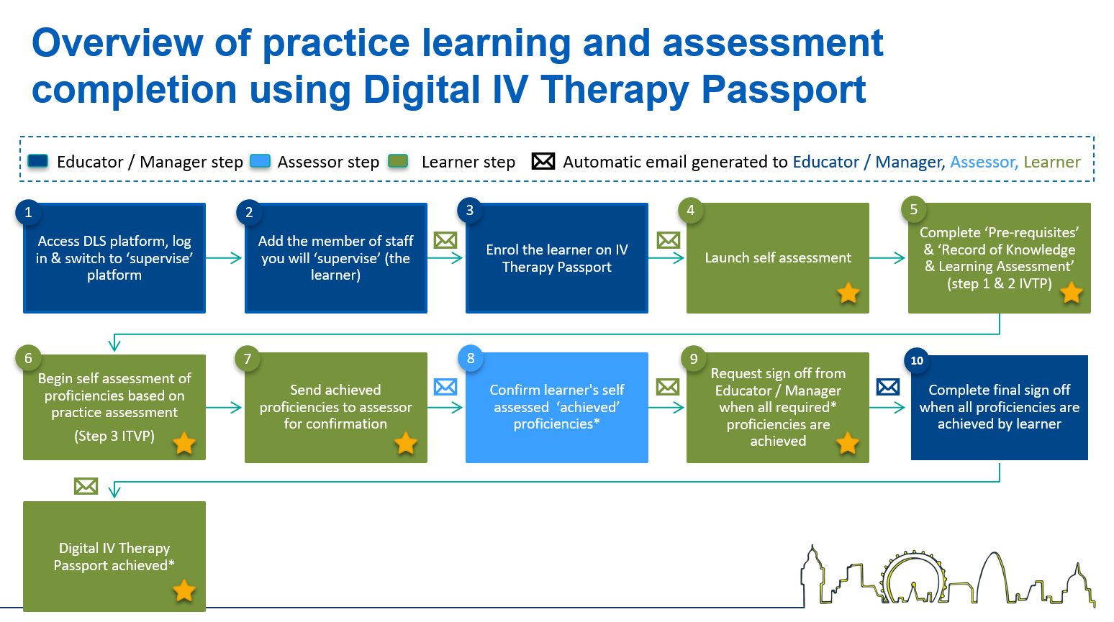
Indicates the learner steps in the process

What is a supervisor expected to do in the digital IV Therapy passport?
The Digital Learning Solutions (DLS) platform uses the umbrella term supervisor to refer to anyone acting as an assessor or an educator / manager.

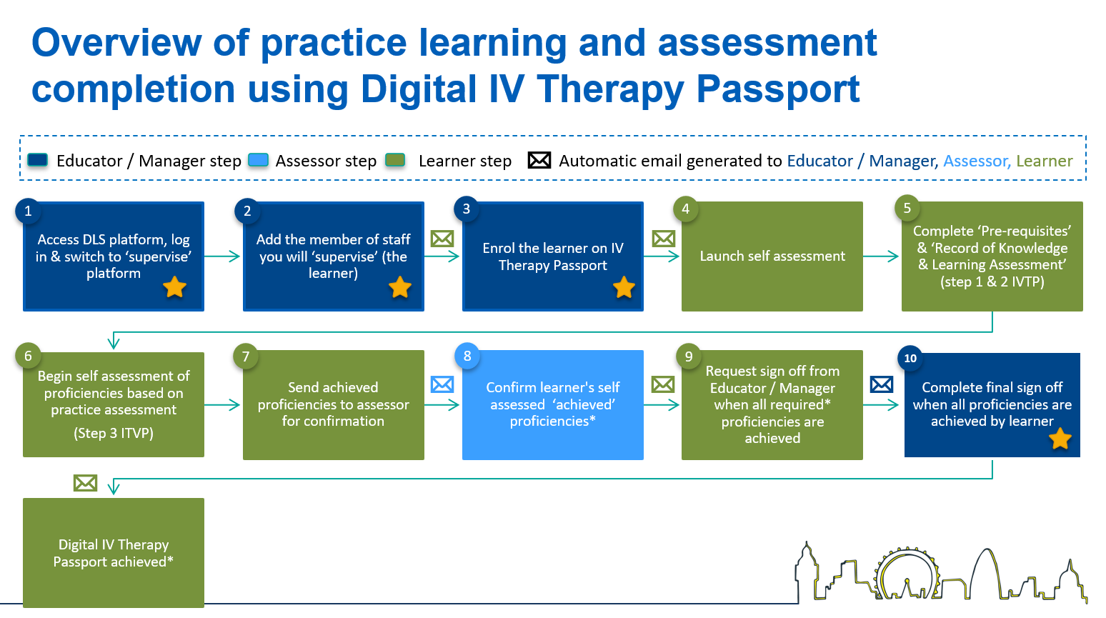
What is an educator / manager expected to do in the digital IV Therapy passport?
Indicates the educator / manager steps in the process

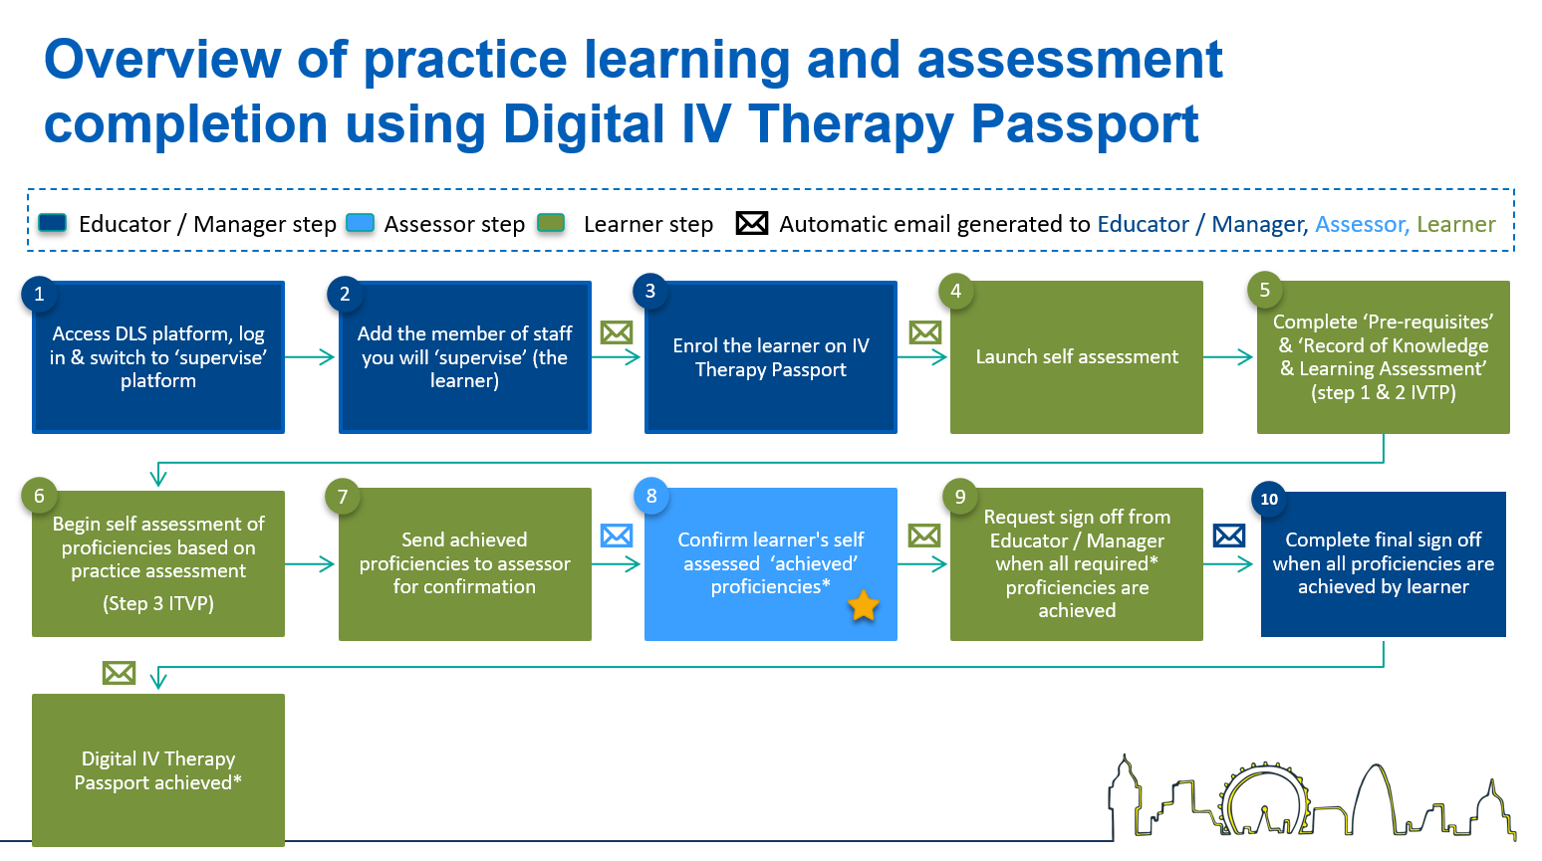
What is an assessor expected to do in the digital IV Therapy passport?

Indicates the assessor steps in the process

3. Supervisor Platform (for educator / managers and assessors)

How do I register as an educator manager or assessor (supervisor)?
It is possible for educator / managers and assessors to be registered by the clinical centre manager or administrator at your local centre. If you are advised to self-register, then you should follow the delegate (learner) self-registration process. Once registered you should inform your local clinical centre manager, who will promote and add permissions to your account so you can access the supervise platform.

Self-register here: https://www.dls.nhs.uk/v2/Home/Welcome
For guidance see the learner guide, section A - Register for a DLS account
In some instances, (for example if you were not at work when you self-registered), you may have to wait while your registration is approved. You will receive an email when your registration is authorised.

Please note: If you have completed any digital skills courses at your organisation in the past, you may already have a DLS account.

Why have I not received my activation email yet?
If you have been registered by someone else to the DLS platform you should receive an email with a link to set up your password. If you don’t receive this email, we’d recommend that you check your junk folder. If you were expecting to receive the email and it doesn’t arrive in the next 48 hours contact your clinical centre manager or administrator.

I’ve self-registered, why does my account need approval?
If you have registered for access to DLS outside of your organisation the centre administrator will need to approve your access to the system. You’ll receive an email when your access has been approved.

How do I access the Supervisor platform
You can access the system using the links in any email notifications you may receive from: Digital Learning Solutions Notifications noreply@dls.nhs.uk

Alternatively access the system here: https://www.dls.nhs.uk/v2/Home/Welcome
For guidance see the educator / manager or assessor guide, section A - Log in Procedure
We recommend that you use your registered email address and the password you set up at registration to access the system.

What is my username?
We recommend that you use your registered email address as your username at login. If you have a DLS registration at another organisation you may be asked to choose which account you want to use at log in.

Can I change my password when I first log into the digital IV Therapy Passport?
Yes. When you’ve logged into your account you can change your password from My account, if you don’t see the My account menu go to Learning Portal, Current Activities then My account.
For guidance see the educator manager guide, section E - Log out procedure or the assessor guide, section D - Log out procedure

When registering, I mistyped my PRN, what should I do?
You can update all your registration details, including the PRN, once you have logged in from My account
For guidance see the educator manager guide, section E - Log out procedure or the assessor guide, section D - Log out procedure

Can I be an assessor and an educator / manager for the same person?
You cannot have both roles on the platform so if you need the permissions of the educator / manager but also need to assess proficiencies then you should sit in the role of educator / manager as you can do both in this role.

What do I do if I’ve been set up with an incorrect email address or it has changed since I started using the IV Therapy Passport?
If you can log in, you can update your own details in the system from My account. For guidance see the educator manager guide, section E - Log out procedure or the assessor guide, section D – Log out procedure
If you are unable to log in, you should contact your local clinical centre manager and inform them of the correct details so that this can be corrected in the system. You’ll find the contact details for your local centre here: https://www.dls.nhs.uk/v2/FindYourCentre

I’m locked out of my account, what should I do?
If you have entered an incorrect password on 5 occasions, your account will be locked.
You will still be able to reset your password if you are locked out or forget it. You can easily do this from the log in screen, select Log in, then select Forgot password, enter your email address, and select Reset.
You will receive an email with a link to a screen that enables you to reset your password. Your account will unlock.
For guidance see the educator manager guide, section K – Forgot password or the assessor guide, section G – Forgot password

How do I access my learner’s digital IV Therapy Passport to review their proficiencies?
You will receive a notification email advising you there are proficiencies waiting for review – either use the link in the email or log in to the DLS site, choose supervise platform and the specific learner from your staff list.
For guidance see the educator manager guide, section F - Self-assessment results review and confirm and the assessor guide, section C - Self-assessment results review and confirm

How do I confirm proficiencies?
From the supervise platform, you can either open individual proficiencies (where you can review the specific guidance notes for assessment) or you can select Confirm multiple results at the top of the page. The confirm multiple option means you can select a number of proficiencies to confirm at the same time.
For guidance see the educator manager guide, section F - Self-assessment results review and confirm and the assessor guide, section C - Self-assessment results review and confirm

Why is it taking me so long to confirm proficiencies?
You may be confirming proficiencies individually – this can take a while but it is necessary if you need to reject the confirmation and write an action plan for any proficiency. If you are happy to confirm all self-assessments, then you can select Confirm multiple results at the top of the page. The confirm multiple option means you can select a number of proficiencies at the same time. You then need to select groups of proficiencies.
For guidance see the educator manager guide. section F - Self-assessment results review and confirm and the assessor guide, section C - Self-assessment results review and confirm

How do I confirm a number of proficiencies at the same time?
Select Confirm multiple results at the top of the page. The confirm multiple option means you can select a number of proficiencies at the same time. You then need to select groups of proficiencies.
For guidance see the educator manager guide, section F - Self-assessment results review and confirm and the assessor guide, section C - Self-assessment results review and confirm

How do I check the guidance notes for the proficiencies?
These are visible when you select view or review for each proficiency

What if I disagree with the learner’s self-assessment?
You can Reject their self-assessment response. If you do this you will be required to add an action plan in the box provided so the learner receives feedback and a plan to improve performance. After doing so, select update.
For guidance see the educator manager guide, section F - Self-assessment results review and confirm and the assessor guide, section C - Self-assessment results review and confirm

Can I reject a self-assessment and create an action plan when I am confirming multiple proficiencies?
No, you would need to open the individual proficiency(s) that you disagree with and create the action plan associated with that proficiency.

How do I check for any action plans?
If a learner has an action plan, this will be indicated by View (action plan) under the confirmation status.
For guidance see the educator manager guide, section G - Review and update self-assessment results with an Action plan and the assessor guide – section E - Review and update self-assessment results with an Action plan
Can I alter the status of a proficiency if I rejected it initially?
Yes, if the learner is now proficient in the proficiency – you can select View (action plan) adjacent to the proficiency, select Update and alter the status. Ideally adding a note in the action plan regarding the improvement in performance. Then Submit. If a learner did not achieve the proficiency in the first or final assessment, but subsequently improved their performance, the proficiency would need updating to reflect it is achieved. This is because all learners must achieve for the first and final assessment to progress to sign off. For guidance see the educator manager guide, section G - Review and update self-assessment results with an Action plan and the assessor guide, section E - Review and update self-assessment results with an Action plan

How do I log out?
Select My account from the Current Activities page, scroll down to the bottom of the page, then select Log out.
For guidance see the educator manager guide, section E – Log out procedure and the assessor guide – section D - Log out procedure

How will I know when my learner is ready for sign off?
They will submit a request to their educator / manager requesting sign off, the educator / manager will receive an email notification.
For guidance see the educator manager guide, section D - Self-assessment final sign-off

How do I sign off a learner’s passport?
The educator / manager will receive a notification via email when a learner requests sign-off. You can click the link in the notification or you can log in to the supervise platform on DLS and open the learner’s passport. You can view the sign off at the end of the proficiencies.
For guidance see the educator manager guide, section D - Self-assessment final sign-off

Does the platform make sure a learner has achieved at least one of each of the optional proficiencies (methods of preparation, methods of administration and vascular access devices)?
No – this is something that needs to be checked by the educator / manager at sign off. This functionality will be added as part of future development.

What must I check at sign off?
You must check those who have acted as assessors for the learner as part of the sign off process. You should also check they have selected, and achieved, at least one of each of the optional proficiencies (methods of preparation, methods of administration and vascular access devices) and all the necessary optional proficiencies for their role.

If this isn’t the case, you can reject the sign off and send a note to the learner about what they need to do for you to sign it off.

What do I check when a new staff member joins the Trust and my department?
Future development to the system will allow a staff member to transfer their digital IV Therapy Passport to your organisation so it becomes visible. Currently, staff will be able to print off, or save a copy of their signed-off passport in Excel to demonstrate they have completed their passport.

On paper, or in future on the digital passport, you should check step 1 and 2 achievement is recorded and which of the optional proficiencies they previously achieved to reach sign off. Depending of the scope of their practice in their new role, you should discuss with them any additional optional proficiencies they may need to complete. For guidance see the learner guide, section K – Download self-assessment.

Who can see the Professional Registration Number (PRN)?

Sometimes referred to as a PIN
The PRN number of staff is visible to clinical centre managers, administrators and educator / managers. Assessors cannot see this information about a learner.

Can I nominate a member of staff as an assessor?
Yes, you can nominate a supervisor and confirm their competence to assess the capability of others. For guidance see the educator manager guide, section J – Nominate a member of staff as an assessor.

Can I remove an enrolment?
If the learner has not started their digital IV passport, the educator manager can Remove the enrolment from the learner record. Supervise, View my staff list, View self assessment on the learner record, select Remove.

4. Support

The Educator / Manager, Learner and Assessor guides can be found here:
https://www.dls.nhs.uk/cms/cmscontent/ivtherapy/help/index.html

DLS Guidance documents and videos resource locator:

If you have been unable to resolve your question after reading the guidance and checking the FAQs below you should contact:

Learners: Your Educator / Manager or Assessor
Educator / Managers and Assessors: Your Clinical Centre Manager or Administrator
Clinical Centre Managers and Assessors: Raise a DLS support ticket, for any issues relating to the platform

Contact details for your local DLS centre should be made available here: https://www.dls.nhs.uk/v2/FindYourCentre

If you’ve been unable to resolve the issue locally or there is a technical issue with the platform, the clinical centre manager or administrator at your organisation, should raise a Tracking System support ticket to receive help from the central team at HEE.

