Digital IV Therapy Passport - Frequently Asked Questions
for Clinical Centre Managers and Administrators

Contents
1. Guidance and support resources 4
2. Joining DLS 6
New DLS centre 6
Existing DLS centre – Centre Manager and Administrator registration. 6
3. Browsers and compatibility 8
What browsers does the digital IV Therapy passport work in? 8
What will I need to complete the digital IV Therapy passport? 8
4. Setting up your centre 9
Where can I find help to set up my centre? 9
What do I need to do? 9
5. Roles in IV Therapy passport 11
What user roles are there in the digital IV Therapy passport? 11
What is a learner expected to do in the digital IV Therapy passport? 11
What is a supervisor expected to do in the digital IV Therapy passport? 12
6. Clinical Centre Managers 13
I am a clinical centre manager, how do I promote delegates to educator / managers or assessors? 13
How can we add additional centre managers? 13
Who can add user permissions? 13
Who can revoke/remove user permissions? 13
I’ve completed a bulk upload and I’m ready to promote the new delegates to educator managers and assessors, how can I find the registrations in the Tracking System, Delegate list? 14
I’m locked out of my account, what should I do? 14
How do I amend a user's permissions? 14
How do we raise a support ticket? 14
7. Administrators and Clinical Centre Managers 15
What is my username? 15
I’ve received an email notification asking me to approve a delegate (learner) registration, what do I do? 15
Can delegates be registered in bulk? 15
How do delegates know they have been registered? 15
Can the welcome email be resent? 15
How long after creation will an inactive (never logged into) digital IV Therapy passport account be deleted? 16
I’m locked out of my account, what should I do? 16
A delegates registration details have changed how can I update them? 16
Who can see the Professional Registration Number (PRN)? 16
Sometimes referred to as a PIN 16
How do we raise a support ticket? 16
8. Additional information 17
Is there a link between digital IV Therapy passport and HEE elfh? 17
Which HEE elfh courses can be viewed in digital IV Therapy Passport? 17
What about reporting? 17
9. Support 18

1. Guidance and support resources

Support resources are available for Clinical Centre Managers and Administrators. Follow the link below to access trainer resources:

https://www.dls.nhs.uk/v2/TrackingSystem/Resources

Note: To access the trainer resources, you need to log in the DLS platform first.

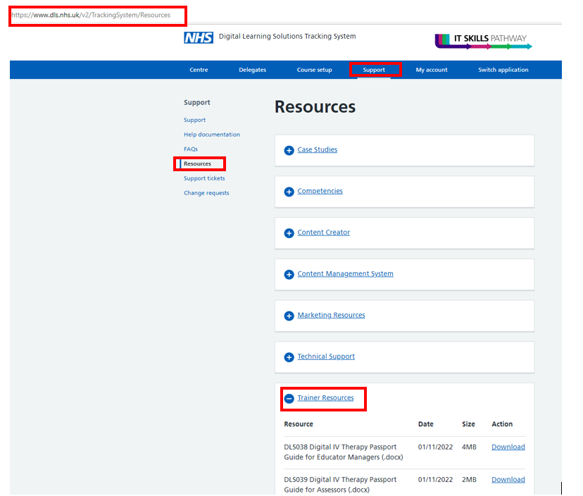

DLS Guidance documents and videos resource locator:

If you have been unable to resolve your question after reading the guidance and checking the FAQs below you should contact your local DLS centre.

Contact details for your local DLS centre can be here: https://www.dls.nhs.uk/v2/FindYourCentre

If you’ve been unable to resolve the issue locally or there is a technical issue with the platform, the clinical centre manager or administrator at your organisation, should raise a Tracking System support ticket to receive help from the central team at HEE.

Guidance: https://www.dls.nhs.uk/tracking/download?content=DLS022
Video: https://www.dls.nhs.uk/tracking/download?content=DLS022V

2. Joining DLS

New DLS centre

Check if your organization appears in the DLS centre list: https://www.dls.nhs.uk/v2/FindYourCentre

If your organisation is not listed, please email support@dls.nhs.uk with the following information:

- Name of centre: Usually your organisation name
- Name of clinical centre manager:
- Email contact:
- Telephone contact:
- Postcode of centre:
- IP Prefix: (e.g. 123.123.123.111 This ensures that delegates registering from within the organisational network don't require administrators approval).

Once the above information is received, DLS support will create your centre and contact the clinical centre manager with access information.

Please refer to the “existing DLS centre section” below for further guidance.

Check with your IT department that your organisation meets the technical specification.

Existing DLS centre – Centre Manager and Administrator registration.

Once the centre set up has been confirmed, any further clinical centre managers or administrators should first self-register as delegates for a DLS account. Then, the clinical centre manager will promote them to clinical centre managers or administrators (as appropriate).

- Self-register as a delegate:
Guide: https://www.dls.nhs.uk/tracking/download?content=DLS001
Video: https://www.dls.nhs.uk/tracking/download?content=DLS001V

- Contact your organisations DLS centre manager. Contact details can be found here: https://www.dls.nhs.uk/v2/FindYourCentre

- Obtain clinical centre manager or administrator permissions (as appropriate).
Guide: https://www.dls.nhs.uk/tracking/download?content=DLS010
Video: https://www.dls.nhs.uk/tracking/download?content=DLS010V

Consult with the centre manager about the additional use of the platform for clinical proficiency self-assessments for nursing teams and centre set up. Some aspects of centre set up will need to be amended and updated to include contact details for IV Passports.

Follow the guidance for setting up your centre

3. Browsers and compatibility

What browsers does the digital IV Therapy passport work in?
Most modern browsers such as Chrome, Edge, Firefox, or other modern browser.

What will I need to complete the digital IV Therapy passport?
- Access to a Desktop PC, Laptop, Tablet, Mobile
- Internet connection
- A browser such as Chrome or Edge
- Windows XP SP2 or newer Operating System

Your organisation will have in place:
- Cookies Enabled
- https://www.dls.nhs.uk added to Trusted Sites
- noreply@dls.nhs.uk added to whitelist

4. Setting up your centre

Where can I find help to set up my centre?

Once you are registered as a clinical centre manager or administrator you have access to support resources and videos in the Tracking System: Go to https://www.dls.nhs.uk/v2/TrackingSystem/Resources Trainer Resources.

DLS Guidance documents and videos resource locator:

Note: To access the trainer resources, you need to log in to the DLS platform first.

What do I need to do?

- Set up notification preferences

Subscribe to email notifications to alert you when something happens on the system.

Guide: https://www.dls.nhs.uk/tracking/download?content=DLS024
Video: https://www.dls.nhs.uk/tracking/download?content=DLS024V

We recommend that you request email notifications for:
- System notification added (used to issue important system information from the central team)
- Delegate registration requires approval (triggered when a delegate has registered outside your organisation and requires approval. Unless you are using a shared mailbox see below, Notify email address)
- Support ticket alerts (when the central team responds to your support ticket)

- Centre configuration

Before you start to use the Digital IV Therapy Passport you’ll need to set up your centre contacts and notifications, we’ve provided a list of the essentials below.

Guide: https://www.dls.nhs.uk/tracking/download?content=DLS012
Video: https://www.dls.nhs.uk/tracking/download?content=DLS012V

- Notify email address – page 4 (optional) You may choose to set up individual notification preferences, see above, (Delegate registration requires approval), if you don’t use a shared mailbox)
Sends email to a shared Inbox when a delegate registration requires approval
- Centre support details – page 5 (essential)
Displays local contact details for learners in their Learning Portal
- Centre content on DLS website – page 10 (essential)
Displays local contact details for learners on the DLS website
- Manage registration prompts – page 12 (recommended)
Add additional registration questions for learners, this is useful for reporting and filtering in the Tracking System
Video: https://www.dls.nhs.uk/tracking/download?content=DLS041V

- Bulk upload delegate registrations for your educator / managers and assesses

To prepare your DLS centre for the Digital IV Therapy passport the clinical centre manager or administrator can bulk upload the registrations for their educator / managers and assessors.

Guide: https://www.dls.nhs.uk/tracking/download?content=DLS009
Video: https://www.dls.nhs.uk/tracking/download?content=DLS009V

Example bulk upload template Spreadsheet:

You can use this spreadsheet to collect registration information about your supervisors or delegates that you want to bulk upload. However, when you are ready to bulk upload, you should always Download delegates (see guide and video) to get the most current spreadsheet, then copy the cells from the template that you need into the most current download spreadsheet.

- Promote delegate registrations to educator / manager or assessor as appropriate (centre manager functionality only)

Once the delegate registrations are available on the system the clinical centre manager will promote the educator / managers and assessors access to DLS, so that they can then supervise the learners.

Guide: https://www.dls.nhs.uk/tracking/download?content=DLS010
Video: https://www.dls.nhs.uk/tracking/download?content=DLS010V

Please note educator managers can also nominate a supervisor and confirm their competence to assess the capability of others.

5. Roles in IV Therapy passport

What user roles are there in the digital IV Therapy passport?

- Learner: any nursing or midwifery staff member, and in the future undergraduate student nurse, who is following the pathway to the IV Therapy Passport.
- Supervisor: an umbrella term in the DLS for any person acting as either an assessor or an educator /manager for the digital IV Therapy Passport, who would be interacting with the supervise dashboard to contribute to learner assessments.
- Educator / Manager: a person who is responsible supervising the pathway through the IV Therapy Passport – this will include enrolling a learner to begin the digital passport and signing it off at the end. Educator /Managers can also assess learners.
- Assessor: a person who supervises and assesses the performance of a learner in practice and records this in the digital IV Therapy Passport.

What is a learner expected to do in the digital IV Therapy passport?

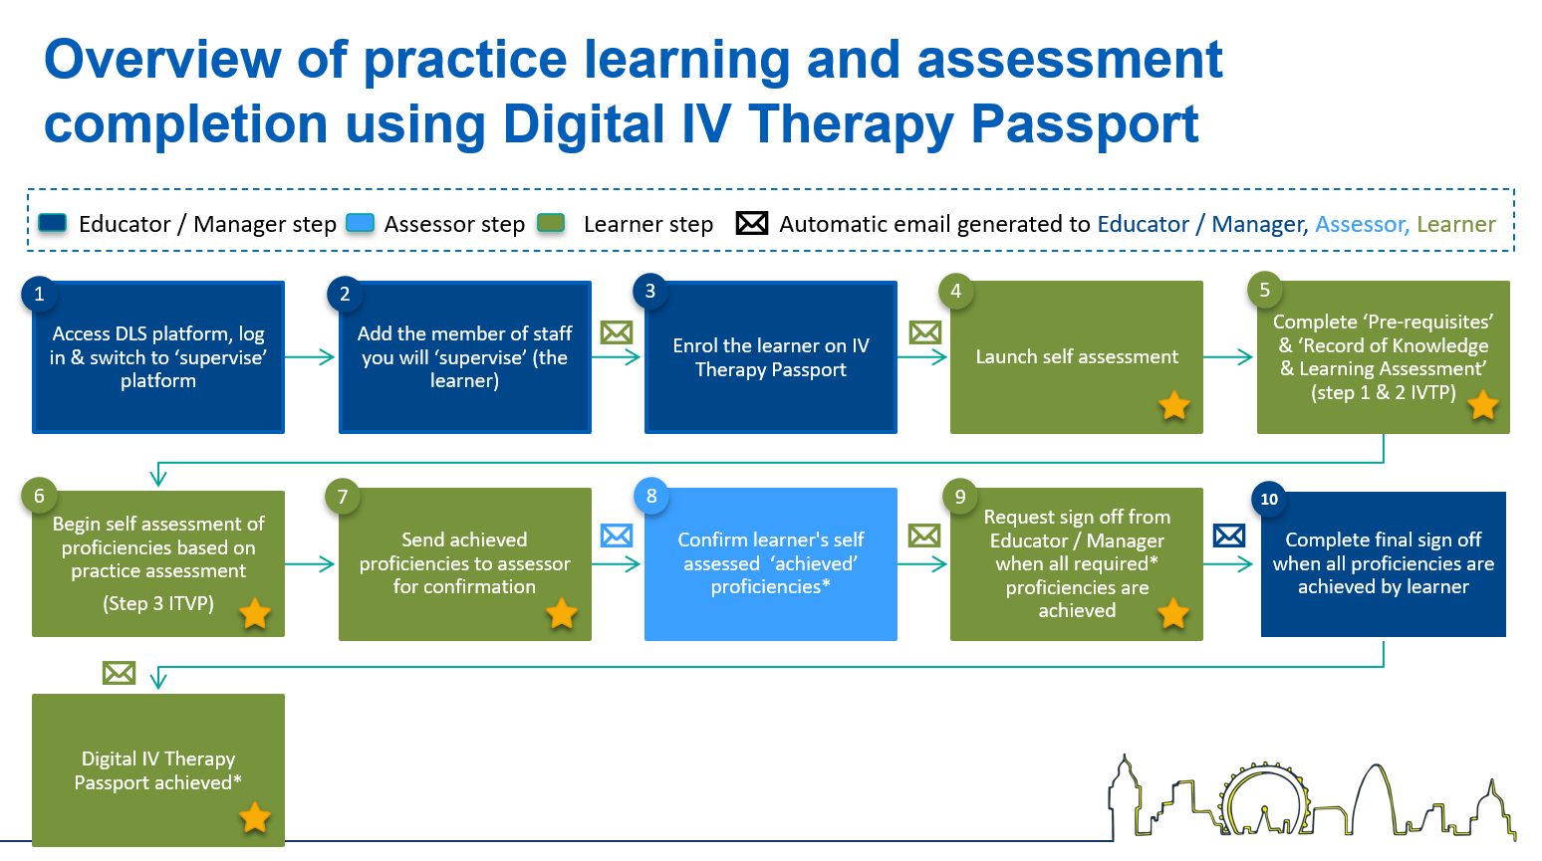
Indicates the learner steps in the process

What is a supervisor expected to do in the digital IV Therapy passport?
The Digital Learning Solutions (DLS) platform uses the umbrella term supervisor to refer to anyone acting as an assessor or an educator / manager.

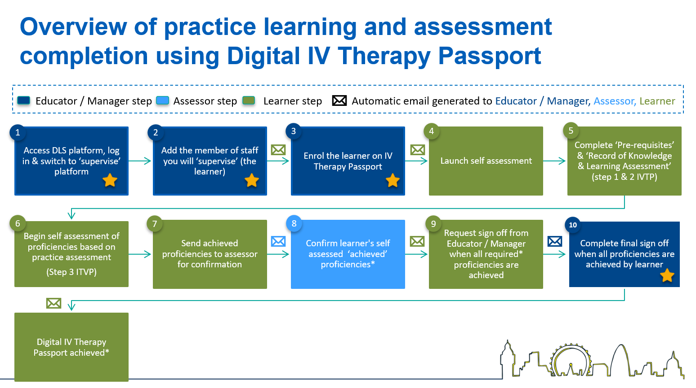
What is an educator / manager expected to do in the digital IV Therapy passport?
Indicates the educator / manager steps in the process

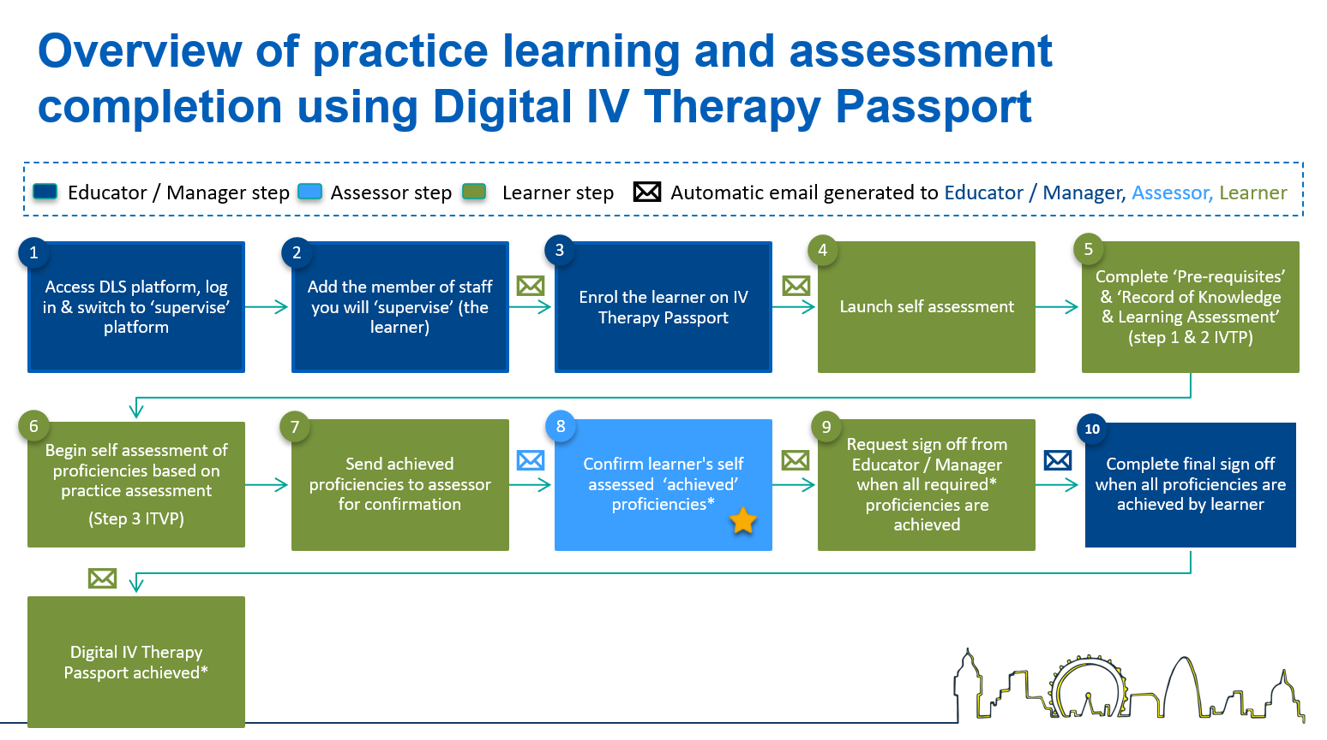
What is an assessor expected to do in the digital IV Therapy passport?
Indicates the assessor steps in the process

6. Clinical Centre Managers

I am a clinical centre manager, how do I promote delegates to educator / managers or assessors?
Only centre managers (and clinical centre managers) can promote delegates and add permissions for access to DLS as administrators or educator / managers. Clinical centre managers and educator managers can promote / nominate assessors.

You can only promote an approved delegate once they have set up a password.

You promote from the Delegate menu, search for the registered delegate, expand the delegate card, Manage delegate, Promote to admin. Select the role/s this delegate will have, then Save.

Please note the roles:
Supervisor = educator / manager
Nominated Supervisor = assessor
Guide: https://www.dls.nhs.uk/tracking/download?content=DLS010
Video: https://www.dls.nhs.uk/tracking/download?content=DLS010V

How can we add additional centre managers?
New clinical centre managers should self-register if they are not currently a delegate.
Guide: https://www.dls.nhs.uk/tracking/download?content=DLS001
Video: https://www.dls.nhs.uk/tracking/download?content=DLS001V

The clinical centre manager should promote the delegate registration to centre manager.
Guide: https://www.dls.nhs.uk/tracking/download?content=DLS010
Video: https://www.dls.nhs.uk/tracking/download?content=DLS010V

Who can add user permissions?
Only a centre manager (and clinical centre managers) can add permissions for new centre managers (clinical centre managers), administrators, educator / managers and assessors.
Guide: https://www.dls.nhs.uk/tracking/download?content=DLS010
Video: https://www.dls.nhs.uk/tracking/download?content=DLS010V

Who can revoke/remove user permissions?
Only a centre manager (and clinical centre managers) can remove permissions for centre managers (clinical centre managers), administrators, educator / managers and assessors. Please note the delegate (learner) account will still be available.
Guide: https://www.dls.nhs.uk/tracking/download?content=DLS011

The centre manager (and clinical centre managers) and administrators can also deactivate learner accounts.
Guide: https://www.dls.nhs.uk/tracking/download?content=DLS020

I’ve completed a bulk upload and I’m ready to promote the new delegates to educator managers and assessors, how can I find the registrations in the Tracking System, Delegate list?
The system has built in Search, Sort and Filter by options to assist you with this task.
- You can Search for an individual delegate by typing, for example, a last name into the Search field.
- You can Sort by Registration Date, Descending, when you select Sort a list starting with the most recent registrations will display in your list.
- Using Filter by is probably the most useful.
  - As a delegate will need to have a password set before you can promote them into a role, Select password status: Password set then Add filter.
  - You will only be looking for delegates that are not already admins, Select admin status: Not admin and Add filter.
  - In addition to this you can Select job group: Nursing / Midwifery and Add filter
This will display a list of delegates based on your filter criteria.

Important note: As the DLS platform is also used for digital skills training, use caution when promoting as there may be other registrations on the system. Be vigilant that you are only promoting the appropriate bulk uploaded delegates into roles. You can use your bulk upload spreadsheet to cross reference and check the details.

I’m locked out of my account, what should I do?
If you have entered an incorrect password on 5 occasions, your account will be locked.
You will still be able to reset your password if you are locked out or forget it. You can easily do this from the log in screen, select Log in, then select Forgot password, enter your email address, and select Reset.
You will receive an email with a link to a screen that enables you to reset your password. Your account will unlock.
Guide: https://www.dls.nhs.uk/tracking/download?content=DLS003

How do I amend a user's permissions?
You can amend or add additional roles from the Tracking System, Centre, Administrators.
Guide: https://www.dls.nhs.uk/tracking/download?content=DLS013

How do we raise a support ticket?
From the Tracking System, Support, Support tickets
Guide: https://www.dls.nhs.uk/tracking/download?content=DLS030

7. Administrators and Clinical Centre Managers

What is my username?
We recommend that you always use your registered email address as your username at login. This gives you access to all the required functionality on the DLS platform for you to carry out your role. If you have a DLS registration at another organisation you may be asked to choose which account you want to use at log in.

I’ve received an email notification asking me to approve a delegate (learner) registration, what do I do?
Clinical centre managers and administrators will receive an email notification (if notifications have been requested see: Set up notification preferences) when a delegate registers from outside of the organisation, for example from home. The registration can be approved from the Tracking System, Delegates, Approve registrations.
Guide: https://www.dls.nhs.uk/tracking/download?content=DLS008

Can delegates be registered in bulk?
Yes, clinical centre managers and administrators can register delegates and the educator / managers and assessors at their organisation using the bulk upload functionality in the Tracking System.
Guide: https://www.dls.nhs.uk/tracking/download?content=DLS009
Video: https://www.dls.nhs.uk/tracking/download?content=DLS009V

How do delegates know they have been registered?
When you register or bulk upload registrations, there is the option to send a welcome email to the delegate (recommended). Your delegates will receive a system generated email with the subject Verify your registration, inviting them to complete the registration and set a password. Please note the link is only valid for 1 month. Example email below:

Dear Test Delegate,
An administrator has registered your details to give you access to the Digital Learning Solutions (DLS) platform under the centre ##HEE Demo Centre##.
You have been assigned the unique DLS delegate number XX111.
Click here to complete your registration and access your Digital Learning Solutions content
Note that this link can only be used once and it will expire in 1 month.
Please don't reply to this email as it has been automatically generated.

Can the welcome email be resent?
Yes. From the Tracking System, Delegates. Search for the delegate, Expand the card, Manage delegate, select: Send welcome email
Alternatively, this can be completed in bulk from Delegates, select Email. The next screen shows every registered delegate on the system who has not yet set up a password. You can select all or filter for your delegates to resend the Welcome email.

How long after creation will an inactive (never logged into) digital IV Therapy passport account be deleted?
Learner registrations can’t be deleted from the system, but can be marked as inactive. This is managed by the administrators at a centre, learners can be made inactive on the system.
Guide: https://www.dls.nhs.uk/tracking/download?content=DLS020

If the learner has not started their digital IV Therapy Passport, the educator/ manager can Remove the enrolment from the learner record. Supervise, View my staff list, View self assessment on the learner record, select Remove.

I’m locked out of my account, what should I do?
If you have entered an incorrect password on 5 occasions, your account will be locked.
You will still be able to reset your password if you are locked out or forget it. You can easily do this from the log in screen, select Log in, then select Forgot password, enter your email address, and select Reset.
You will receive an email with a link to a screen that enables you to reset your password. Your account will unlock.
Guide: https://www.dls.nhs.uk/tracking/download?content=DLS003

A delegates registration details have changed how can I update them?
Everyone can update their own registration details from the Learning Portal, My account. We recommend that you advise delegates to follow the guidance available in the learner guide, section J - Log out procedure
Guide: https://www.dls.nhs.uk/tracking/download?content=DLS007

If a delegate is unable to log in, you should be provided with the correct registration details from the delegate and correct them in the Tracking System, Delegates.
Guide: https://www.dls.nhs.uk/tracking/download?content=DLS018

Who can see the Professional Registration Number (PRN)?

Sometimes referred to as a PIN
The PRN number of staff is visible to clinical centre managers, administrators and educator / managers. Assessors cannot see this information about a learner.

How do we raise a support ticket?
From the Tracking System, Support, Support tickets
Guide: https://www.dls.nhs.uk/tracking/download?content=DLS030
Video: https://www.dls.nhs.uk/tracking/download?content=DLS022V

8. Additional information

Is there a link between digital IV Therapy passport and HEE elfh?
The platforms, DLS and elfh, are both developed by HEE. You may be familiar with using elfh for the pre-requisite courses. At this time there is no link between the platforms.

Which HEE elfh courses can be viewed in digital IV Therapy Passport?
There is no link between the platforms at this time. To view the courses on the elfh platform you will need to use your elfh login. From the DLS platform you can access digital skills courses, if your centre make these available.

What about reporting?
Reporting for the digital IV Therapy Passport is currently being scoped and developed The early adopter sites will help to scope the requirements for reports over the next few months – this will help identify what data needs to be available.

9. Support

Support resources are available for Clinical Centre Managers and Administrators from the Tracking System: Go to https://www.dls.nhs.uk/v2/TrackingSystem/Resources Trainer Resources.

DLS Guidance documents and videos resource locator:

The Educator / Manager, Learner and Assessor guides can be found here:
https://www.dls.nhs.uk/cms/cmscontent/ivtherapy/help/index.html

If you have been unable to resolve your question after reading the guidance and checking the FAQs above you should contact:

Learners: Your Educator / Manager or Assessor
Educator / Managers and Assessors: Your Clinical Centre Manager or Administrator
Clinical Centre Managers and Assessors: Raise a DLS support ticket, for any issues relating to the platform

Contact details for your local DLS centre should be made available here: https://www.dls.nhs.uk/v2/FindYourCentre

If you’ve been unable to resolve the issue locally or there is a technical issue with the platform, the clinical centre manager or administrator at your organisation, should raise a Tracking System support ticket to receive help from the central team at HEE.
Guidance: https://www.dls.nhs.uk/tracking/download?content=DLS022
Video: https://www.dls.nhs.uk/tracking/download?content=DLS022V

